D.O.C.K.
December 2014 Holiday Happenings

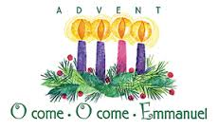
December 7th: D.O.C.K. meets from 5:00 – 7:00. We’ll be studying scripture from the Old Testament and showing how it pointed to Jesus way before he was born.

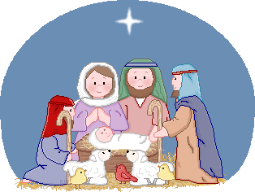
December 14th: D.O.C.K. meets from 5:00 – 7:00. We’ll continue our scripture study and then watch the movie, “The Nativity”.


December 21st: Following worship we will go Christmas Caroling. We’ll eat a light lunch and then car pool with members of RUMC. We’ll return to church and head upstairs for a Youth Christmas Party. We should be ready to go home by 3:00. NO EVENING MEETING.


December 28th: Please meet upstair at 9:00 a.m. to prep for our YOUTH LED WORSHIP Service. NO EVENING MEETING.


RUMC is collecting food for Christmas baskets that will be given to people in need. If you’re able, please help us by bringing the listed items to D.O.C.K.
Nov. 30
Canned fruits and veggies
Dec. 7
Boxes of pasta, cereal, potatoes, etc.
Dec. 14
Jars of peanut butter and jelly
Dec. 21
Canned tuna, meats, soups, etc.

Thank you,
Terri Seibold
Director of Youth Ministry

