

October 2018

Rossford

United Methodist Church
Our Mission:
"To Know Christ And to Make Christ Known"

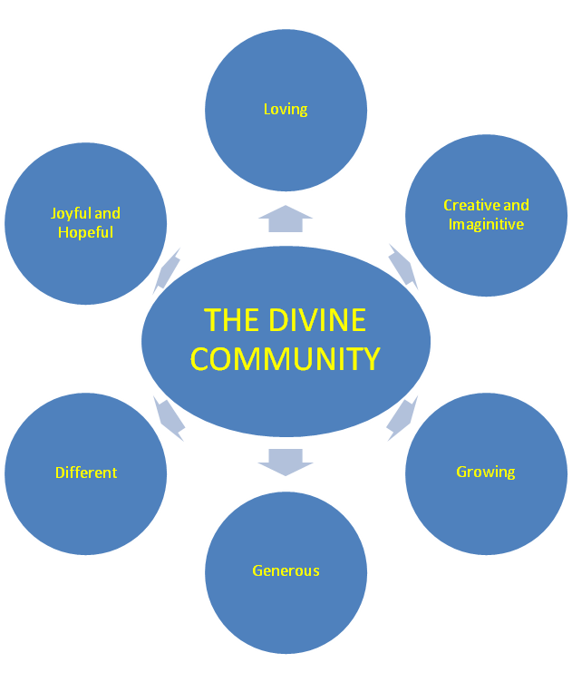

Rossford United Methodist Church

270 Dixie Hwy

Rossford, OH 43460

Phone:

(419) 666-5323

Services

9:00 am Sunday School

10:30am Worship

Office Hours:

M-F 8:15am-2:15pm

Facebook:

www.facebook.com/

RossfordUMC

E-Mail:

rossfordumc@yahoo.com

Visit us online at:
www.rossfordumc.org

Inside This Issue:

Pastor's Message 1/2

DOCK 2

How can you help/
Fundraising/ Sermon Series 3

Worship/Kids Kingdom Choir 4

Congregational Care Committee
Celebrations/ Thanksgivings 5

Jamie Baumgartner's Concert 6

Helping Hands 7

Watoto 8

Calendar of events 9

**If you would like to receive our electronic newsletter please call or email us. **

FROM PASTOR DWAYNE

Here is a visual representation of what the Church, the Divine Community, is to look like. The Divine Community is to reflect the Divine Community of the Trinity - God the Father, God the Son, and God the Holy Spirit. As they are in prefect relationship with each other, we are to work and strive for a community that reflects this kind of love to each other and others. Or as Jesus said when asked about what is the greatest commandment (Matthew 22:37-40),

"Love the Lord your God with all your heart and with all your soul and with all your mind. This is the first and greatest commandment. And the second is like it: Love your neighbor as yourself. All of the Law and the Prophets hang on these two commandments."

Continued on page 2…

Continued from page 1…

We are a community that is defined by love. Everything we do is about loving God and loving others. That's why that on top of the Divine Community visual is the word loving. It is primary, the first, it is what we are. And as we go around we live into the other aspects of our faith and Christianity. We are to be creative and imaginative in how we live and grow in our faith. Our growth, spiritually and numerically, is creative and imaginative. Our growth comes by worship and serving others and learning Jesus and praying and using our gifts to make disciples of Jesus Christ for the transformation of the world.
We are to be people who are generous. Generous with our money, time, energy, wisdom, friendships, and our space. And when we live this kind of life the world will see us as different. A different kind of community and church and people. A people, church, who have a deep sense of joy and hope. Which leads us back to loving God and loving others. Which continues to lead us to become the church that is defined by love which leads to reconciliation, truth, forgiveness and seeking forgiveness, connection, invitation and welcome and an outward focus so others can experience the love and grace and hope and joy of Jesus Christ.
As you can see, this is an ongoing process, one in which are we continuing to love and learn and grow so we can help make the world better. Let us fill our community and our world with love, hope, joy, peace, kindness, generosity, grace, forgiveness, creativity and imagination.
Grace and Peace,
Pastor Dwayne

DOCK
Hello from D.O.C.K. October will be a busy month for us. We’ll be joining the choir on World Communion Sunday, Oct. 7th singing “He Reigns”. It’s a perfect song for the day. Following worship we will be running the drive-thru for the Chicken BBQ. That’s always fun for us and then we eat pizza!
The theme for the Halloween Parade is “DECADES…Looking forward to looking back”. Miss Judy has many ideas. Some ideas include poodle skirts!!! We’ll be building the float on Saturday, the 27th and marching in the parade after our Youth Led Worship service on the 28th!!! It’ll be a busy weekend but fun one.
We’ve been meeting on Sunday nights as usual. We begin each meeting discussing how we were blessed and how we blessed someone during the week. We’ve also been talking a little bit about “why should we fit in when we were born to stand out”. It’s a great topic for the beginning of the school year. We’ve got a great group of youth and each one of them has their own unique personality and style.

We celebrate that God created each of us to be just the way we are…and God doesn’t make mistakes!

D.O.C.K.
Disciples Of Christ's Kingdom
FUN - FOOD - FELLOWSHIP - FAITH
Grades 6-12
Sundays
5:00 - 7:00 pm
Terri Seibold
Director of Youth Ministry

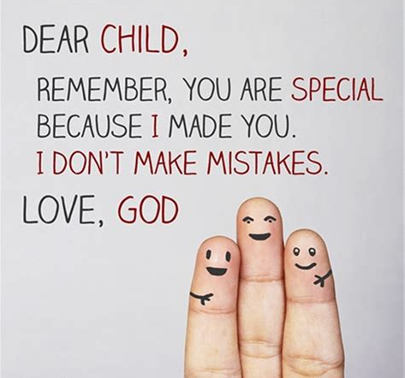



FUNDRAISING

FREE MONEY FROM KROGER
USE THE POWER OF YOUR PLUS CARD FOR GOOD!
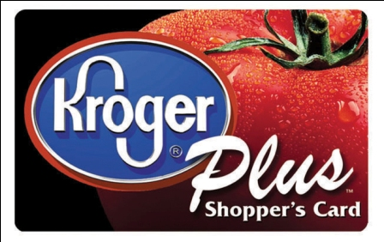
Did you know that every purchase you make at your local Kroger could be helping RUMC? Register your Kroger Plus Card today
# 84283
UPCOMING EVENTS:
Look out for more information and volunteer sign up sheets

October 7th: Fall Chicken BBQ
November 17th: Craft Bazaar
Thank you!
Sue Perkins

Ushers and Greeters
Please see Bob Baughman to Usher or Brenda and Al Weis to Greet or Valet.
Helping Hands of St. Louis
Thursday, November 1st, 2018. Questions please contact Jerry Baumgartner at
419-666-7236.
Prayer Quilts
If you know of anyone who would benefit from a prayer quilt please call or see Nancy Stonerock. She can be reached at 419-874-3504.
UMC Market
The United Methodist Church has started a "market." This is a way for our church to earn money. You need to go online to www.umcmarket.org and sign up. Whenever you order from this site our church receives a % of what you purchase. There are 89 pages of participating stores and the amount we receive varies. Any questions, see Sue Perkins.
Cancelled Stamps
We are collecting cancelled postage stamps. The collection box is located in the Narthex. Please see Barb Chesson if you have any questions.
Can Drive
We would like to remind you that we are still collecting aluminum cans to raise money for our church. If you have any to donate, the container is outside the kitchen door. If you need a pickup, please call Doug Williams at 419-661-9484.
Kroger Rewards Program
Our last check received was for $79.45! Your spending at Kroger really helps!
The Kroger Rewards Program is a nationwide program that lets loyalty card holders select charities to which Kroger will donate, based on dollars they spend in stores. If you have a Kroger card, PLEASE check to see that you are signed up, so that our church gets a percentage of what you buy.
Our Kroger Plus Rewards Organization
# 84283

UPCOMING SERMON SERIES:

"What Is The CHURCH sermon series"
Sept. 30th - "R - Redemption/Reconciliation"
Romans 3: 21-31
Oct. 7th - "C - Community"
Revelation 21: 1-4
Oct. 14th - "H - Healing"
Matthew 8:1-4



WORSHIP NEWS
The Worship Committee is pleased with the new offering of Sunday School for our Kingdom Kids during Worship. We have partnered with Kim Weyandt, Children's Coordinator, in working out details and feel this is a great opportunity for our kids at RUMC.
Also, please remember the Kids Corner in the Narthex if your little ones are wanting a place to color or play before worship or during worship if they become restless. Hopefully you have noticed how wonderful this area looks. Many thanks to Judy Bowerman for adding color and design to that niche!
Our committee will meet on Thursday, Sept.26, to discuss Worldwide Communion, schedule for worship services through November, Veteran's Sunday, Consecration Sunday, etc.
As always, if you have comments to share about worship services, please see Cheryl or Nancy.
Thank you!
Cheryl Garlow and Nancy Rust
Co-Chairpersons of Worship Committee

KIDS KINGDOM CHOIR
I love the name. We’re rehearsing on the third Sunday of the month in the music rehearsal room downstairs. After the kids have met for a bit with their teacher they come to me. Our theme for the year is from Psalm 98: 4-6
Tell everyone on this earth
to sing happy songs
in praise of the Lord.
⁵ Make music for him on harps.
Play beautiful melodies!
⁶ Sound the trumpets and horns
and celebrate with joyful songs
for our Lord and King!
We sang “I Love Bugs” at our first meeting and “Sing For Joy” complete with jumping, clapping, shouting and marching! We’ll begin our Christmas song in October, “This Is The Day of Our Savior’s Birth”.
Tell all your friends to join us for Kingdom Kids and Kingdom Kids Choir.
Terri Seibold
Kingdom Kids Choir Director

CONGREGATIONAL CARE COMMITTEE

Here we are, another month gone by. As we approach the beautiful cool fall days I know Kim and myself are happy to see the brutal hot summer weather gone! I'd like to reflect on the name of our committee..... Congregational Care; let's also take care of ourselves and slow down! We are approaching the busiest time of the year so I for one would like to just "Be still and know that I am God.".
That being said, we did try something new this fall with football Friday tailgate parties. This was to reach out to our community and provide parking and shuttles to high school games, also giving hot dogs and other food out. Unfortunately the first 2 games haven't shown much interest so we are not going to continue the tailgate for the remaining home games. Parking is still available but no tailgate. Thank you to everyone who has helped and we enjoyed some fellowship among ourselves!
October craft night will be Tuesday Oct. 23rd and from now on be the 4th Tuesday of the month.
We will also be busy with the church BBQ, trunk or treat on Oct 21st and if course the Rossford Halloween parade Oct 28th. Look for details and sign up sheet in the bulletin.
We plan another Pallet painting Friday Oct. 19th. See Kim for information and sign up for this through Facebook.
October greeter and valet are Christy and Matt Foster.
Remember to take time to "Be Still"
Al and Brenda Weis, Kim Weyandt, Congregational Care committee co-chairs
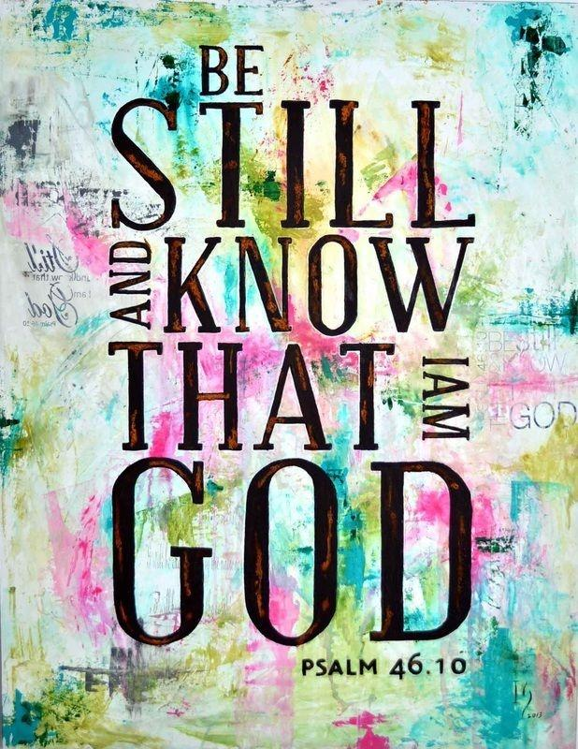
We were fortunate enough to offer our facilities to the RHS Football team on August 30th for their team dinner. The team sent us a wonderful thank you card. If you would like to check it out it is in the Narthex on the bulletin board.
RUMC hosted an American Red Cross Blood Drive on August 31st in the Narthex. We were able to produce 21 units of blood! We host a blood drive a few times a year and it is open to the public. Our next scheduled drive will be Friday, January 25th, 2019.



BIRTHDAYS
Betty Woods 10/1
Carole Allen 10/4
Paul Pertner 10/6
Nancy Stonerock 10/6
Dave Olwick 10/8
Jack Engwert 10/12
Deb James 10/12
Laurie Clingo 10/17
Kim Weyandt 10/27
Lindsay Brant 10/30
Wendell James 10/30
ANNIVERSARIES
John & Bethany Rust 10/2
Jim & Judy Sikorski 10/20
***If we missed you or someone else, please let us know at rossfordumc@yahoo.com or call 419-666-5323***

JAMIE BAUMGARTNER IN CONCERT AT RUMC
I'd like to personally invite my entire church family to my Concert at the church Friday Oct. 19th!
And I encourage everyone to bring a friend! This is going to be an awesome event and I will be pouring my heart out. I've performed all over, but a headlining concert in my hometown, at our church, means a great deal to me and it would mean the world to me to see you all there!
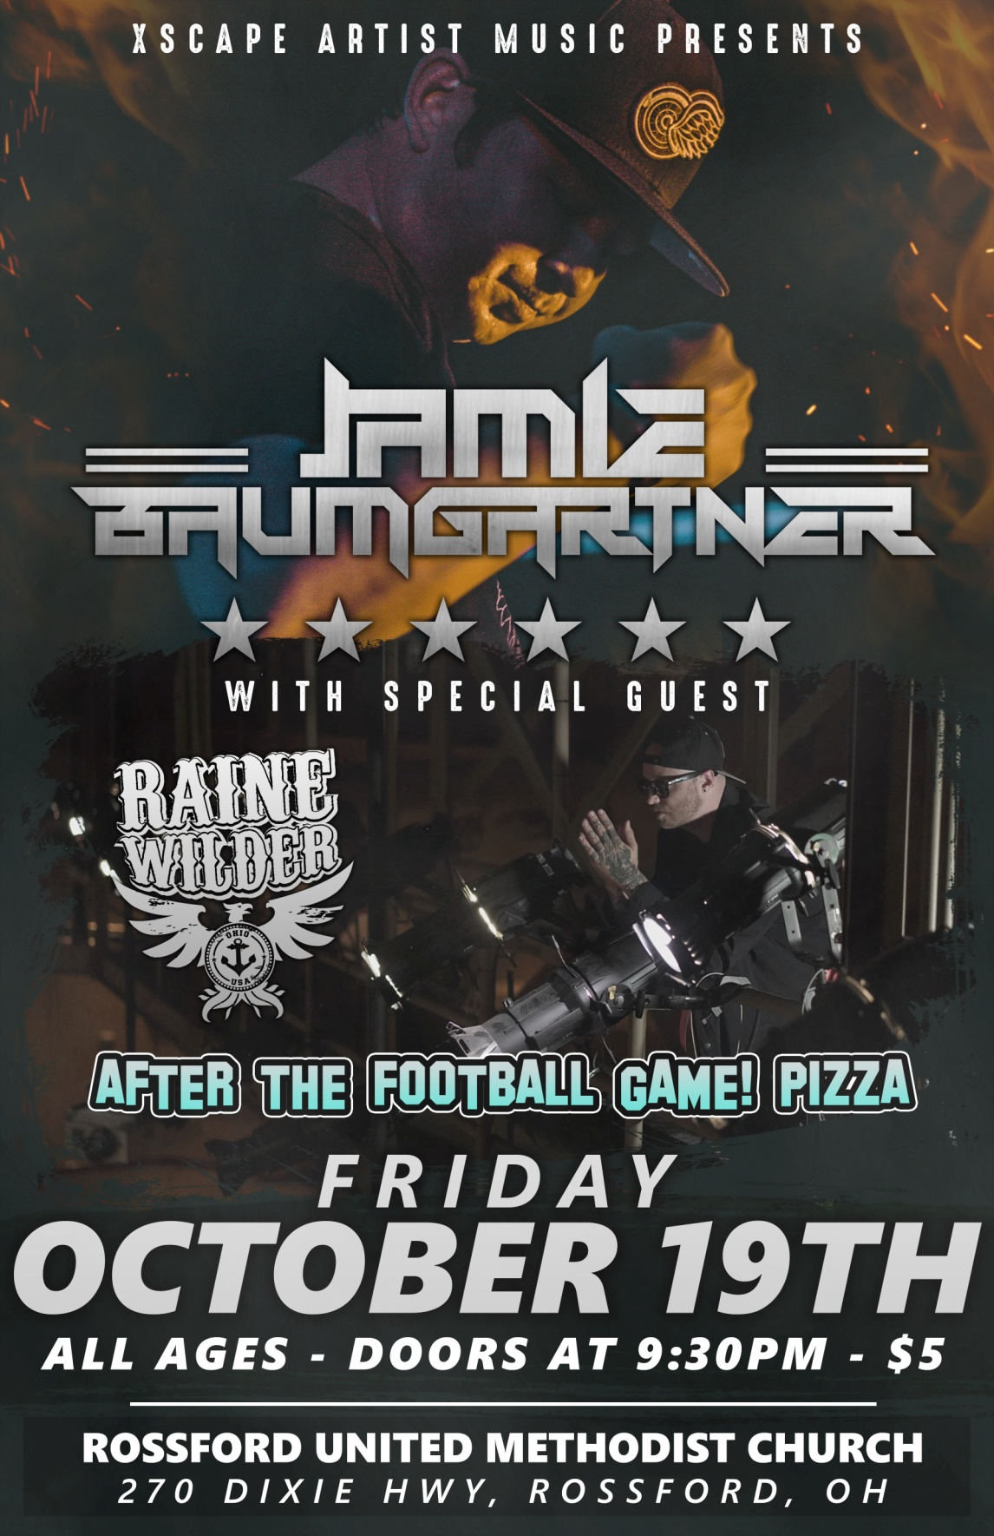

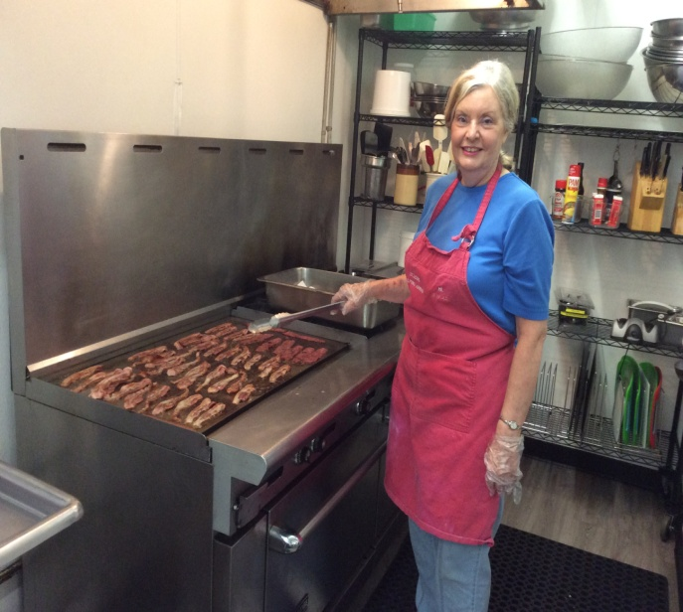
HELPING HANDS OF ST. LOUIS
Helping Hands of St. Louis, located at 443 Sixth St., Toledo, Ohio, serves low income and homeless families and individuals. The outreach center includes a soup kitchen, food pantry and clothing center. Additional services include providing hygiene packs to families and hot showers and hygiene and snack kits to the homeless.
Since 1982, Helping Hands has served more than 1.5 million meals to people in need. An average of 250 meals are now served each day, Monday through Friday, through the generosity of local community members and businesses and through the dedication of our volunteer teams.
The mission of Helping Hands of St. Louis is to provide hot nutritious meals, groceries, clothing, hot showers and other social services for all who come to our doors. We strive to acknowledge the dignity of each and every person by assisting with a smile, an embrace, or a material or a spiritual need. We welcome everyone who comes to our doors for a warm meal. We never ask questions of eligibility, religious affiliation or residency. We want to provide a refuge for those who have no place to go, who are hungry and looking for someone with whom to talk. We try to stress the importance of the person and the need for human dignity and respect.
Know Someone Who is in Need?
Please contact Helping Hands for more information:
Helping Hands of St. Louis
443 Sixth Street, Toledo, OH 43605
Phone: 419-691-0613
Fax: 419-697-4223
E-mail: helpinghands@bex.net
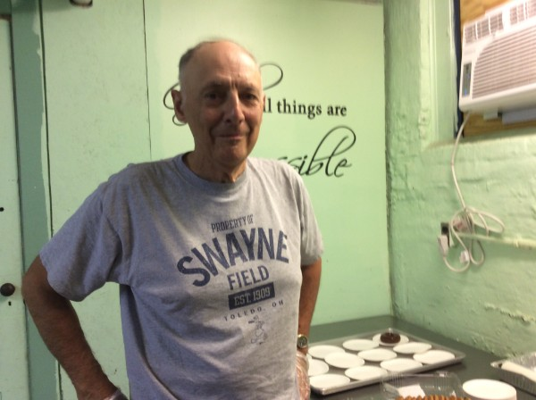
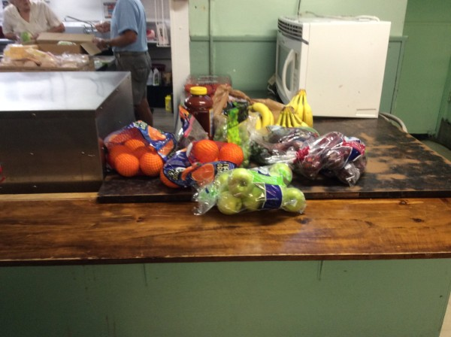
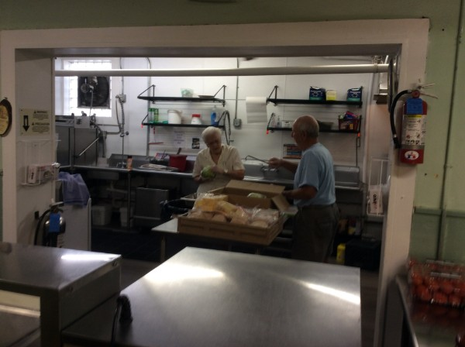

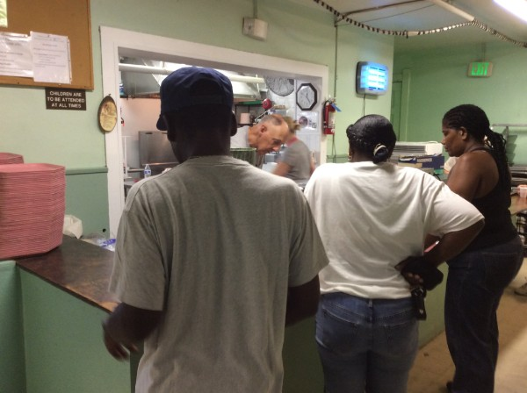

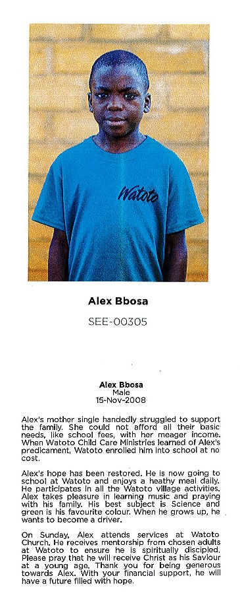

Meet Alex Bbosa! He is our RUMC sponsored child. He is 10 years old and just as cute as can be. He sends us letters periodically to update us on how he is doing. We received one in September. You can read it in the Narthex.
During our Youth Led Worship Services we insert a envelope labeled as "Special offering for children of the Watoto village in Africa" These funds directly help young children who are in need. If you want to learn more about Watoto and how you can help please click here.
You can respond to Alex at any time. I'm sure he will love to hear from us. Send an email to uganda.sponsor@watoto.com. Please insert "Alex Bbosa" in the subject line and do not include attachments. Your email will be printed and mailed to Alex from Watoto. I'm sure he would love to hear more about us. If you are unable to send on your own, drop it off in the office and it can be sent on your behalf.
Thank you for your continued donations!
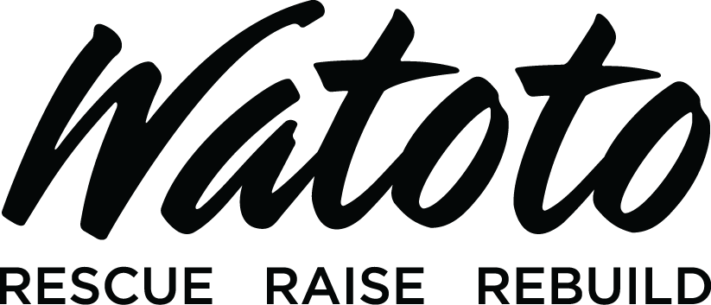

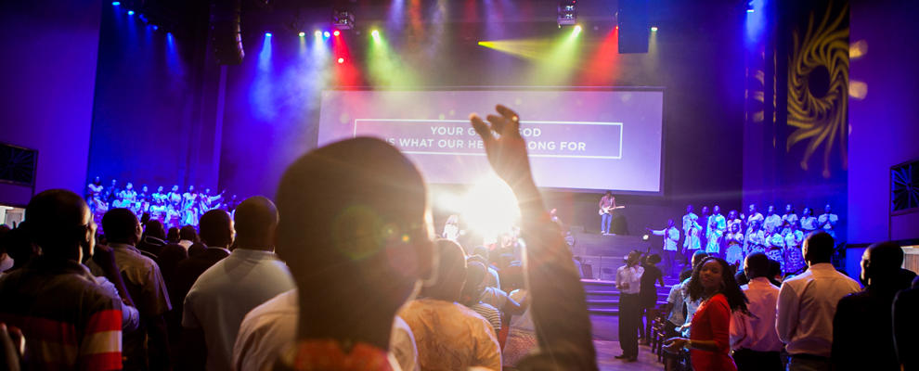

October 2018
SUN | MON | TUES | WED | THURS | FRI | SAT
 | 1 | 2 | 3 | 4 | 5 | 6
 | 6:15-9 pm RHS Drama (Sanct.)  8 - 10 pm HEMA (FLC) | 9:15 am Ladies Bible Study (Parlor)  6:15 - 9 pm RHS Drama (FLC)  6:30 pm Scouts | 6:30 pm Scouts | 6:15-9 pm RHS Drama (FLC)  6:00 pm Bells  6 - 8:00 pm Girl Scouts  7:00 pm Choir  8:30 pm AA
7 | 8 | 9 | 10 | 11 | 12 | 13
9:00 am Adult Sunday School  10:30 am Worship  CHICKEN BBQ after services  No DOCK | 6:15-9 pm RHS Drama (Sanct.)  6:30 pm Private Event (Parlor)  8 - 10 pm HEMA (FLC) | 9:15 am Ladies Bible Study (Parlor)  6:15 - 9 pm RHS Drama (FLC)  6:30 pm Finance& Trustees  6:30 pm Scouts  7:30 pm Admin. | 6:30 pm Scouts | 6:6:15-9 pm RHS Drama (FLC)  6:00 pm Bells  6 - 8:00 pm Girl Scouts  7:00 pm Choir  8:30 pm AA |  | 9:00 am Men's Breakfast (Silver Moon)  7:30 pm Contra Dancers (FLC)
14 | 15 | 16 | 17 | 18 | 19 | 20
9:00 am Adult Sunday School  10:30 am Worship  5:00 pm DOCK | 6:15-9 pm RHS Drama (Sanct.)  8 - 10 pm HEMA (FLC) | 9:15 am Ladies Bible Study (Parlor)  6:15 - 9 pm RHS Drama (FLC)  6:30 pm Scouts | 6:30 pm Scouts | 6:00 pm Bells  6 - 8:00 pm Girl Scouts  7:00 pm Choir  8:30 pm AA | 6:00 pm Pallet Painting (FLC)  Jamie Baumgartner Concert following football game (Sanct.) | 11:30 - 4:00 pm Baby Shower (FLC)
21 | 22 | 23 | 24 | 25 | 26 | 27
9:00 am Adult Sunday School  10:30 am Worship  5:00 pm DOCK | 6:15-9 pm RHS Drama (Sanct.)  8 - 10 pm HEMA (FLC) | 9:15 am Ladies Bible Study (Parlor)  6:15 - 9 pm RHS Drama (FLC)  6:30 pm Scouts | 6:30 pm Scouts | 6:00 pm Bells  6 - 8:00 pm Girl Scouts  7:00 pm Choir  8:30 pm AA |  | 8 - 3 pm Kitchen booked  Youth float building
28 | 29 | 30 | 31
9:00 am Adult Sunday School  10:30 am Youth Led Worship  2:00 pm Rossford Halloween Parade | 8 - 10 pm HEMA (FLC) | 9:15 am Ladies Bible Study (Parlor)  6:00 pm Craft Night (Parlor)  6:30 pm Scouts | 


NON-PROFIT
US POSTAGE
PAID
TOLEDO, OH
PERMIT #522

ROSSFORD UNITED METHODIST CHURCH
270 DIXIE HWY
ROSSFORD, OH 43460




Staff

Pastor: Pastor Dwayne Shugert
Ministers: Every Member
Children’s Ministry: Kim Weyandt
Youth Ministry: Terri Seibold
Secretary: Jenny Graffius
Music Program Director: Sarah Buehrer
Organist: JeanE Waggoner
Custodians: Steve Agler
Jenny Riehm
Nursery: Carol Kotecki
MacKenzie Rodriguez

Lay Leadership

Lay Leader: Tom Ridenour
Head Usher: Bob Baughman
Media Directors: Troy Westfall
Jeff Comley

