

October 2016 Blessings

Rossford United Methodist Church
Our Mission: To Know Christ And to Make Christ Known

From the Pastor's Pen…

A WORD OF THANKS FOR THE CELEBRATION

On the afternoon of Sunday, September 11th, our church created a wonderful celebration of recognition for those who serve the Rossford city and Schools.
We wanted to let all who seek to make live better for the residents and our children how much we appreciate their dedication and service. However, now is the time to recognize and say “Thank You” to those who worked to design and implement the afternoon celebration with free food, fun, games, entertainment and, of course, recognition of those who serve our city and schools. So to those who worked hard to organize and carry off the event, we, your brothers and sisters in Christ and members of the Rossford United Methodist Church was to recognize you and say Thanks you. They are as follows:

Thank you for making the “Celebration of life: Live, Laugh, Love” event possible:
First the Committee that launched the idea began the process of designing the event are Kim Weyandt - Children’s Ministry Coordinator
Cheryl Garlow and Nancy Rust - Co Chairs of Worship
Terri Seibold - Director of Youth Ministry

As it evolved, we had input from Sarah Buehrer, Director of Music, Suggestions from the School Superintendent office regarding Possibility of School Choir, A parent suggested inviting the school Band. (Unfortunately neither the school band nor choirs were able to participate)
Those anonymous donors proving the hamburgers and hotdogs and the grill on which to cook Cheryl for securing the banners outside and along with Bill setting them up and suggestion the pens and having them made
To those who served on Kim’s work team which included:
Tori Westfall, Troy Westfall, Jeff Comley, Tom Ridenour, Jerry Baumgartner, Larry Ulrich, Kathy Ulrich, Nancy Stonerock, Sue Perkins, Judy Bowerman, Tina Vogelpohl, Charline Crispen, and Mike Hoffman for transporting all of the equipment grill, snow cone and cotton candy machines, building a frame attachment for the banners makes them reusable, Taking down the banners, building the frame around the Memorial Flag secured by Jim and Judy Sikorski, and for Mike’s beautifully done song, Proud to be an American.

Terri secured the stage, Jim and Terri for the PA system musical instruments and leading the youth in their music portion. Weren’t the youth fantastic?
Sarah and JeanE with the Men’s Chorus and Choir, weren’t they great?

Darrell and Caroline, Steve, Tim, Lindsay, Kristen, Eric for helping with the parking and greeting. John Rust for coordinating the parking - transporting people in his golf cart, Setting up tables and chairs and all who pitched in to help.

We received wonderful comments from members of the city, schools and community. Thank you.

Grace and Peace,
Bob

Rossford United Methodist Church

270 Dixie Hwy

Rossford, OH 43460

Phone:

(419) 666-5323

Office Hours:

M-F 8:00am-2:00pm

Facebook:

www.facebook.com/RossfordUMC

E-Mail:

rossfordumc@yahoo.com

Visit us online at:
www.rossfordumc.org

Services

9:00 am Sunday School

10:30am Worship

10:00am Summer Worship

Inside This Issue:

Pastor's Pen 1

You are a Miracle 2

Dock News & Worship 3

How Can You Help? Thanks 4 & Hospitality/Fellowship

Celebrations and 5 Fundraising Events

Calendar 6


You Are A Miracle
Psalm 139: 13-18

BOB HOPE was one of the great comedian of the last century. As he was getting along in years, he once commented that he’d been reading and was astonished to discover:

“Today my heart beat over 103,000 times,
my blood traveled 168 million miles,
I breathed 23,400 times,
I inhaled 438 cubic feet of air, ate 3 pounds of food, and drank 2.9 pounds of liquid,
I perspired 1.43 pints… gave off 85.3 degrees of heat… generated 450 tons of energy,
I spoke 4,800 words, I moved 750 major muscles,
and I exercised 7 million brain cells.
(pause…) It’s no wonder I’m tired all the time.”

You are going to think that you are in a class of Physiology this morning. However, this is a message about the unique gift of God that you are. It is the Theology of Creation. It is about the nature of God and Human beings.

So do you understand that you are a miracle?
Do you know how uniquely special you are?

ST AUGUSTINE once said, "People travel to wonder at the height of mountains, at the huge waves of the sea, at the long courses of the rivers, at the vast compass of the ocean, at the circular motion of the stars -- and (yet we) pass by (ourselves) without wondering."

AUGUSTINE was right.
Most of don’t realize how intricate and wondrous our bodies really are.
I did some reading recently, and I was amazed at the uniqueness and intricateness of our bodies.

For example: In a square inch of skin (1), you would find:
19 yards of blood vessels;
65 muscles;
78 yards of nerves;
78 sensors for heat, 13 for cold, 160 for pressure;
650 sweat glands;
1300 nerve endings;
and 9,500,000 cells.

GET RID of 30 - 40,000 skin cells every day. The skin you see today will be gone in a month

THE SKIN SERVES several purposes including providing a protective shield against bacteria and viruses and the absorbing of bumps and bruising that might otherwise damage your bones and internal organs.… and in that inch of skin, your sweat glands in your body do double duty, helping to eliminate wastes and cool your body.

BRAIN Then, there’s your brain which weighs about three pounds, but stores 100 trillion bits of information over the course of 70 years. That storage capacity is roughly equal to 500,000 sets of the Encyclopedia Britannica (which, if stacked, would stretch out over 442 miles). Your brain does all this and uses less power than a 100-watt bulb.

Your brain is serviced by about 45 miles of nerves that send impulses through your body as rapidly as 325 miles per hour. Your nervous system is so sensitive you are able to feel on your fingertips (or face) a pressure that depresses your skin a bare .00004 (400,000’s) inch - roughly the weight of a bee’s wing falling on your cheek.

EARS Then, there’s your ears: A piano has 88 keys, but each of your ears has a keyboard with 1500 keys. They are so finely tuned that you can hear the blood running through your vessels.

EYES Your eyes are capable of seeing a small candle flame from 30 miles away on a clear, dark night. And can distinguish among more than 300,000 different color variations

NOSE Your nose can smell one drop of perfume diffused through a 3 room apartment.
Continued on Page 3…



DOCK News

D.O.C.K. is back in full swing now. The youth performed a couple of songs at our “Celebration of Life: Live Laugh Love” event on September 11th. The celebration continued at our youth led worship service on September 25th with the theme “Celebrate the Lord of Love”.

On October 2nd the youth will be running the drive-thru for the Chicken BBQ fundraiser. We work hard to earn tips for our youth activities. We always end the day with a pizza party before we go home.

The Rossford parade theme this year is “Candy Land…Everything is Sweeter in Rossford”. Judy Sikorski has already found 40 candy canes to use on our float. We’ll be spending time planning and building our float during October.

We’ll end the month leading worship with a stewardship theme on October 30th and then heading to the marina to be in the parade.
Remember, youth in grades 5 – 12 are invited to join our youth group. We love visitors and friends and new members. If you have questions call or email me: 419-344-3123 or Terri@seiboldbaker.com.

In accordance with Safe Sanctuaries, I am in need of adult volunteers. Most Sunday evenings D.O.C.K. meets from 5:00 – 7:00 p.m. I would like to have an adult at the church during that time in case of an emergency (I’d prefer people other than the kids’ parents/grandparents). All you would need to do is sit in the parlor or narthex or sanctuary. I don’t need assistance with teaching. You can read a book, take a nap, pray, work on crossword puzzles, polish your nails, post on Facebook, whatever. Keep a cell phone handy just in case I need you. There is a sign-up sheet in the narthex with October and November dates and times.

Thank you,
Terri Seibold
Director of Youth Ministries

We are Disciples Of Christ’s Kingdom!

Continued from page 2…

YET, THAT WHICH SETS YOU APART FROM EVERYONE IS THAT
No one looks exactly like you
Thinks for acts exactly like you
has your finger prints
has your personality

YOU ARE A UNIQUE GIFT AND CREATION OF GOD

David wrote: “I praise you because I am fearfully and wonderfully made; your works are wonderful, I know that full well.” Psalms 139:14

TODAY WE WILL CELEBRATE LIFE
You are a miracle
You are a very special gift of God
No one in all of creation has ever been like you
Never has been, Not now, Never will be
When you look in the mirror you are looking at a miracle
Today, we celebrate the gift of your life, a gift of God
I celebrate you
You are a miracle, wonderfully and fearfully made
And I praise God for you.

(1) Baseline of Health Foundation

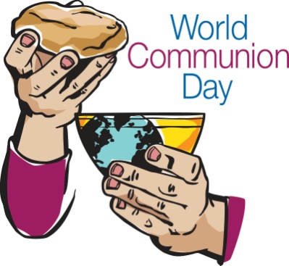


Worship News

The Worship Committee met August 29th to plan for the September and October upcoming special events.

October events include Worldwide Communion Sunday on October 2nd and stewardship speakers.

We will meet again October 27th to plan for November and December which is a very busy but exciting time of year. During Advent we need groups of volunteers to do readings. If you are interested please see Cheryl or Nancy.

With Love,
Cheryl Garlow and Nancy Rust
Co-Chairpersons of Worship Committee

Page 3


Ushers and Greeters

Please see Bob Baughman to Usher or Brenda and Al Weis to Greet or Valet.

Helping Hands of St. Louis

The next date is October 6th. Interested, please contact Jerry Baumgartner at 419-666-7236.

Prayer Quilts

If you know of anyone who would benefit from a prayer quilt please call or see Nancy Stonerock. She can be reached at 419-874-3504.

Kroger Store

The Kroger Rewards Program is a nationwide program that lets loyalty card holders select charities to which Kroger will donate, based on dollars they spend in stores. If you have a Kroger card, PLEASE check to see that you are signed up so that our church gets a percentage of what you buy. Your purchases really helps us out. Thank you!

UMC Market

The United Methodist Church has started a "market." This is a way for our church to earn money. You need to go online to www.umcmarket.org and sign up. Whenever you order from this site our church receives a % of what you purchase. There are 89 pages of participating stores and the amount we receive varies. Any questions, see Sue Perkins.

Box Tops and Stamps

We are still collecting Box Tops for Education and used stamps. The collection box is located in the Narthex. Please see Barb Chesson if you have any questions.

Can Drive

We would like to remind you that we are still collecting cans to raise money for our church. If you have any to donate, the container is outside the kitchen door. If you need a pickup, please call Doug Williams at 419-661-9484.


"Thank You" is a simple phrase, But still, it's meant to show that we appreciate your help more than you could know.

~From the Officers and Firefighters of the Rossford Fire & Rescue Department.

Hospitality/Fellowship

The committee met today Sunday Sept 25th after the worship service. We have decided to only have coffee hour on the 2nd Sunday (*birthday Sunday) and the 4th Sunday of the month. However, if someone has a desire to make something and serve it along with coffee and drinks we certainly won't turn it down. We feel so many of us are involved in multiple committees, and we have other family commitments so staying at church for a lengthy time is not part of them.

We are planning a chili cook-off contest for Sunday Oct 16th immediately after the worship service. Get your best chili recipes out and bring a Crockpot to share and be judged by our panel of celebrity judges!! Should be a fun event!!

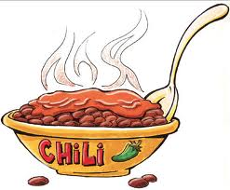

The hospitality/fellowship committee will meet again on Oct. 9th directly after service to address Veteran's day cards to Veterans staying at the Ann Arbor VA hospital. This was a successful project last year and we know the Veteran patients really appreciated it!!

Greeter for October: Christy Foster
Valet for October: Matt Foster

Tentative greeter and valet for November are Betty Dowell and Al Weis, respectively

Happy Fall Y'all

Al and Brenda Weis, co-chair Hospitality
Kim Weyandt and Brenda Weis, co-chair Fellowship

Page 4

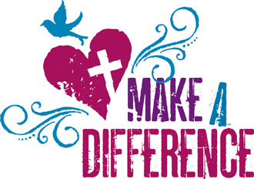
Trunk or Treat
The Trunk or Treat will be October 30th, 2016 from 5:00 p.m. to 7:00 p.m. There will be a sign up sheet in the Narthex beginning in October if you want to decorate your cars and hand out candy. There will be a prize for the best decorated vehicle! See Kim Weyandt if you have any questions.
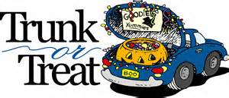

FALL CHICKEN BBQ - Sunday, October 2 at Noon. Until sold out…These chickens will 'fly' out of here.
MAKING APPLE DUMPLINGS - Friday, evening October 14 and Saturday, October 15 during the day Friday evening October 21 and Saturday, October 22 during the day
CHILI COOK OFF - Sunday, October 16th. Sign up in the Narthex if you are interested.
CRAFT BAZAAR - Saturday, November 12th from

Collecting food for advent baskets - Dates to be determined

Christmas Services - December 24th at 7pm, and December 25th at 10:30 am

Thank you for all your continued support of RUMC,
Sue Perkins
Chair-Fundraising Committee

Rossford DECA Halloween Parade

Sunday, October 30, 2016
2:00 p.m.
“Candy Land….Everything is Sweeter in Rossford!”

Nursery Worker needed permanently
We have an opening for a nursery worker during worship each Sunday to work with Carol Kotecki. The position pays $10/hr and you will be required to get finger prints taken as well as a background check as we are part of our 'Safe Sanctuaries' program.

If you or someone you know like babies and young children, please contact Kay Jacob, Chair of SPRC Committee at 419-407-5555. If not home please leave a message. Thank you!

Anniversaries

John and Bethany Rust 10/2

Jim and Judy Sikorski 10/20

Birthdays

Thomas Olds 10/1
Betty Woods 10/1
Paul Pertner 10/6
Nancy Stonerock 10/6
Dave Olwick 10/8
Jack Engwert 10/12
Deb James 10/12
Sarah Buehrer 10/13
Cameron Agler 10/26
Kim Weyandt 10/27
Lindsay Brant 10/30
Wendell James 10/30

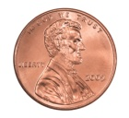
Heifer Project nearing
1 million Pennies!!!

To date our total pennies collected are 988,003. For more information, please see Steve Agler or visit www.heifer.org

- For more than 70 years Heifer International has partnered with and helped communities.
- They've worked in more than 125 countries to attain sustainable livelihoods through community-owned interventions.
- Helped over 25 million families lift themselves out of poverty.
- There are still nearly 1 billion people in the world that live in extreme poverty.

Page 5

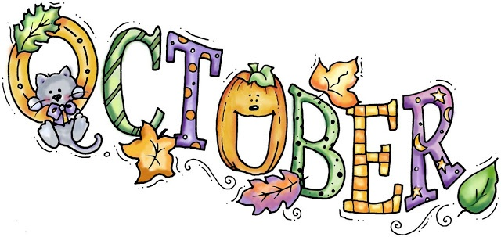
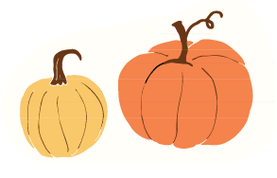

Sun. | Mon. | Tue. | Wed. | Thur. | Fri. | Sat.
 |  |  |  |  |  | 1
 |  |  |  |  |  | BBQ Set Up
2 | 3 | 4 | 5 | 6 | 7 | 8
10:30am Worship  12:00 Chicken BBQ  NO DOCK |  | 9:15 am Women's Morning Bible Study  6:30 pm Scouts | 6:30 pm Scouts | 6:00pm Bells  7:00pm Choir  8:30pm AA | 5:00 pm Wedding Rehearsal | 9:00am Men's Breakfast  Silver Moon  3:30 pm Wedding (Sanct.)  7pm Contra
9 | 10 | 11 | 12 | 13 | 14 | 15
10:30am Worship  Hosp./Fellow. Mtg after worship  5:00 pm DOCK |   Rossford Leaf Pickup begins until first snowfall | 9:15 am Women's Morning Bible Study  6:30 pm Scouts  MEETING NIGHT | 6:30 pm Scouts | 6:00pm Bells  7:00pm Choir  8:30pm AA | Making Apple Dumplings | Making Apple Dumplings
16 | 17 | 18 | 19 | 20 | 21 | 22
10:30am Worship  12:00 Chili Cook Off  5:00 pm DOCK |  | 9:15 am Women's Morning Bible Study  6:30 pm Scouts | 6:30 pm Scouts | 6:00pm Bells  7:00pm Choir  8:30pm AA | Making Apple Dumplings | 9:30 am Private Event
23 | 24 | 25 | 26 | 27 | 28 | 29
10:30am Youth Led Worship  NO DOCK |  | 9:15 am Women's Morning Bible Study  6:30 pm Scouts | 6:30 pm Scouts | 6:00pm Bells  7:00pm Choir  8:30pm AA
30 | 31 |  |  |  | Reserve your event today!  Contact Jenny at  419-666-5323
10:30am Worship  2:00 pm Parade  5:00 pm Trunk or Treat  NO DOCK | Rossford Trick or Treating  6:00 pm-8:30 pm


NON-PROFIT
US POSTAGE
PAID
TOLEDO, OH
PERMIT #522
ROSSFORD UNITED METHODIST CHURCH
270 DIXIE HWY
ROSSFORD, OH 43460

Staff

Pastor: Rev. Dr. Robert Ball
Ministers: Every Member
Children’s Ministry: Kim Weyandt
Youth Ministry: Terri Seibold
Secretary: Jenny Graffius
Music Program Director: Sarah Buehrer
Organist: JeanE Waggoner
Custodians: Steve Agler
Jenny Riehm
ASL Interpreter Karen Whalen
Nursery: Carol Kotecki

Lay Leadership

Lay Leader: Tom Ridenour
Head Usher: Bob Baughman
Media Directors: Troy Westfall
Jeff Comley

