

November 2016 Blessings

Rossford United Methodist Church

Our Mission: To Know Christ And to Make Christ Known

Consecration Sunday Is Coming…

Congregations that approach financial stewardship from a biblical
perspective do not view the money Christians give to their church merely as a way to pay its bills. Rather, such congregations see financial contributions as a way to help people grow spiritually in their relationship with God by supporting their church’s mission and ministry with a percentage of their incomes.

Our congregation’s finance Committee with the approval of the Administrative Council has selected the New Consecration Sunday Stewardship Program as a way to teach the biblical and spiritual principles of generous giving during our stewardship education emphasis this year.

New Consecration Sunday is based on the biblical philosophy of the need of the giver to give for his or her own spiritual development, rather than on the need of the church to receive. Instead of treating people like members of a social club who should pay dues, we are treating people like followers of Jesus Christ who want to give unselfishly as an act of discipleship. New Consecration Sunday encourages people toward proportionate and systematic giving in response to the question, “What percentage of my income is God calling me to give?”

During morning worship on Consecration Sunday, we are asking our attendees and members to make their financial commitments to our church’s missionary, benevolent, and educational ministries in this community and around the world.

Every attendee and member who completes an Estimate of Giving Card does so voluntarily while attending morning worship on Consecration Sunday.

Thanks in advance for your enthusiastic participation in Consecration Sunday events.

Larry Ulrich and Ray McLargin,
Co-Chairs of the Finance Committee

Rossford United Methodist Church

270 Dixie Hwy

Rossford, OH 43460

Phone:

(419) 666-5323

Office Hours:

M-F 8:00am-2:00pm

Facebook:

www.facebook.com/RossfordUMC

E-Mail:

rossfordumc@yahoo.com

Visit us online at:
www.rossfordumc.org

Services

9:00 am Sunday School

10:30am Worship

10:00am Summer Worship

DOCK meets most Sunday's at 5:00 pm


Inside This Issue:

Pastor's Pen 1

Consecration 2/3

DOCK news 4

Hospitality/Fellowship 5

Thanks & Worship News 6

How Can You Help?
Celebrations 7

Calendar 8

What are these charts?

Our spiritual growth and journey is the most important part of our personal lives. One part of that journey is learning to trust God to provide for us. Jesus has told us that our hearts are where our treasure is. We all know that we live in a broken world. Nothing exemplifies this more clearly than watching the candidates vie for the office of president of the United States. These charts are meant to help each of us take steps in growing our commitment to Christ and the Kingdom of God. Please take a look at them and find where you are. Then pray about how you might take one step forward toward deepening your commitment to Christ and His Church.

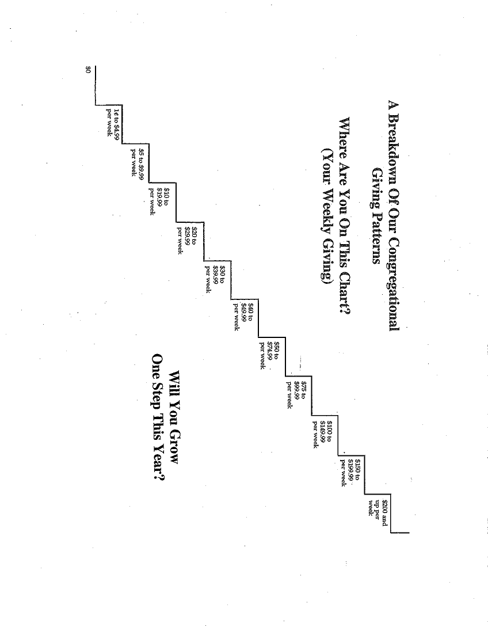

Page 2

DOCK News

By the time you read this article we will have participated in the Rossford parade. The theme was “Candy Land…Everything is Sweeter in Rossford.” Judy Sikorski was our head float builder, Tom Ridenour drove the truck, Jim Sikorski and Mike Hoffman helped with the build and D.O.C.K. members decorated and rode on the float. Whether we win or not, we had fun.

During the month of November the youth will be collecting shoe boxes for Operation Christmas Child. Please see OCC information below.

We will end November by leading worship for the 1st Sunday of Advent.
Remember, youth in grades 5 – 12 are invited to join our youth group. We love visitors and friends and new members.

If you have questions call or email me: 419-344-3123/Terri@seiboldbaker.com

Thank you,
Terri Seibold
Director of Youth Ministries

We are Disciples Of Christ’s Kingdom!

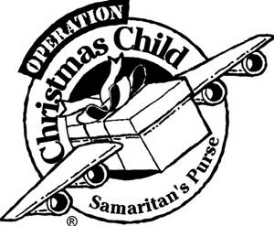
D.O.C.K. will be collecting and packing shoeboxes for OPERATION Christmas Child during the month of November. Please consider either packing a shoebox or donating supplies to be packed.

There will be a large box in the Narthex throughout November for any donations and/or shoeboxes. There will be some empty shoeboxes in the narthex that you can use or you can pack your own. If you go to the website www.samaritanspurse.org/operation-christmas-child/ and click on “How to Pack a Shoebox” you will see instructions. Instructions on what and how to pack the boxes will be included in the bulletin throughout November.

Our final collection day will be Sunday, Nov. 20th. We will drop off all of the boxes at Waterville United Methodist Church on the 21st. Please remember that each box must include $7.00 to cover the shipping and handling costs. If you don’t add the money, D.O.C.K. ends up using their Activity Fund to cover the cost. Thanks for your help.

Suggestions:

- TOYS! Start with a central item that a child will cherish, like a beautiful doll, a deflated soccer ball with pump, or a plush stuffed animal. Then add quality items like cars, musical instruments, puzzles, jump ropes, etc.
- School Supplies: pencils, pens, crayons, notebooks, coloring books, etc.
- Non-liquid hygiene Items: toothbrushes, bar soap, washcloths, combs, etc.
- Accessories: socks, hats, t-shirts, flip-flops, hair bands, sunglasses, etc.
- Crafts: Make your own items such as hair bows, finger puppets, and friendship bracelets.
- Younger Children: Blankets, sticker and picture books, blocks, finger puppets, pages of colorful stickers.
- Older Children: Small tools, tape measures, sewing kits, fabric squares, etc; deflated balls with pumps and needles; solar calculators, rulers
- A Personal Note: You may enclose a note to the child and a photo of yourself or your family. If you include your name and address, the child may be able to write back.

*Please Do Not Include: Used or damaged items; war-related items such as toy guns, knives, or military figures; chocolate or food; out-of-date candy; liquids or lotions; medications or vitamins; breakable items such as snow globes or glass containers; aerosol cans.

Page 4

Clark Street United Methodist Church
1133 Clark Street, Toledo
(Off of Fassett between Oak & Utah Streets)

Ladies
Soup, Salad, and Dessert Luncheon
Thursday, November 17th
12:00 noon

Folliwng the luncheon, a program will be presented by NICU Cuddler, Diane Worcester

Please call with approzimate reservations to
Pat Davis, 419-666-3147 by November 11th.

First St. John Lutheran Church
2471 Seaman St, Toledo

Chicken & Ham Dinner with Craft and Bake Sale
Saturday, November 5th
4:00 pm to 7:00 pm

Tickets: Adults $10
Children: $4
Age 2 & Under: Free

All you can eat - Family Style chicken, ham, mashed potatoes/gravy, green beans, coleslaw, applesauce, rolls/butter, beverage, and homemade dessert

Hospitality/Fellowship

Greetings and happy fall! Our committee had a successful chili cook-off with 12 entries. 1st place went to Charlene Crispen and 2nd place to Jan Ridenour. Our 5 celebrity judges were Lissa Guyton, Mackenzie Kuehnlein, Ben Cathey and Joe Nugent from Channel 13 News and Joe Stoll from Channel 11 News. They were really fun and got into the spirit of the cook-off. It was quite a process to Come up with only 2 prize winners as all 12 were great! We look forward to this being an event in the future! Many thanks to Ron McCamey for being our resident photographer and Jenny for creating a presentation on the TV's in the Narthex using those great pictures.

We have addressed 50 Veterans Day cards that will be sent to hospitalized veterans at the Ann Arbor VA. These are always appreciated by veterans who don’t get much mail.

Our next event that involves our committee will be the annual conference to be held at our church on Sunday Nov 20th at 2:00pm. We will provide a light snack for the participants. Then comes December which is always a busy month at church. Dec 11th is the Choraliers concert at 7 pm and we will provide refreshments. Sunday Dec 18th will be the church Christmas caroling, details to follow in the Dec newsletter.

November greeter and valet:
Betty Dowell and Al Weis
December Christy and Matt Foster

Lastly, our committee is still looking for volunteers to provide food for the coffee hour. We will only be holding coffee hour the 2nd and 4th Sundays of the month. The signup sheet will be out for each Sunday, however if no one signs up then we’ll only have coffee. Al is scheduled for knee replacement Jan 5th so he’ll be on the mend for the month of January and part of February. Any help during this time will be appreciated.

In Christ,
Kim Weyandt and Brenda Weis, co-chair, fellowship committee
Brenda and Al Weis, co-chair, hospitality committee

2016 Chili Cook-Off Winners and Judges!

1st Place: Charline Crispen
2nd Place: Jan Ridenour
Celebrity Judges: Ben Cathey- Channel 13 Meteorologist, Joe Nugent - Channel 13 Sports Reporter, Heather Pollauf - Channel 13 Traffic Reporter, Lissa Guyton - Channel 13 Reporter, McKenzie Kuehnlein - Channel 13 Anchor and Reporter, and Joe Stoll - Channel 11 Reporter

Page 3

Page 5

Dear Friends, October 10, 2016

Thank you so much for your donation of food left from your chicken barbeque dinner to use for our onsite meal program. Our Clients certainly benefited from the deliciousness of your generosity!
It is through donations like yours that we are able to reach out in a special way to help the families that come to us in need. Each day hundreds of men, women and children pass through our doors., carrying their own pain and story. We at Helping Hands are committed to serving our poor brothers and sisters in a dignified manner. We are not here to cure but to care.

On behalf of those we serve, I thank you and ask God to bless you!

Sincerely,
Sue Shrewsbery
Admin Assist.
Helping Hands of St. Louis

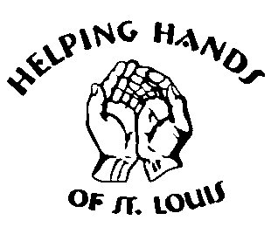


Dear Rossford United Methodist Church,

Thank you so much for your generous gift to my family and I. We are truly grateful. My family has been through something terrible, but thankful to God our family is here.

Love and God Bless,
Amy Horvath and Family

*If you recall The Horvath Family suffered a total loss when their home caught fire in August of this year.
Worship News

Thank you to Jim Siebold, Troy Brandt, and Nancy Stonerock who spoke the communion blessings in Russian, French, and Spanish for us on Worldwide Communion Sunday on. What a great way to bring home that we were communing with our Christian brothers and sisters all over the world that day!

The Worship Committee met on Oct. 27 to plan for the upcoming advent and Christmas seasons. You will hear much more about it all as it is a busy time for our church.

We welcome Kristen Vargo and Donna Robbins to our committee as new members. Our committee works hard behind the scenes and we are glad to have them as helpers.

We say good-bye and thank you to Pat Baumgartner who has served on our committee for more than 25 years. We appreciated her input over the years and all of her help. We will miss her. Thank you Pat!

Veterans, we will see you on Nov.6 for our annual service to honor you. If you have a veteran or current military member in your family, please turn a picture in to the office as soon as possible. If you have already sent pictures other years, you don’t need to send another one.

Nov.6 – Veteran’s Sunday, Communion
Nov.13 - Regular worship
Nov.20 – Consecration Sunday, Thanksgiving
Nov.27 – First Sunday of Advent, Youth Led Sunday

See you at church! Don’t forget to wear your nametags to help us know one another better and to welcome new visitors.

With Love,
Cheryl Garlow and Nancy Rust
Co-Chairpersons of Worship Committee





Page 6



Ushers and Greeters

Please see Bob Baughman to Usher or Brenda and Al Weis to Greet or Valet.

Helping Hands of St. Louis

Our next date isn't until 2017. Please stay tuned for more information. Questions? please contact Jerry Baumgartner at 419-666-7236.

Prayer Quilts

If you know of anyone who would benefit from a prayer quilt please call or see Nancy Stonerock. She can be reached at 419-874-3504.

Kroger Store

The Kroger Rewards Program is a nationwide program that lets loyalty card holders select charities to which Kroger will donate, based on dollars they spend in stores. If you have a Kroger card, PLEASE check to see that you are signed up so that our church gets a percentage of what you buy. Your purchases really helps us out. Thank you!

UMC Market

The United Methodist Church has started a "market." This is a way for our church to earn money. You need to go online to www.umcmarket.org and sign up. Whenever you order from this site our church receives a % of what you purchase. There are 89 pages of participating stores and the amount we receive varies. Any questions, see Sue Perkins.

Box Tops and Stamps

We are still collecting Box Tops for Education and used stamps. The collection box is located in the Narthex. Please see Barb Chesson if you have any questions.

Can Drive

We would like to remind you that we are still collecting cans to raise money for our church. If you have any to donate, the container is outside the kitchen door. If you need a pickup, please call Doug Williams at 419-661-9484.

Anniversaries

Wendell & Deb James 11/10

Dave & Marcia Olwick 11/26

Birthdays

Janet Pertner 11/1

Kay Jacob 11/4

Logan Vargo 11/5

Sharon Zuchowski 11/6

Kaitlin Moore 11/6

Lou Maidlow 11/9

Tom Ridenour 11/9

Matt Sutter 11/9

Gerry Baumgartner 11/10

Lisa Comley 11/10

Sharon Engwert 11/11

Doris Bachar 11/12

Nicki Agler 11/15

Elaine MacKinnon 11/16

Barb Chesson 11/17

Robert Bashaw 11/20

Patricia Bruce 11/21

Bill Bowerman 11/23

Kevin Cox 11/23

Darlene Limmer 11/23

Bethany Rust 11/26

Anita Giles 11/28

George Woods 11/30

Heifer Project nearing
1 million Pennies!!!

THANK YOU!!
As of this print date we have collected over
990,110 pennies!
For more information, please see Steve Agler or visit www.heifer.org

- For more than 70 years Heifer International has partnered with and helped communities.
- They've worked in more than 125 countries to attain sustainable livelihoods through community-owned interventions.
- Helped over 25 million families lift themselves out of poverty.
- There are still nearly 1 billion people in the world that live in extreme poverty.



Page 7



Sun. | Mon. | Tue. | Wed. | Thur. | Fri. | Sat.
 |  | 1 | 2 | 3 | 4 | 5
 |  | 9:15 am Women's Morning Bible Study  6:30 pm Choralier's | 6:30 pm Scouts | 6:00pm Bells  7:00pm Choir  8:30pm AA
6 FALL BACK! | 7 | 8 | 9 | 10 | 11 | 12
10:30am Veteran's Day Worship    5:00 pm DOCK | Set Up for Bazaar | 9:15 am Women's Morning Bible Study  6:30 pm Scouts  Set Up for Bazaar | 6:30 pm Scouts  Set Up for Bazaar | 6:00pm Bells  7:00pm Choir  8:30pm AA  Set Up for Bazaar |   Veterans Day  Set Up for Bazaar | 9:00am Men's Breakfast-  Frisch's Big Boy, BG Ohio  10-4 Craft Bazaar  7pm Contra
13 | 14 | 15 | 16 | 17 | 18 | 19
10:30am Worship  5:00 pm DOCK |  | 9:15 am Women's Morning Bible Study  6:30 pm Scouts  MEETING NIGHT | 6:30 pm Scouts | 6:00pm Bells  7:00pm Choir  8:30pm AA
20 | 21 | 22 | 23 | 24 | 25 | 26
10:30am Worship  2:00 pm Charge Conference  5:00 pm DOCK  Final collection for shoeboxes |  | 9:15 am Women's Morning Bible Study  6:30 pm Scouts | 6:30 pm Scouts | Happy Thanksgiving    Offices Closed
27 | 28 | 29 | 30
10:30am Youth Led Worship  Advent Begins  NO DOCK |  | 9:15 am Women's Morning Bible Study  6:30 pm Scouts | 6:30 pm Scouts |  | 


NON-PROFIT
US POSTAGE
PAID
TOLEDO, OH
PERMIT #522
ROSSFORD UNITED METHODIST CHURCH
270 DIXIE HWY
ROSSFORD, OH 43460

Staff

Pastor: Rev. Dr. Robert Ball
Ministers: Every Member
Children’s Ministry: Kim Weyandt
Youth Ministry: Terri Seibold
Secretary: Jenny Graffius
Music Program Director: Sarah Buehrer
Organist: JeanE Waggoner
Custodians: Steve Agler
Jenny Riehm
ASL Interpreter Karen Whalen
Nursery: Carol Kotecki

Lay Leadership

Lay Leader: Tom Ridenour
Head Usher: Bob Baughman
Media Directors: Troy Westfall
Jeff Comley



