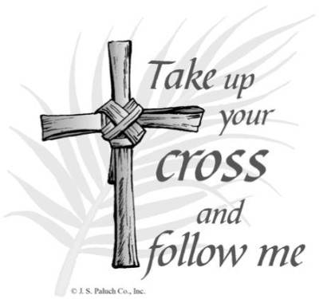

March 2017

Blessings

Rossford United Methodist Church
Our Mission: To Know Christ And to Make Christ Known

Rossford United Methodist Church

270 Dixie Hwy

Rossford, OH 43460

Phone:

(419) 666-5323

Office Hours:

M-F 8:00am-2:00pm

Facebook:

www.facebook.com/RossfordUMC

E-Mail:

rossfordumc@yahoo.com

Visit us online at:
www.rossfordumc.org

Services

9:00 am Sunday School

10:30am Worship

10:00am Summer Worship

DOCK meets most Sunday's at 5:00 pm

From the Pastor's Pen…

A Journey to Calvary

On March 1, at 7:00 pm, we will begin the Lenten season that culminates with Palm Sunday and Easter. We will launch ourselves on a journey to Calvary by sharing in a worship service marking ourselves with ashes to indicate our brokenness and need for the saving love of Christ. It is a time for us to engage our spiritual journey at a deeper level and once again experience the life and ministry of Jesus.

Each Wednesday evening following Ash Wednesday during the Lenten season we will gather at 7:00 pm for our Lenten Study. This year we will be focusing on Jesus’ calling the people of his day saying, “If you would be my disciple take up your cross and follow me.” So what does it mean to take up the cross today in this 21st century? I do not need to tell you that we live in a very challenging world filled with conflict and division. We live in a society where people hold different world views, different philosophies of life, different religious theologies and convictions and speak different languages.

Today, more than any other day that I remember in my life, we live in a country that is guided by fear. We are afraid of people who are different from us. We are afraid of people who are from another country and are seeking to come and live among us. We don’t understand them and in many cases we don’t want to take the time or energy to try. Christians are divided on many of the most critical issues that are facing our nation and world. The truth is that our world is not so different than the world in which Jesus lived. So the question is, “What does it mean to answer the call of Jesus to take up your cross and follow him?”

I am hoping that in a very small way, we who are willing to gather each Wednesday evening during Lent will find ourselves discovering a way to be leaders within our spheres of influence and thus be agents of healing in our broken world and communities.

Please plan to join the journey to Calvary and discover another way to be a bearer of the cross of Christ in a world that needs Him so very much.

Grace and Peace,
Bob

Worship News

2017 Lenten Study Series
7:00 pm in the Parlor

March 15
March 22
March 29
April 5th

Inside This Issue:

Pastor's Pen 1

DOCK and Worship 2

Hospitality/Fellowship 3

How Can You Help? 3

Celebrations/Thanks and
Fundraising 4

Calendar 5/6

Pictures 7

Worship News

As we enter the month of March, we will also enter the holy season of Lent. Here is a schedule of services and events from March through Easter. We will present more detail as we move through Lent.

March 1st - Ash Wednesday Service at 7:00 pm
March 5th - Rev. Scott Ocke, our District Superintendent will be the guest preacher
March 12th - Rev. Rae Lynn Schleif, our Assistant District Superintendent, will be guest preacher. This will also be Youth Led Service as Terri Seibold and family will be out of town the end of March.
March 19th and 26th - Pastor Bob returns from New Orleans.
April 2nd - Holy Communion
April 9th - Palm Sunday with our donkey walk
April13th - Maundy Thursday Service at 7:00 pm
April 14th - Good Friday
April 16th - Easter Sunday - 8:00 am Sonrise Service
Sonrise breakfast following service
10:30 am Easter Worship

The worship committee will be meeting on March 19th to finalize details for all of these services throughout Lent.

With Love,
Cheryl Garlow and Nancy Rust - Co-Chairpersons of Worship Committee




DOCK News

Thank you to all who participated in the Dessert Auction/Talent Show “How Sweet It Is”! We had 50 desserts to auction off. Tom Ridenour coaxed (coerced?) you to purchase them and we made $1805.00. WOW!!

D.O.C.K. kept $805 for their activity fund and $1000.00 was given to the New Orleans/Hurricane Katrina mission trip. To those who performed in the talent show, BRAVO!! Thanks to the audience, as well. Without you there’s no show!! What a lovely day!

March will be a bit quieter for the youth. We will be leading worship on March 12th instead of the last Sunday. Bob will be in New Orleans and the Assistant District Superintendent will be preaching. Our theme will be “Trade Your Sorrow For Joy”. During Lent we remember that Jesus came to the world to restore our relationship to God. What could give us more reason to rejoice than that!!!

D.O.C.K. will meet on March 5, 12 and 19th from 5 – 7 p.m. There will be no meeting on March 26th. Remember to sign up in the Narthex to help us comply with the Safe Sanctuary rules.

Thanks to all for your support of our youth.

Terri Seibold
Director of Youth Ministry

We are Disciples Of Christ’s Kingdom!

Page 2



Ushers and Greeters

Please see Bob Baughman to Usher or Brenda and Al Weis to Greet or Valet.

Helping Hands of St. Louis

Our next scheduled date is March 23rd. Questions please contact Jerry Baumgartner at 419-666-7236.

Prayer Quilts

If you know of anyone who would benefit from a prayer quilt please call or see Nancy Stonerock. She can be reached at 419-874-3504.

Kroger Store

The Kroger Rewards Program is a nationwide program that lets loyalty card holders select charities to which Kroger will donate, based on dollars they spend in stores. If you have a Kroger card, PLEASE check to see that you are signed up so that our church gets a percentage of what you buy. Your purchases really helps us out. Thank you!

UMC Market

The United Methodist Church has started a "market." This is a way for our church to earn money. You need to go online to www.umcmarket.org and sign up. Whenever you order from this site our church receives a % of what you purchase. There are 89 pages of participating stores and the amount we receive varies. Any questions, see Sue Perkins.

Box Tops and Stamps

We are still collecting Box Tops for Education and used stamps. The collection box is located in the Narthex. Please see Barb Chesson if you have any questions.

Can Drive

We would like to remind you that we are still collecting cans to raise money for our church. If you have any to donate, the container is outside the kitchen door. If you need a pickup, please call Doug Williams at 419-661-9484.

Rehearsals
Bell Choir will not practice on March 2nd, but will resume regular practice on March 9th

Choir will rehearse on Thursday evenings at 7:00pm.

Hospitality

Our committees have once again had a quiet February by just having the coffee hours each Sunday.

The Fellowship committee held a Craft Night on Feb 21st from 6-10 PM. We had lots of fun.

We have another Craft Night planned for Tuesday, March 21st. Bring your own crafts and join us for fellowship and creativity. Use this time to finish up those projects that have been collecting dust. We know you all have them.

March valet: Darrel Eschedor

March greeter: Sherry Engwert

Thank you to all the volunteers that help out this special ministry.

In Christ,
Al and Brenda Weis, Hospitality co-chair
Kim Weyandt and Brenda Weis, Fellowship co-chair





Craft night was held Tuesday February 21st. and was a rousing success.

We had 10 attendees for fun and fellowship in the parlor. Oh, we did get a little crafting done also. Everything from cross stitch, painting, crochet, using Cricut machines for items to even making a diaper cake and chair caning!!!

Plan to join us Tues March 21st. We are going to adjust our time from. 6-9 pm. We will start at 6 pm with a pizza supper then get busy with our crafts! Plan to be there!! We will have a signup sheet in the narthex soon.

Page 3

MARCH

Celebrations

and Thanks
Fundraising Calendar for 2017

SPRING RUMMAGE SALE - March 9th from 9am to 6pm, 10th from 9am to 4pm and the 11th from 9am to 12 noon.

SPRING BBQ - Sunday, May 7

FALL BBQ - Sunday, October 8

CHRISTMAS STORY SHOW - Sunday, October 8
(A new Fundraiser)

FALL RUMMAGE SALE - October 19, 20 and 21. Set up October 8 after Christmas Story Show

CRAFT BAZAAR - Date not set. Probably November 4th or 11th.

"LET IT GLO" - Christmas Tree and wreath decorating contest. December 1st and 2nd. Another new fundraiser. More information to come

CHURCH HISTORY
More information will be coming soon.

We are also planning on selling t-shirts/sweatshirts this spring.

Please put these dates on your calendar and plan on helping in any way you are able.

Thank you!
Sue Perkins, Chairperson

Anniversaries

Bill & Cheryl Garlow 3/14

Mark & Darlene Limmer 3/18

Steve & Carol Kotecki 3/25

Birthdays

Shirley Ball 3/1

Dawn Bashaw 3/2

Ron McCamey 3/3

Zach Sutter 3/3

JeanE Waggoner 3/3

Aiden Agler 3/4

Alex Vargo 3/9

Martha Seal 3/10

Matt Foster 3/11

Mallory Senn-Flinn 3/11

Michelle Sutter 3/17

Pete Petersen 3/21

Brad Agler 3/23

Marcia Burwell 3/25

John Rust IV 3/29

Welcome New Professing Members of RUMC

Benjamin and Kathy Slomski
and
Jim and Terri Seibold

The below children were baptized during services on February 19th

Obadiah James Brant
Suzanna Jane Lahaie
Bryan Joel Lahaie
Isabelle Cadence Blair
Nathan Bradley Agler
Carley Jo Agler
Benjamin Wesley Gordon

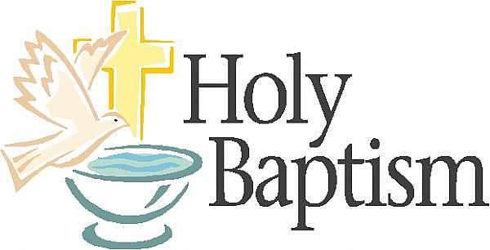

Page 4



Sun. | Mon. | Tue. | Wed. | Thu. | Fri. | Sat.
 |  |  | 1 | 2 | 3 | 4
 |  |  | 7:00 pm Ash Wednesday Service  Rummage Sale Set Up | No Bells  7:00pm Choir  8:30pm AA
5 | 6 | 7 | 8 | 9 | 10 | 11
9:00am Sunday School  10:30am Worship  5:00pm  Rummage Sale Set Up | 5:30 pm Parent Project (Sanct) | 9:15am Ladies Morning Bible Study  6:30pm Cub Scouts | 6:30pm Boy Scouts | 6:00pm Bells  7:00pm Choir  8:30pm AA  9:00-6:00pm  Rummage Sale | 9:00-4:00pm  Rummage Sale | 9:00am Men's Breakfast Silver Moon  9:00-Noon Rummage Sale  7:00pm Contra Dance
12 | 13 | 14 | 15 | 16 | 17 | 18
9:00 am Sunday School  10:30am Worship  Hospitality Mtg after services  Daylight Savings Time Begins - Spring Ahead! | 5:30 pm Parent Project  (Parlor) | 9:15am Ladies Morning Bible Study  6:30pm Cub Scouts  6:30pm SPRC, Finance, Trustees  7:30pm Admin | 6:30pm Boy Scouts  7:00pm Lenten Study | 6:00pm Bells  7:00pm Choir  8:30pm AA |  | 2:00-5:00pm Bridal Shower
19 | 20 | 21 | 22 | 23 | 24 | 25
9:00 am Sunday School  10:30am Worship  5:00pm DOCK | 5:30 pm Parent Project  (Parlor) | 9:15am Ladies Morning Bible Study  6:30pm Boy Scouts  6:00 - 9:00 pm Craft Night (Parlor) | 6:30pm Boy Scouts  7:00pm Lenten Study | 6:00pm Bells  7:00pm Choir  8:30pm AA |  | 9-12pm Heartsaver CPR/AED  3:00 pm  Boy Scouts Blue & Gold Banquet
26 | 27 | 28 | 29 | 30 | 31
9:00 am Sunday School  10:30am Youth Led Worship  NO DOCK | 5:30 pm Parent Project  (Parlor) | 9:15am Ladies Morning Bible Study  6:30pm Cub Scouts | 6:30pm Scouts Pack Meeting  7:00pm Lenten Study | 6:00pm Bells  7:00pm Choir  8:30pm AA

Page 5



Heartsaver CPR/AED Course​​ at RUMC
Saturday, March 25th 2017
9 am to 12 pm

Course Covers
• Adult CPR and AED Use
• Opioid-associated Life-threatening Emergencies
• Adult Choking
• Child CPR and AED Use
• Child Choking
• Infant CPR
• Infant Choking

Primary Audience
Heartsaver courses are intended for anyone with little or no medical training who needs a course completion card for job. These courses can also be taken by anyone who wants to be prepared for an emergency in any setting.

Duration
3 Hours

Cost
$42 per person
The cost of the course includes your registration, all of the materials for the class and a card e-mailed to you at the time of course completion.

$5 off per person with coupon code: RUMC

TO REGISTER: www.restarttheheart.org
Click on: Register / Pay for Class
Select: Heartsaver CPR/AED Only

Name Tags

We encourage you to wear your nametags while here at RUMC, for services as well as other events. This is an important way for new members and visitors to get to know you. If you have problems with your current name tag or need to request a new one please see the form in the Narthex or contact Mary Hill at 419-666-2059

Tuesday Morning Bible Study
On Tuesday, March 7, the Tuesday morning Bible Study will be starting the study "The Gospel of Matthew" by Max Lucado. If you are interested in joining this group, see Sue Perkins so that books can be ordered. This is a 12 week study.


Meeting Night for March

Tuesday, March 14th, 2017

6:30pm SPRC
6:30pm Trustees and Finance
7:30pm Admin

Page 6

How Sweet It Is - Talent Show and Dessert Auction

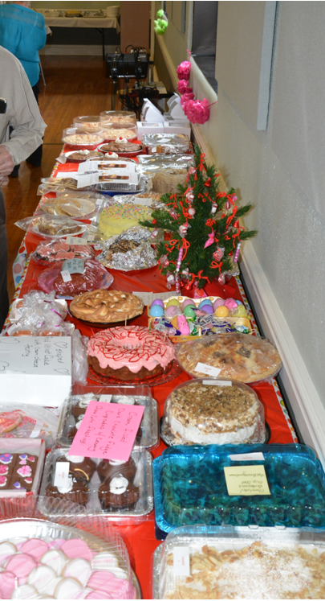

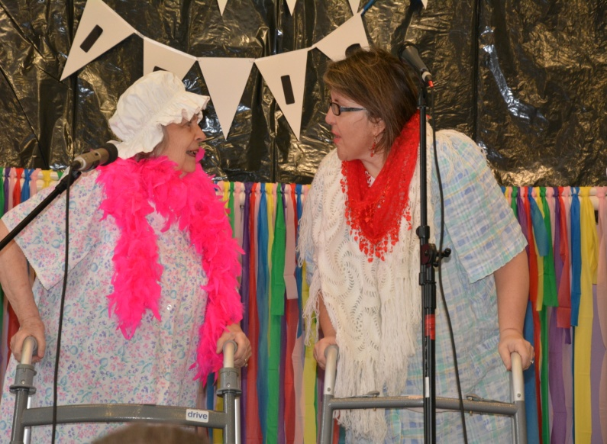

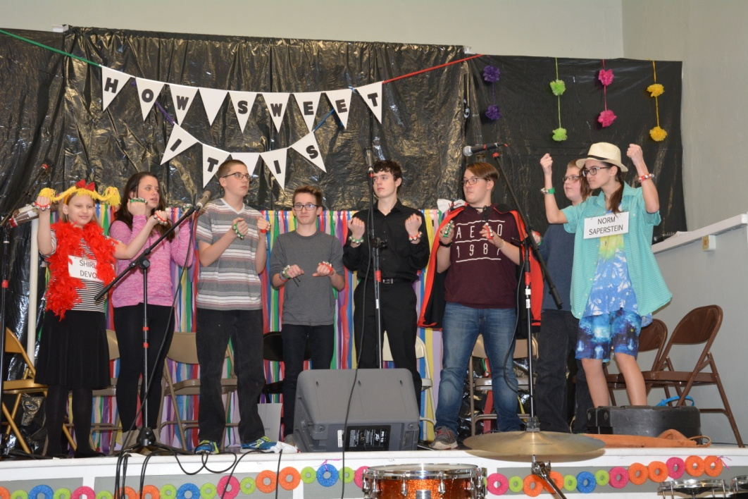


NON-PROFIT
US POSTAGE
PAID
TOLEDO, OH
PERMIT #522
ROSSFORD UNITED METHODIST CHURCH
270 DIXIE HWY
ROSSFORD, OH 43460



Staff

Pastor: Rev. Dr. Robert Ball
Ministers: Every Member
Children’s Ministry: Kim Weyandt
Youth Ministry: Terri Seibold
Secretary: Jenny Graffius
Music Program Director: Sarah Buehrer
Organist: JeanE Waggoner
Custodians: Steve Agler
Jenny Riehm
Nursery: Carol Kotecki
MacKenzie Rodriguez

Lay Leadership

Lay Leader: Tom Ridenour
Head Usher: Bob Baughman
Media Directors: Troy Westfall
Jeff Comley

