

January 2019

Rossford

United Methodist Church
Our Mission:
"To Know Christ And to Make Christ Known"

From Pastor Dwayne
Happy New Year! As we enter this new year, we can look back and see how God worked in and through us over this past year. We feed children throughout the summer. We help feed and serve those who are hungry with those at the Helping Hands of St. Louis. We reached out with love and support and prayers and food to those who were sick or had surgery or who a loved one had passed away. We signed and gave away prayer quilts so that those who are hurting would know that they are not alone, that we are surrounding them with love and prayers. We won first place in the Halloween parade, small float division. We taught youth and kids (think DOCK and VBS and Children's time during worship and our Kingdom Kids choir) that they are loved, always and forever. We have an amazing choir, and bells and youth who lead is in amazing moments of worship. We responded to God's call to live generously so that others will hear and respond to the Good News of Jesus Christ. We have taken in new members and others who worship with us. We have served our community with chicken dinners and rummage sales. We have loved our neighbors and reminder our community that God is love and God loves them (think yard signs). We have grown in our relationship with God and as the people of God. We have prayed and loved and served and given. And because there are so many other things that we have done, I know that I have forgotten so many amazing things that we have accomplished because of God's love and Spirit working in and through us.
I am so proud of you and I am honored to be your pastor and be in ministry with you! But we still work to do. God is still calling us, God is not done with us yet. There are plenty more opportunities to live out our faith. Like eating breakfast with students at Glenwood Elementary school and surrounding those children with love and prayers and safe adults who care for them. It is a proven fact that children learn better and have less issues when they know they are loved and cared for. So, we have an opportunity to serve those little ones. Let me know if you want to help in this.
As we move through out 2019 we will other amazing opportunities to learn and grow and serve and give and love. So, remember what we do here at RUMC matters. We are continuing to bring Heaven and Earth together, so others can know and experience the love and grace of Jesus Christ. One of those amazing opportunities is through our worship. So, I want to encourage you to invite someone. Invite someone to come and be with us as we live out our faith, as we love with wild abandon, as we learn Jesus, as we live generously, as we follow the living Christ.
I hope and pray that you have an amazing New Year filled with the presence of Christ, who loves you beyond your wildest imagination every moment of every day!
Grace and Peace,
Pastor Dwayne

Rossford United Methodist Church

270 Dixie Hwy

Rossford, OH 43460

Phone:

(419) 666-5323

Services

9:00 am Sunday School

10:30am Worship

Office Hours:

M-F 8:15am-2:15pm

Facebook:

www.facebook.com/

RossfordUMC

E-Mail:

rossfordumc@yahoo.com

Visit us online at:
www.rossfordumc.org

Inside This Issue:

Pastor's Message 1

DOCK/ Kids Kingdom Choir 2

Worship 3/4

How can you help?/Sermon Series
5
Calendar of events 6

Thanksgivings/Celebrations 7

Website information 8

**If you would like to receive our electronic newsletter please call or email us. **



We began our online newsletter in September of 2018. It has been received very well. It is a much easier and cost effective form of communication for the church.
Each month we receive a report of how many of you have opened and read the newsletter. We are proud to show you the results from September through December. We currently send the newsletter to 119 households. There is also a printed version for those that don't or can't access the online version. Look on the table in the Narthex for the paper copies.
September opens: 57.5%
October opens: 61%
November opens: 48%
December opens: 47%
Thank you for all your hard work this year and I hope to continue it into 2019.
If you would want to submit articles or advertisements please send them directly to the office at the contact details below. Pictures and videos are welcome.
rossfordumc@yahoo.com or 419-666-5323
Thanks,
Jenny Graffius

DOCK

January will be a quiet month for D.O.C.K. We’ll meet on the 6th and catch up on all of our Christmas stories and talk about what we’d like to do in 2019. We’ll talk about how we can make our lives better, and the lives of others better in the New Year. I will be out of town on the 13th. Hopefully Pastor Dwayne can sub for me or we’ll skip that evening. Jim and I will be on vacation!!! I’ll make sure everyone knows what’s up . We will have our regular meeting and music prep on the 20th and we’ll lead worship on January 27th. Happy New Year everyone.
Terri Seibold
Director of Youth Ministry

KINGDOM KIDS CHOIR
I thought our Kingdom Kids choir did a fantastic job singing about our Savior’s birth in December. They were the best angels ever.
We will continue rehearsing on the third Sunday of the month. January 20th is our next rehearsal. We’ll be working on a new song that we can present in the spring. Happy New Year!
Tell all your friends to join us for Kingdom Kids and Kingdom Kids Choir.
Terri Seibold
Kingdom Kids Choir Director

WORSHIP NEWS
Thank you to everyone who helped make our Christmas season so beautiful and heartfelt this year. Our amazing worship committee, the special decorations, the music, the choir, Sarah, JeanE, the children's presentation, DOCK, Terri, our Advent readers, John Rust and Wendell James for all the new lighting in the Sanctuary making it warm and bright for our Christmas Services, Jenny and the media guys. Also, thank you to Mike Hoffman and Wendell James for creating a new choir robe closet in the parlor.
Thank you everybody for contributing all the food for our baskets. We helped 9 families. What a blessing we are able to help others. The nativity display was lovely and meaningful. Christmas caroling was a joy and a lot of fun.
Merry Christmas and a Happy, Healthy New Year to our church family and your families.
Next worship meeting will be January 3rd at 6:30 pm.
Cheryl Garlow and Nancy Rust
Co-Chairpersons of Worship Committee

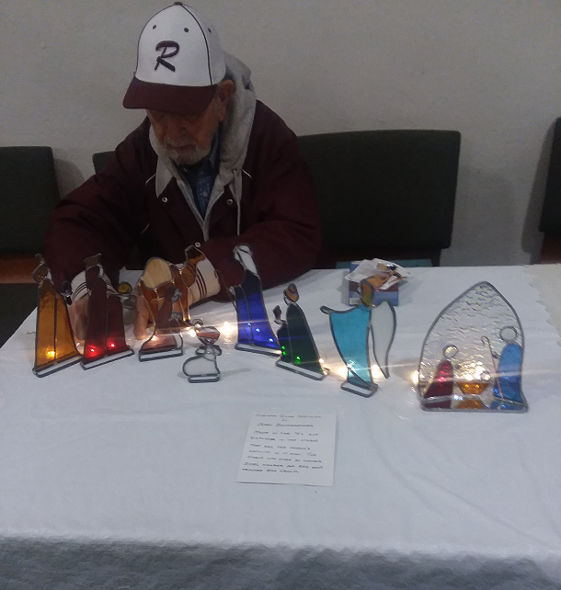
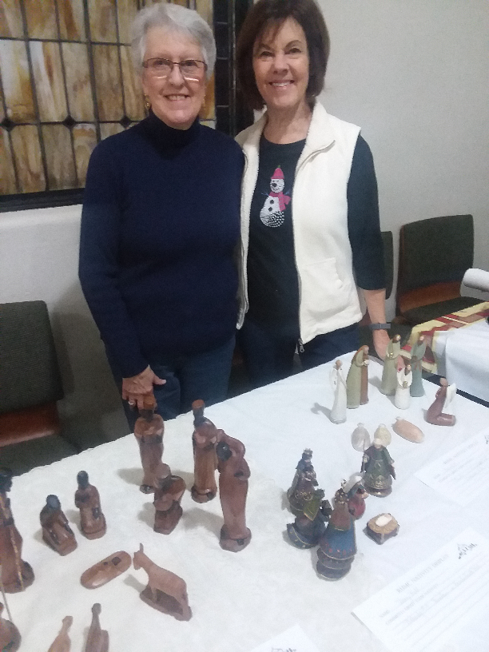

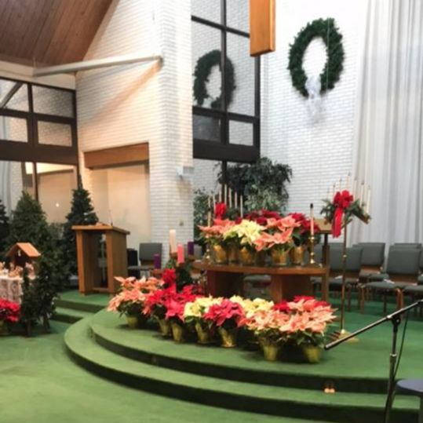
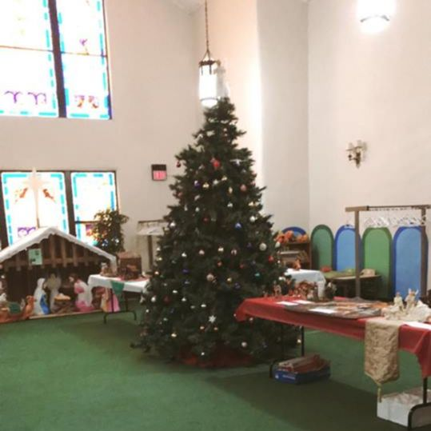

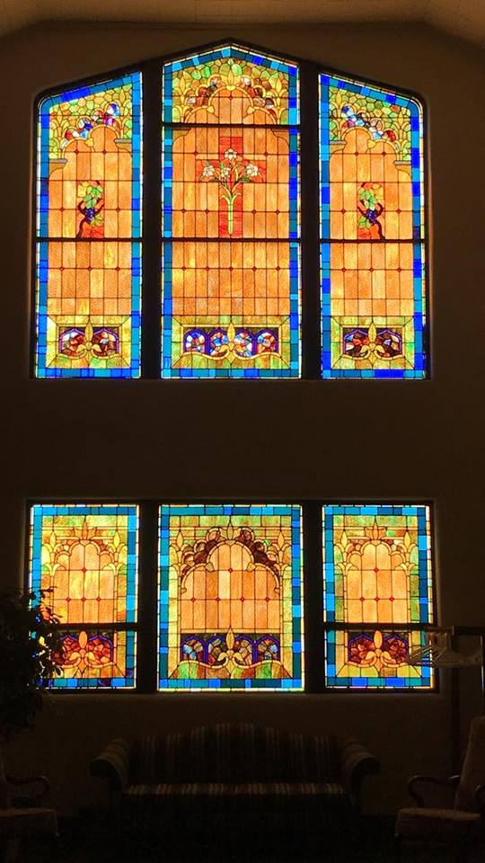
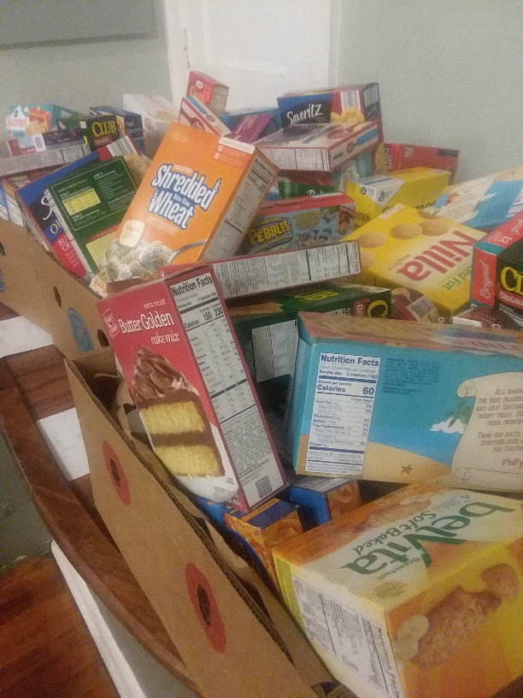

RUMC LUMINARIES

The Worship committee is looking to form a committee to assist with the luminaries for the 2019 holiday season. It has been a tradition for years to light the path in front of the church. We would like to continue the tradition but with the help of a separate committee. Duties would include but not limited to the following. Preparing the jugs, bringing the up from the basement, lighting, and cleaning up and putting them away. If you are interested in being on this committee please contact the Worship Committee.
Thank you!

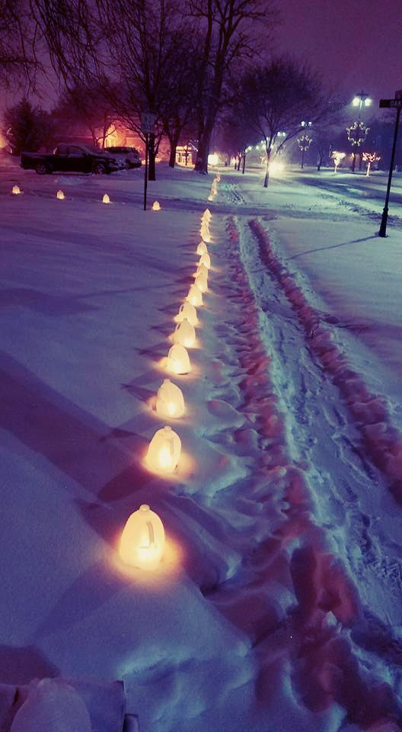

UPCOMING SERMON SERIES
Have you ever read a book or seen a movie where the main character has no idea whom they are. Throughout the whole story, it is revealed that they are a queen, or champion, or savior, or king, or someone special. Well, the Bible is that kind of story too. In the next 9 weeks we will be learning about what the Bible, and specifically the book of Psalms, reveals about you and I, who we truly are. The sermon series is called "We Are . . . " Invite someone to join us as we discover who we truly are.

"We Are . . . " Sermon Series
We will be looking at 10 Psalms and hearing what the Bible tells us that we are...

1/6 - Psalm 1
"We Are . . . Blessed"

1/13 - Psalm 13
"We Are . . . Hurting"

1/20 - Psalm 23
"We Are . . . Not Alone"

1/27 - Psalm 46
"We Are . . . Held"

2/3 - Psalm 100
"We Are . . . God's People"

2/10 - Psalm 130
"We Are . . . Forgiven"

2/17 - Psalm 117 and Psalm 137
"We Are . . . Human"

2/24 - Psalm 139:1-16
"We Are . . . Fearfully and Wonderfully Made"

3/3 - Psalm 150
"We Are . . . "



HOW CAN YOU HELP OUT?
Ushers and Greeters
Please see Bob Baughman to Usher or Brenda and Al Weis to Greet or Valet.
Helping Hands of St. Louis
Thursday, January 24th. Questions please contact Jerry Baumgartner at
419-666-7236.
Prayer Quilts
If you know of anyone who would benefit from a prayer quilt please call or see Nancy Stonerock. She can be reached at 419-874-3504.
UMC Market
The United Methodist Church has started a "market." This is a way for our church to earn money. You need to go online to www.umcmarket.org and sign up. Whenever you order from this site our church receives a % of what you purchase. There are 89 pages of participating stores and the amount we receive varies. Any questions, see Sue Perkins.
Cancelled Stamps
We are collecting cancelled postage stamps. The collection box is located in the Narthex. Please see Barb Chesson if you have any questions.
Can Drive
We would like to remind you that we are still collecting aluminum cans to raise money for our church. If you have any to donate, the container is outside the kitchen door. If you need a pickup, please call Doug Williams at 419-661-9484.
Kroger Rewards Program
The Kroger Rewards Program is a nationwide program that lets loyalty card holders select charities to which Kroger will donate, based on dollars they spend in stores. If you have a Kroger card, PLEASE check to see that you are signed up, so that our church gets a percentage of what you buy.
Our Kroger Plus Rewards Organization
# 84283

CONGREGATIONAL CARE COMMITTEE
January Greeter: Caroline Eschedor
January Valet: Darell Eschedor


SUN | MON | TUES | WED | THURS | FRI | SAT
 |  | 1 | 2 | 3 | 4 | 5
 |  | Closed |  | 6 - 8:00 pm Girl Scouts  7:00 pm Choir  8:30 pm AA
6 | 7 | 8 | 9 | 10 | 11 | 12
9:00 am Adult Sunday School  10:30 am Worship  5:00 pm DOCK | 8 - 10 pm HEMA (FLC) | 9:15 am Ladies Bible Study (Parlor)  3-5 pm Drama Practice (Narthex)  6:30 pm Scouts  6:30 pm Finance, SPRC, Trustees  7:30 pm Admin | 3-5 pm Drama Practice (Narthex) | 3-5 pm Drama Practice (Narthex)  6 - 8:00 pm Girl Scouts  7:00 pm Choir  8:30 pm AA |  | 9:00 am Men's Breakfast (Silver Moon)  7:30 pm Contra Dancers (FLC)
13 | 14 | 15 | 16 | 17 | 18 | 19
9:00 am Adult Sunday School  10:30 am Worship  5:00 pm DOCK | 6 - 8 pm Drama Practice (Narthex)  8 - 10 pm HEMA (FLC) | 9:15 am Ladies Bible Study (Parlor)  6 - 8 pm Drama Practice (Narthex)  6:30 pm Scouts | 3-5 pm Drama Practice (Narthex) | 3-5 pm Drama Practice (Narthex)  6 - 8:00 pm Girl Scouts  7:00 pm Choir  8:30 pm AA
20 | 21 | 22 | 23 | 24 | 25 | 26
9:00 am Adult Sunday School  5:00 pm DOCK | 8 - 10 pm HEMA (FLC) | 9:15 am Ladies Bible Study (Parlor)  3-5 pm Drama Practice (FLC)  6:30 pm Scouts | 3-5 pm Drama Practice (Narthex) | 3-5 pm Drama Practice (FLC)  6 - 8:00 pm Girl Scouts  7:00 pm Choir  8:30 pm AA
27 | 28 | 29 | 30 | 31
9:00 am Adult Sunday School  10:30 am Worship | 3-5 pm Drama Practice (Narthex)  8 - 10 pm HEMA (FLC) | 9:15 am Ladies Bible Study (Parlor)  3-5 pm Drama Practice (FLC)  6:30 pm Scouts | 3-5 pm Drama Practice (Narthex) | 3-5 pm Drama Practice (FLC)  5:00 pm Drama meeting  6 - 8:00 pm Girl Scouts  7:00 pm Choir  8:30 pm AA



MEN'S BREAKFAST

Saturday, January 12th at 9:00 am
at Silver Moon Soda Grill. Sign up in the Narthex



Thank you to the Almester family who provided the fresh Christmas swags on the front doors of the church.
Words cannot express how thankful my family and I are for your love, support, prayers, gifts and generosity especially in these last few months. Your love and support and prayers in the death of my brother Doug was simply amazing and we are so thankful that you are our church family. Your gifts and generosity at Christmas are and were truly humbling and overwhelming. Thank you doesn't seem to be enough, but truly and from the bottom of our hearts, Thank You!
Love,
Pastor Dwayne, Melissa, Grace, Joel, Malachi, Joseph and Isaiha
Thank You for the mitten donations! Little hands will be warm this winter because of you!
~Students and Teachers of WSOS


Birthdays
Gerri Hoffman 1/6
Jeff Comley 1/9
Obidiah Brant 1/13
Mike Hoffman 1/13
Sue Stolar 1/16
Carol Kotecki 1/17
Jim Sikorksi 1/20
Christy Foster 1/21
Tammy Miller 1/25
Karen Whalen 1/30
Neil MacKinnon 1/310

Anniversaries
We have no anniversaries this month. If by chance we missed yours please let us know.

***If we missed you or someone else, please let us know at rossfordumc@yahoo.com or
call 419-666-5323***



The 2019 Altar Flower schedule is out on the table in the
Narthex. Please consider signing up and honoring your
loved ones with flowers.

CHECK OUT OUR ONLINE FORUM AND MEDIA TAB ON OUR WEBSITE
The Forum tab on our website includes a lifetime of top-quality Christian study and Bible sites. The Media tab is filled with fantastic Christian quality music and videos. Thank you to Larry Keeler who keeps this up to date and filled with useful information.
Forum
We learn by interacting with other Christians. The articles offered below provide an opportunity to discuss current events in the life of the church, offer sermon texts, and allow us to be in relationship with our Christian brothers and sisters online. Click the picture to be taken to the forum section of our website.

Media
Click the picture below to experience fabulous Christian music.




ROSSFORD UNITED METHODIST CHURCH
270 DIXIE HWY
ROSSFORD, OH 43460




Staff

Pastor: Pastor Dwayne Shugert
Ministers: Every Member
Children’s Ministry: Kim Weyandt
Youth Ministry: Terri Seibold
Secretary: Jenny Graffius
Music Program Director: Sarah Buehrer
Organist: JeanE Waggoner
Custodians: Steve Agler
Jenny Riehm
Nursery: Carol Kotecki
MacKenzie Rodriguez

Lay Leadership

Lay Leader: Tom Ridenour
Head Usher: Bob Baughman
Media Directors: Troy Westfall
Jeff Comley

