

January 2018

Rossford

United Methodist Church
Our Mission:
"To Know Christ And to Make Christ Known"

Greetings Church,

As we move into this new year, one of the things I want us to focus on is joy. Too often our focus is not on the joy of life that surrounds us, but rather on the fear or worry or anxiety of the present. Sometimes, this is simply unavoidable, like in the midst of tragedy or heartbreak. But sometimes we let our fear and worry rule our lives for no good reason.
In this new year then I want us to focus on joy and we will be doing this in two distinct ways. First, on Sunday mornings in our worship we will be reading, studying and learning from the book of Philippians, which is called the book of joy. So, I encourage you to read Philippians, it only has four chapters. Read it through several times and then read the scripture for each Sunday the week before that Sunday. Read the scripture every day, several times a day. Let God speak to you through these words. Meditate and think about the words and what they mean to you and your life and what God is calling you to do and be.

To help you in this, here is the schedule for the next two months:

1/7 - "Life of Joy" Philippians 1:1-14
1/14 - "Focus on Joy" Philippians 1:15-30
1/21 - "Let Your Joy Shine" Philippians 2:1-18
1/28 - "The Joy of Friendship" Philippians 2:19-30
2/4 - "The Joy of Jesus" Philippians 3:1-11
2/11 - "The Joy of Moving Forward" Philippians 3:12-21
2/18 - "Always Joy" Philippians 4:1-9
2/25 - "The Joy of the Lord is my Strength" Philippians 4:10-23

And then second, I am encouraging you to read. Read a book or books about Jesus, God, the Spirit, faith, church, or a good novel. Need some recommendations? Good...I got several!

Christian books:
1. What's So Amazing About Grace by Philip Yancey - Brilliant!
2. Searching For Sunday, by Rachel Held Evans - Amazing!
3. The Strength to Love by Martin Luther King Jr. - Awe inspiring!
4. Holy Superheroes: Exploring Faith and Spirituality in Comic Books by Greg Garrett - Fun!
Good Novels:
1. Mr. Penumbra's 24-Hour Bookstore by Robin Sloan
2. A Monster Calls by Patrick Ness
3. The Storied Life of A.J. Fikry by Gabrielle Zevin
4. A Wrinkle in Time by Madeleine L'Engle

If none of these jump out at you, I have about 1,000 more recommendations, just ask. Remember, "The Joy of the Lord is your Strength" (Nehemiah 8:10). And I hope and pray that you have an amazing new year!
Grace and Peace,
Pastor Dwayne

Rossford United Methodist Church

270 Dixie Hwy

Rossford, OH 43460

Phone:

(419) 666-5323

Office Hours:

M-F 8:00am-2:00pm

Facebook:

www.facebook.com/

RossfordUMC

E-Mail:

rossfordumc@yahoo.com

Visit us online at:
www.rossfordumc.org

Services

9:00 am Sunday School

10:30am Worship

Inside This Issue:

Pastor's Message 1

DOCK/Children's Choir 2

Hospitality/Fellowship 3

Worship 4

Celebrations and
Fundraising 5

Calendar 6


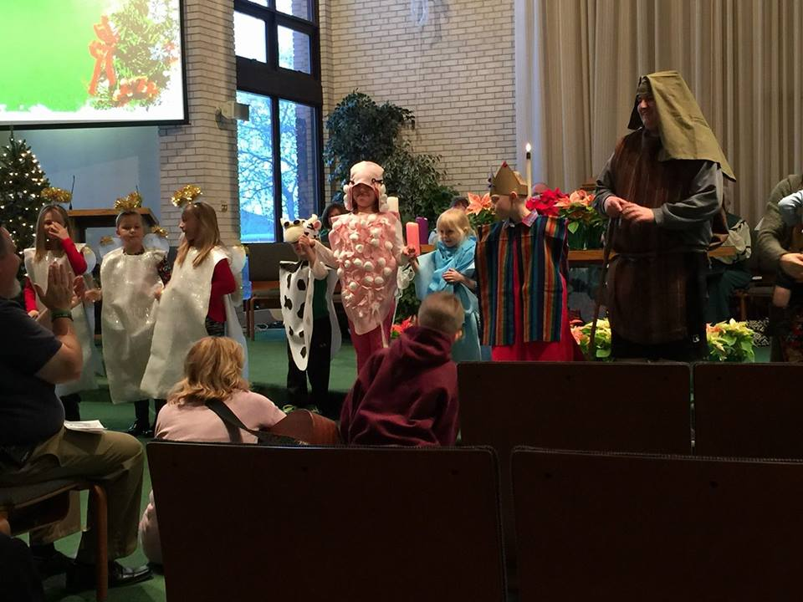

DOCK News

Happy New Year everyone! We had a great December with the youth: Music rehearsals, glass craft with Jerry Baumgartner, caroling, party, joined the choir for an anthem on Christmas Eve morning and led worship on Dec. 31st. It was a busy month.

January will be less busy for all of us. We’ll be preparing for the Dessert Auction/Talent Show during the month of January. The date will be Feb. 11th so get your acts together.
When we attended the BIG CHURCH NIGHT OUT in Novemeber we were given the opportunity to sponsor a child. Those that attended decided it would be a good thing to do…so we did. The cost of sponsorship is $33.00/mo. This means that every month each DOCK member will donate $2.00 to cover the sponsorship fee. Our sponsored child’s name is Yacine Ndiaye. Please see her story below. The youth sent Christmas cards to her and we will stay in touch with her throughout the year.

We look forward to a great 2018.

CHILDREN’S CHOIR
The Children’s Choir made their debut on Dec. 17th singing “There Was a Little Baby”. They did a fantastic job. A special thank you needs to go out to Joel Shugert who graciously stood in for his brother Joe as the shepherd. Oh, how I enjoyed THAT!!

The Children’s Choir meets every third Sunday of the month, so Jan. 21st will be our next rehearsal. Once we’re prepared we’ll sing for you again. Perhaps around Easter.

Terri Seibold
Director of Youth Ministry
Disciples Of Christ’s Kingdom!



Ushers and Greeters
Please see Bob Baughman to Usher or Brenda and Al Weis to Greet or Valet.

Helping Hands of St. Louis
Thursday, January 11th, 2018. Questions please contact Jerry Baumgartner at 419-666-7236.

Prayer Quilts
If you know of anyone who would benefit from a prayer quilt please call or see Nancy Stonerock.
She can be reached at 419-874-3504.

UMC Market
The United Methodist Church has started a "market." This is a way for our church to earn money. You need to go online to www.umcmarket.org and sign up. Whenever you order from this site our church receives a % of what you purchase. There are 89 pages of participating stores and the amount we receive varies. Any questions, see Sue Perkins.

Box Tops and Stamps
We are still collecting Box Tops for Education and cancelled postage stamps. The collection box is located in the Narthex. Please see Barb Chesson if you have any questions.

Can Drive

We would like to remind you that we are still collecting aluminum cans to raise money for our church. If you have any to donate, the container is outside the kitchen door. If you need a pickup, please call Doug Williams at 419-661-9484.

Kroger Rewards
Program

We received our quarterly check for $84.83 just from your purchases! We appreciate your help.

The Kroger Rewards Program is a nationwide program that lets loyalty card holders select charities to which Kroger will donate, based on dollars they spend in stores. If you have a Kroger card, PLEASE check to see that you are signed up so that our church gets a percentage of what you buy. We get a check quarterly from Kroger.
Our Kroger Plus Rewards Organization
# 84283

Fellowship and Hospitality

The last report of 2017 brings several things to mind. Another year in the books and another year of lots of happenings at RUMC.

Hospitality has been good. Thank you to everyone who volunteered your time and snacks this past year. Please consider doing this in the next year if you haven’t yet. It’s a wonderful easy way to connect with other’s after church over coffee and a snack.

Our committee sent Christmas greeting cards to our own shut in list, please let us know if you have a loved one who would enjoy greetings from our committee from time to time.

We served cookies and punch on Dec. 10th after the Choraliers concert. This was such an enjoyable evening with about 100 people in attendance.

On the Fellowship side we just had Christmas caroling on Sunday Dec. 17th. About 20 of us including Terri and the DOCK kids sang to residents of Lane Park in Oregon, the visited the homes of June Gillingham, Bob and Jane Hubley, and Jake Shufritz and Helen Shufritz. They all enjoyed the carols and it was very gratifying providing a little Christmas joy to others who aren’t able to attend church regularly.

January greeter and valet: Sherry Engwert and Al Weis

Enjoy the rest of the holiday season and a very Happy New Year to all,

Al and Brenda Weis, Hospitality co-chairs
Kim Weyandt and Brenda Weis, Fellowship co-chairs

VALET PARKING AVAILABLE
We have valet parking available each week for those that need it. Please keep these spots open for this purpose. Questions see Al Weis

Page 3

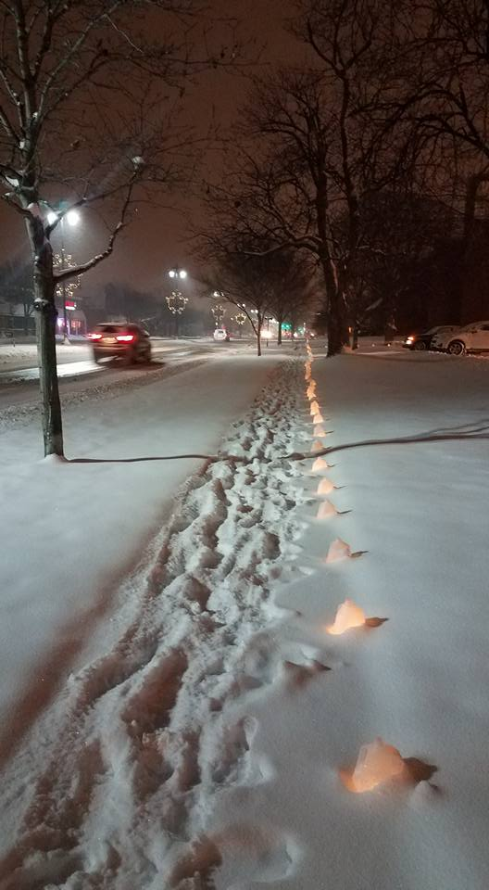
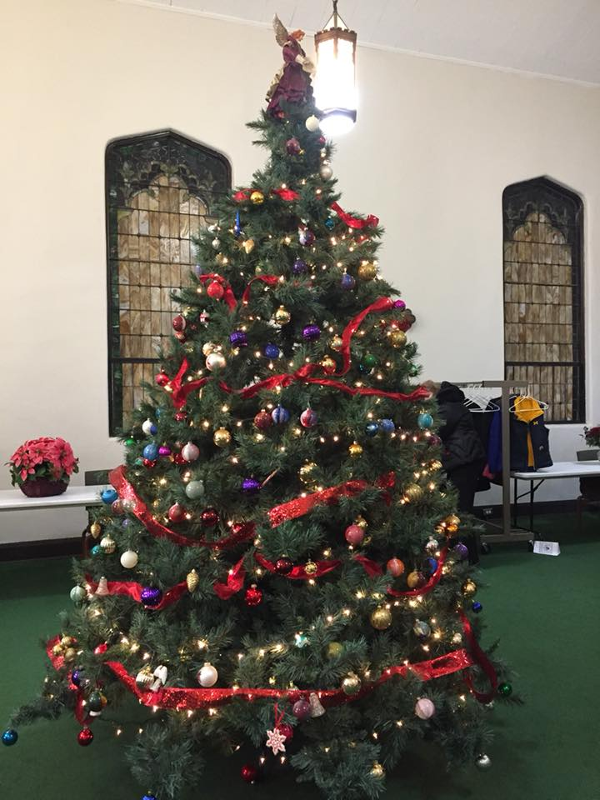

Worship News

What a beautiful Advent and Christmas Season it was at Rossford UMC. Thank you to Sarah, JeanE, and Terri for all their music selections. Kim Loch played the oboe for us so beautifully too! Wasn't it great to have a children's choir again? The Adult choir and the youth added greatly to our Worship services. Thank you! The families who led the advent candle lighting did a great job! The church was decorated and looked so pretty and everyone helped to decorate our gorgeous tree. Pastor Dwayne led us in worship each Sunday with creative and meaningful sermons tying together Christmas movies and faith in our everyday lives. Weren't the luminaries so welcoming Christmas Eve? Let's have a bigger and better Nativity Exhibition next year! Generous donations allowed food baskets to be given to 7 families this year and they were gratefully received.

All of these traditions we enjoy so much at our church take a lot of work behind the scenes. Your Worship Committee spent hours planning, decorating, cleaning, organizing, and preparing for Christmas. Members are Kristen Vargo, Donna Robinson, Darlene Limmer, Terri Siebold, Sarah Buehrer, Michelle Sutter, Jane Williams, Lisa Comley, Marcia Olwick, Trudi McCamey, Laurie Clingo, Cheryl Garlow, and Nancy Rust. Be sure to thank them if you enjoyed their work.

A special thank you to those that helped and braved the snow and cold to set up and take down the luminaries for our Christmas Eve services. We appreciate your help and hard work.

As the new year of 2018 approaches, we will be enjoying a series of sermons by Pastor Dwayne from the Book of Philippians. Don't miss these!

Our committee will be meeting again on Jan.11 at 6PM to plan for winter and Lenten services.

With Love,
Cheryl Garlow and Nancy Rust
Co-Chairpersons of Worship Committee
Page 5

JANUARY CELEBRATIONS

Anniversaries

We have no anniversaries this month. If by chance we missed yours please let us know.

Birthdays

Gerri Hoffman 1/6

Jeff Comley 1/9

Obadiah Brant 1/13

Mike Hoffman 1/13

Sue Stolar 1/16

Carol Kotecki 1/17

Jim Sikorski 1/20

Tammy Miller 1/25

Karen Whalen 1/30

Neil MacKinnon 1/31

Thank You

Thank You for the mitten donations! Little hands will be warm this winter because of you!
~Students and Teachers of WSOS

Thank you! Thank you! Thank you!

Thank you so much for all your Christmas gifts, we are truly humbled and overwhelmed by your love and generosity. Words will never fully express how thankful we are for all of you and what you have done for us this Christmas, and really since we got here in June. You all are so amazing and wonderful! We are truly blessed to be a part of such a genuine and loving church.

With all our Love,
Pastor Dwayne and Family

FUNDRAISING NEWS

January is quiet but we are planning an exciting 2018…stay tuned for more information

Meeting Night for January

Tuesday - January 9th, 2018
6:30 pm SPRC
6:30pm Trustees and Finance
7:30pm Admin

Contact your council chair if you have questions or can't make the meeting

If your contact information has changed, don't forget to let us know.



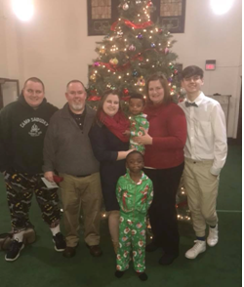



Did you know RUMC now videos the sermons each week? We've placed a link on the Rossfordumc.org website for you to view and share with others or check out our Facebook page (www.facebook.com/rossfordUMC)



Sunday | Monday | Tuesday | Wednesday | Thursday | Friday | Saturday
 | 1 | 2 | 3 | 4 | 5 | 6
 | Happy New Year  Offices Closed | 9:15am Ladies Bible Study  6:30pm Cub Scouts | 6:30pm Boy Scouts | No Bells  7:00pm Choir 8:30pm AA |  | Boy Scout Pinewood Derby Test day (FLC)
7 | 8 | 9 | 10 | 11 | 12 | 13
9:00am Sunday School  10:30am Worship  5:00pm DOCK | 8-10pm HEMA (FLC) | 9:15am Ladies Bible Study  6:30pm Cub Scouts  6:30pm Finance, Trustees, SPRC  7:30pm Admin | 6:30pm Boy Scouts | 6:00pm Worship Mtg  No Bells  7:00pm Choir 8:30pm AA |  | 9:00am Men's Breakfast @ Silver Moon  7:00pm Contra Dance (FLC)
14 | 15 | 16 | 17 | 18 | 19 | 20
9:00am Sunday School  10:30am Worship  5:00pm DOCK | 8-10pm HEMA  (FLC) | 9:15am Ladies Bible Study  6:00 pm Craft Night (Parlor)  6:30pm Cub Scouts | 6:30pm Boy Scouts | No Bells  7:00pm Choir 8:30pm AA
21 | 22 | 23 | 24 | 25 | 26 | 27
9:00am Sunday School  10:30am Worship  5:00 pm DOCK | 8-10pm HEMA  (FLC) | 9:15am Ladies Bible Study  6:30pm Cub Scouts | 6:30pm Boy Scouts | No Bells  7:00pm Choir 8:30pm AA
28 | 29 | 30 | 31
9:00am Sunday School  10:30am Youth Led Worship  No DOCK | 8-10pm HEMA  (FLC) | 9:15am Ladies Bible Study  6:30pm Cub Scouts | 6:30pm Boy Scouts


NON-PROFIT
US POSTAGE
PAID
TOLEDO, OH
PERMIT #522

ROSSFORD UNITED METHODIST CHURCH
270 DIXIE HWY
ROSSFORD, OH 43460



Staff

Pastor: Pastor Dwayne Shugert
Ministers: Every Member
Children’s Ministry: Kim Weyandt
Youth Ministry: Terri Seibold
Secretary: Jenny Graffius
Music Program Director: Sarah Buehrer
Organist: JeanE Waggoner
Custodians: Steve Agler
Jenny Riehm
Nursery: Carol Kotecki
MacKenzie Rodriguez

Lay Leadership

Lay Leader: Tom Ridenour
Head Usher: Bob Baughman
Media Directors: Troy Westfall
Jeff Comley

