

January 2016

Blessings

Rossford United Methodist Church

270 Dixie Hwy

Rossford, OH 43460

Phone:

(419) 666-5323

Office Hours:

M-F 8:00am-2:00pm

Facebook:

www.facebook.com/RossfordUMC

E-Mail:

rossfordumc@yahoo.com

Visit us at:
www.rossfordumc.org

Services

9:00 am Sunday School (All ages)

10:30 am Worship Service

Rossford United Methodist Church
Our Mission: To Know Christ And to Make Christ Known

From the Pastor's Pen…

CHILDREN LEARN WHAT THEY LIVE

As I stood in a Funeral Home recently waiting for the service to begin, I notice on the wall beside a picture of a child a framed poem written by Dorothy Law Nolte. I had read the poem before yet it is one of those things that can easily slip from one’s mind in the midst of the demands of life. So I thought it would be good to remind ourselves of how to live making a New Year's resolution to create a more positive world. If we are more positive with children, we will be with others If we are more positive with others we will create a more positive world.

If children live with criticism, they learn to condemn.
If children live with hostility, they learn to fight.
If children live with fear, they learn to be apprehensive.
If children live with pity, they learn to feel sorry for themselves.
If children live with ridicule, they learn to feel shy.
If children live with jealousy, they learn to feel envy.
If children live with shame, they learn to feel guilty.
If children live with encouragement, they learn confidence.
If children live with tolerance, they learn patience.
If children live with praise, they learn appreciation.
If children live with acceptance, they learn to love.
If children live with approval, they learn to like themselves.
If children live with recognition, they learn it is good to have a goal.
If children live with sharing, they learn generosity.
If children live with honesty, they learn truthfulness.
If children live with fairness, they learn justice.
If children live with kindness and consideration, they learn respect.
If children live with security, they learn to have faith in themselves and in those about them.
If children live with friendliness, they learn the world is a nice place in which to live.

Happy New Year,

Pastor Bob Ball

Inside This Issue:

Pastor's Pen 1

Dock News 2

How Can You Help? 3

Music and Bell Choir 3

Celebrations & Thanks 4

Calendar of Events 5/6

Worship & Finance News 6

Worship News




DOCK News

Happy New Year! DOCK hosted a Christmas party for the Confirmation Class and their mentors. We enjoyed pizza, games and visiting with each other. We ended the month by leading worship on the 27th with the Christmas theme: The Greatest Gift.

DOCK will spend most of January getting ready for the talent show that we are hosting on Jan. 24th. We will rehearse our acts, make decorations and prep FLC for the show.

We enjoy our time together whether we are studying scripture, working on projects or just hanging out.

We are Disciples Of Christ’s Kingdom!

Terri Seibold
Director of Youth Ministries

Page 2

Talent Show

Happy New Year Everyone!! January 24th is the date for the Talent Show. We’ll have a potluck following worship with the show beginning at about 12:30.

Get your acts together!!! There’s no show without you.

Please sign up in the Narthex or let me know.

If you’re interested in participating in the large group numbers, please join us at these rehearsal times.

Sunday, Jan. 10th Noon – 1:00 p.m. (right after church)

Thursday, Jan. 14th 8:00 p.m. – 8:45 p.m. (after choir practice)

Thursday, Jan. 21st 8:00 p.m. – 8:45 p.m. (after choir practice in FLC for staging)

Sunday, Jan. 24th TALENT SHOW

If you have questions call or email me. Thank you! Terri

419-344-3123/terri@seiboldbaker.com

Heifer International Penny Drive 2016

Throughout the year pennies have been collected to help with the Heifer Project. This year we have raised $1,000! That is 100,000 pennies!!

Our running total of donations have reached 973,883. Thank you to all that continue to think of this ministry and support it.

(Heifer International's mission is to work with communities to end world hunger and poverty and to care for the Earth. More information can be found at www.heifer.org)



Box Tops, Campbell's, Stamps

Thank you for all your help with the stamps. We are still collecting Box Tops for Education, Campbell's soup labels and cancelled stamps. The boxes are located in the Narthex. Please see Barb Chesson if you have any questions.

Can Drive

We would like to remind you that we are still collecting cans to raise money for our church. If you have any to donate, the container is outside the kitchen door. If you need a pickup, please call Doug Williams at 419-661-9484.

UMC Market

The United Methodist Church has started a "market." This is a way for our church to earn money. You need to go online to www.umcmarket.org and sign up. Whenever you order from this site our church receives a % of what you purchase. There are 89 pages of participating stores and the amount we receive varies. Any questions, see Sue Perkins.

Kroger Store

If you have a Kroger card, PLEASE make sure you are signed up so that our church gets a percentage of what you buy. This is "Free" money for our church. You MUST sign up EACH YEAR so our church gets credit for what you buy. Any questions, see Sue Perkins.

Prayer Quilts

If you know of anyone who would benefit from a prayer quilt please call or see Nancy Stonerock. She can be reached at 419-874-3504.

Helping Hands of St. Louis
Please contact Jerry Baumgartner at 419-666-7236. The next date is January 28th 2016.

Ushers and Greeters
Please see Bob Baughman to Usher or Betty Dowell or Brenda and Al Weis to Greet.

Rehearsals

Bell Choir will hold regular Thursday
evening practices at 6:00pm.

Choir will rehearse Thursday evenings at 7:00pm.



Hospitality

As I'm writing this at the tail end of the year, I'm reminded of all the blessings that have been bestowed on Al and myself. We are so thankful for our wonderful church family and all the friends we have made at RUMC. Its been a pretty great year and we are looking forward to 2016.
We reported last month that Lindsay Brant is stepping down as Fellowship Chairperson. Kim Weyandt has graciously stepped up to help with this committee so she and myself will co-chair this subcommittee of hospitality. Any help will certainly be appreciated.
The hospitality committee will not meet on Jan. 12th. Fortunately a lot of our business can be taken care of by phone calls, emails and texts. thank goodness for technology.

We met on Dec. 8th to address Christmas cards to our shut in list and also sent 35 Christmas cards to recovering veterans at the VA hospital in Ann Arbor. These people sometimes never get visitors or mail.

Please remember to let us know if you have anyone you would like added to the shut in list and we'll be sure to send them various holiday cards.

Also, we ask that you continue to sign up for greeter, valet and of course to bring yummy snacks for coffee hour. I do see many people who love to eat but haven't ever contributed......lets jump on the bandwagon and not let this just be the same 5-6 people bringing snacks.

Our January greeter is Sherry Engwert
Our January valet is Al Weis.

Once again, Happy New Year and Blessing to all!!
Brenda Weis, Hospitality co-chair

Page 3

January Celebrations

and Thanks

Anniversaries

We have no anniversaries this month. If by chance we missed yours please let us know.

Birthdays

Paula Ball 1/5

Gerri Hoffman 1/6

Jeff Comley 1/9

Kathleen Mulinix 1/12

Mike Hoffman 1/13

Sue Stolar 1/16

Carol Kotecki 1/17

Gretchen Miller 1/17

Jim Sikorski 1/20

Marilyn Jacoby 1/22

Dave Baur 1/23

Tammy Miller 1/25

Ryan Almester 1/29

Russ Uncapher 1/30

Karen Whalen 1/30

Neil MacKinnon 1/31

Thank You

Thank you to the Almester family who provided the fresh Christmas wreaths on the front doors of the church.

Dear Pastor Ball,

Thank you for preparing for and conducting the memorial services for Gayl. We are thankful for the family at the church that she was able to be a part of.

~Mike & Michelle McDougall and Family

THANK YOU! THANK YOU! THANK YOU!
Words cannot convey the depth of our appreciation for the generous gift that you gave us this Christmas. You had already poured out your hearts and generous giving for so many other projects. Your love for us is so amazing. We just want you to know that we are deeply touched and in many ways overwhelmed by the privilege we have to be a part of your life and ministry. Thank you again for the gift of love.

Pastor Bob and Shirley
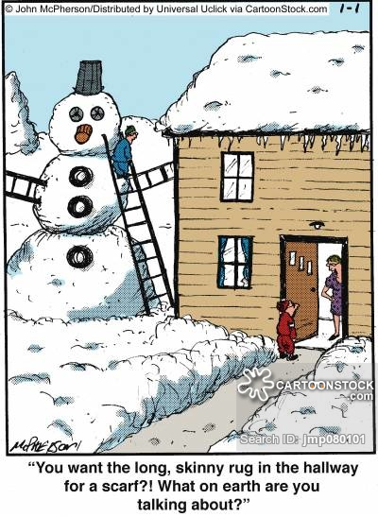

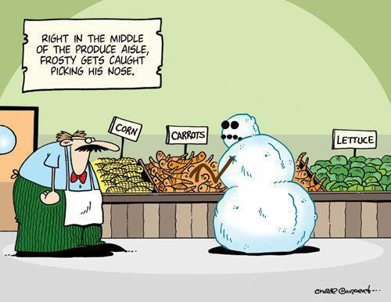

Page 4



Sun. | Mon. | Tue. | Wed. | Thu. | Fri. | Sat.
 |  |  |  |  | 1 | 2
Happy New Year!
Offices closed
3 | 4 | 5 | 6 | 7 | 8 | 9
9:00am Sunday School  10:30am Worship  Holiday Décor cleanup  5:00pm DOCK | 6:30pm Cardio Drumming  (FLC) | 9:15am Ladies Morning Bible Study  6:30pm Cub Scouts  6:30pm Ladies Evening Bible Study | 6:30pm Boy Scouts  6:30pm Cardio Drumming (Narthex) | No Bells in Jan.  7:00pm Choir  8:30pm AA |  | 9:00am Men's Breakfast Silver Moon  7:00pm Contra Dance
10 | 11 | 12 | 13 | 14 | 15 | 16
9:00 am Sunday School  10:30am Worship  12:00 Talent Show Practice  4:00pm Confirmation Class #7  5:00pm DOCK | 6:30pm Cardio Drumming  (FLC) | 9:15am Ladies Morning Bible Study  6:30pm Cub Scouts  6:00pm Hospitality  6:30pm SPRC, Trustees, Finance  6:30pm Ladies Evening Bible Study  7:30pm Admin | 6:30pm Boy Scouts  6:30pm Cardio Drumming  (Narthex) | 7:00pm Choir  8:00 Talent Show Practice  8:30pm AA
17 | 18-MLK Day | 19 | 20 | 21 | 22 | 23
9:00 am Sunday School  10:30am Worship  4:00pm Confirmation Class #8  5:00pm DOCK | 6:30pm Cardio Drumming  (FLC) | 9:15am Ladies Morning Bible Study  6:30pm Cub Scouts  6:30pm Ladies Evening Bible Study | 6:30pm Boy Scouts  6:30pm Cardio Drumming  (Narthex) | 7:00pm Choir  8:00 Talent Show Practice  8:30pm AA
24 | 25 | 26 | 27 | 28 | 29 | 30
9:00 am Sunday School  10:30am Worship  Talent Show after services  NO DOCK | 6:30pm Cardio Drumming (FLC) | 9:15am Ladies Morning Bible Study  6:30pm Cub Scouts  6:30pm Ladies Evening Bible Study | 6:30pm Boy Scouts  6:30pm Cardio Drumming  (Narthex) | 9:00 Helping Hands of St. Louis  7:00pm Choir  8:30pm AA
31
9:00 am Sunday School
10:30am Youth Led Worship
NO DOCK

Worship News

We would like to thank the hard-working members of our committee for all that they do all year long, in working behind the scenes to assist Pastor Ball in our services.

They are a great group! Michelle Sutter, Mike Hoffman, Terri Seibold, Jane Williams, Marcia Olwick, Lisa Comley, Darlene Limmer, Sue Perkins, Pat Baumgartner, Trudy McCamey, Sarah Buehrer.

Thank you to the advent candle lighters: The Youth, Mike and Gerri Hoffman, David Feltner and Charline Crispen, Ethan and Joanne Remley, and Kim Weyandt and her family for participating in the services.

Thank you also to the bell choir, chancel choir, Jeannie, Sarah, and Terri for all the lovely Christmas music this year and of course, as always to our hard-working pastor for his leadership. Our Worship Committee decorated, cooked dinner for the helpers, and took down decorations, set out poinsettias, prepared and set out the luminaries and collected them after Christmas - a special thank you to the Sutters for lighting them. They were so beautiful on Christmas Eve! Jerry Baumgartner painted and set out the manger in the front of the church. You might say we were pretty busy!

Now on to the new year! May God continue to bless our church in 2016.

With Love,
Worship Committee




Finance News

The Finance Committee wishes to thank everyone who committed to giving to the church in 2016. Without your help our church would not be able to provide as much as we do.

2016 Counters

We need two people to count money after services on Sunday. If you would like to fill in the remaining spots please contact Larry Ulrich. Thank you!

January - Bill Seibold, Tom Ridenour
February - Judy Bowerman, Elaine MacKinnon
March - Dan Buehrer, Bill Seibold
April - Ray McLargin, Jerry Baumgartner
May - Linda Rickwald, Kay Jacob
June - Dan Buehrer
July -
August - David Feltner, Charline Crispen
September - Ray McLargin, Jerry Baumgartner
October - Judy Bowerman, Elaine MacKinnon
November - Linda Rickwald, Kay Jacob
December -

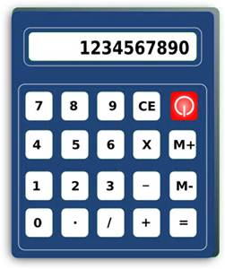

Page 6

NON-PROFIT
US POSTAGE
PAID
TOLEDO, OH
PERMIT #522
ROSSFORD UNITED METHODIST CHURCH
270 DIXIE HWY
ROSSFORD, OH 43460



Staff

Pastor: Rev. Dr. Robert Ball
Ministers: Every Member
Children’s Ministry: Kim Weyandt
Youth Ministry: Terri Seibold
Secretary: Jenny Graffius
Music Program Director: Sarah Buehrer
Organist: JeanE Waggoner
Custodians: Steve Agler
Jenny Riehm
Nursery: Kaitlin Moore

Lay Leadership

Lay Leader: Tom Ridenour
Head Usher: Bob Baughman
Media Directors: Troy Westfall
Jeff Comley

