February 2017

Blessings



Rossford United Methodist Church
Our Mission: To Know Christ And to Make Christ Known

Rossford United Methodist Church

270 Dixie Hwy

Rossford, OH 43460

Phone:

(419) 666-5323

Office Hours:

M-F 8:00am-2:00pm

Facebook:

www.facebook.com/RossfordUMC

E-Mail:

rossfordumc@yahoo.com

Visit us online at:
www.rossfordumc.org

Services

9:00 am Sunday School

10:30am Worship

10:00am Summer Worship

DOCK meets most Sunday's at 5:00 pm

From the Pastor's Pen…

Charting a Way Forward

When we travel into a new territory where we have never been before, the best choices we can make are to discover all of the resources available to us, talking with others, looking at older maps and seeking to find every bit of information that we can find. Having completed this process, the wise person will engage in a season of prayer to seek divine guidance. Then, after having done all that we can, we make our choice, chart our route and begin moving forward.

This is where we are at this moment in time in our beloved United Methodist Church. To be sure, we need to remember that you and I are not the only members of that church. We are 1 of 12.8 million members worldwide. In fact, Rossford United Methodist Church is one of over 43,000 congregations across the world. Today we speak many languages and live in many countries—with different cultures, ethnic traditions, national histories and understandings of Christian faith and practice. Every United Methodist congregation is interconnected throughout the denomination via a unique, interlocking chain of conferences. United Methodist trust free inquiry in matters of Christian doctrine. Our faith is guided by Scripture, tradition, experience and reason. Of paramount importance, however, is Scripture as the witness of God’s creating, redeeming and sustaining relationship with God’s people.

Today we are faced with another major spiritual question the answer we come to will have a profound effect on who we are and will be for the next 50 years. A commission of 32 clergy and laity from 9 countries and 14 states are charged with charting a way forward. They are asking that we join them over the next 75 weeks to pray for them and our church. The issue is how do we include members of the LGBTQ community in our life as a church. We are deeply divided on this question so the commission is charged with the responsibility of coming to a special General Conference in 2019 with A WAY FORWARD.

One pastor has suggested three prayers to help guide the church. The Prayer of St. Francis, The Breastplate of St. Patrick and the Wesleyan Covenant Prayer. Within the body of this newsletter you will find each of these prayers. Lets pray with and for our church.

Grace and Peace,
Bob

Worship News

Inside This Issue:

Pastor's Pen 1

Special Prayers 2

DOCK and Worship 3

Hospitality/Fellowship 4

How Can You Help? 4

Celebrations/Thanks and
Fundraising 5

Calendar 6

Penny Man and Heifer International 7

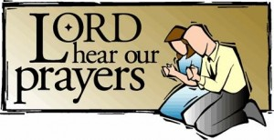

The Prayer of St. Francis

Lord, make me an instrument of your peace:
where there is hatred, let me sow love;
where there is injury, pardon;
where there is doubt, faith;
where there is despair, hope;
where there is darkness, light;
where there is sadness, joy.

O divine Master, grant that I may not so much seek
to be consoled as to console,
to be understood as to understand,
to be loved as to love.
For it is in giving that we receive,
it is in pardoning that we are pardoned,
and it is in dying that we are born to eternal life.
Amen.

The Breastplate Prayer
of St. Patrick

Christ with me,
Christ before me,
Christ behind me,
Christ in me,
Christ beneath me,
Christ above me,
Christ on my right,
Christ on my left,
Christ when I lie down,
Christ when I sit down,
Christ when I arise,
Christ in the heart of every man who thinks of me,
Christ in the mouth of everyone who speaks of me,
Christ in every eye that sees me,
Christ in every ear that hears me.

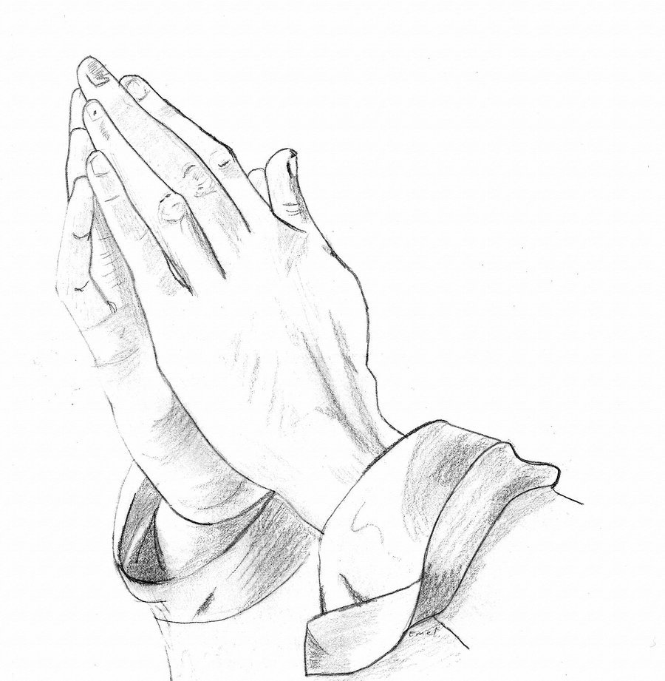
John Wesley’s
Covenant Prayer

I am no longer my own, but thine.
Put me to what thou wilt, rank me with whom thou wilt.
Put me to doing, put me to suffering.
Let me be employed for thee or laid aside for thee,
exalted for thee or brought low for thee.
Let me be full, let me be empty.
Let me have all things, let me have nothing.
I freely and heartily yield all things to thy pleasure and disposal.
And now, O glorious and blessed God, Father, Son and Holy Spirit,
thou art mine, and I am thine.
So be it.
And the covenant which I have made on earth,
let it be ratified in heaven.
Amen.

Page 2

Worship News

Happy New Year 2017.

As we begin the new year, we welcome three new faces on the Worship Committee - Laurie Clingo, Kristen Vargo, and Donna Robinson. We say good-by and thank you to Sue Perkins who has resigned. She has been a faithful servant on the committee for at least 30 years. We appreciate so much her help over the years and will miss her spirit of cooperation and willingness to do whatever needed to be done. Thank you, Sue!

The members of our committee are Co Chairs Cheryl Garlow and Nancy Rust, Michelle Sutter, Jane Williams, Lisa Comley, Marcia Olwick, Trudy McCamey, Darlene Limmer, Laurie Clingo, Kristen Vargo, and Donna Robinson, and staff members Sarah Buehrer and Terri Siebold. . Each person also serves on a sub-committee to be sure that all the tasks to prepare for Worship each Sunday are taken care of. Our main purpose is to be supportive of our pastor and help him with details to enhance the services.

We met on January 12th to plan for January and February. Please feel free to contact any member of the Worship Committee if you have any questions about worship-related issues.

Thank you all volunteers who help decorate our Altar throughout the year.

With Love,
Cheryl Garlow and Nancy Rust - Co-Chairpersons of Worship Committee





DOCK News

We’re doing something new this February. We’re having a combined Dessert Auction/Talent Show. Mark your calendars for Sunday, Feb. 12th. Following worship, lunch will be provided by the youth group. They’ll be serving pasta, sauce, meatballs and salad. Immediately following lunch we’ll begin the auction/show. We will alternate between performances and auctioning desserts. Tom Ridenour has graciously agreed to be our auctioneer!! The youth and several other church members will be performing. Jamie Baumgartner will be sharing his rapping talent with us again this year. All of the proceeds from the auction will be split between the youth group for their various fun activities and the New Orleans mission trip.

We hope to see you there on the 12th! It will be a lot of fun and it’s for two great causes.

Terri Seibold
Director of Youth Ministry

We are Disciples Of Christ’s Kingdom!

Page 3



Ushers and Greeters

Please see Bob Baughman to Usher or Brenda and Al Weis to Greet or Valet.

Helping Hands of St. Louis

Please stay tuned for more information. Questions please contact Jerry Baumgartner at 419-666-7236.

Prayer Quilts

If you know of anyone who would benefit from a prayer quilt please call or see Nancy Stonerock. She can be reached at 419-874-3504.

Kroger Store

The Kroger Rewards Program is a nationwide program that lets loyalty card holders select charities to which Kroger will donate, based on dollars they spend in stores. If you have a Kroger card, PLEASE check to see that you are signed up so that our church gets a percentage of what you buy. Your purchases really helps us out. Thank you!

UMC Market

The United Methodist Church has started a "market." This is a way for our church to earn money. You need to go online to www.umcmarket.org and sign up. Whenever you order from this site our church receives a % of what you purchase. There are 89 pages of participating stores and the amount we receive varies. Any questions, see Sue Perkins.

Box Tops and Stamps

We are still collecting Box Tops for Education and used stamps. The collection box is located in the Narthex. Please see Barb Chesson if you have any questions.

Can Drive

We would like to remind you that we are still collecting cans to raise money for our church. If you have any to donate, the container is outside the kitchen door. If you need a pickup, please call Doug Williams at 419-661-9484.

Rehearsals
Bell Choir practices at 6:00pm beginning February 9th.

Choir will rehearse on Thursday evenings at 7:00pm.

Hospitality

January is almost done as I write this. It's been a quiet month which is fine in our world. Thank you everyone for the prayers and good wishes to Al after his knee surgery.

We are still looking for people to sign up for coffee hour. Luckily we’ve had some cookie frozen to use after church. Please see list in the narthex.

The fellowship side of Our committee is planning a craft night on Feb 21st in 8th parlor at 6 pm. This is something new but my mom and I enjoy cross stitching and thought that and Fellowship go together. We hope it will be a success and a fun night together.

February valet: Matt Foster

February greeter: Kristen Vargo

Thank you to all the volunteers that help out this special ministry.

In Christ,
Al and Brenda Weis, Hospitality co-chair
Kim Weyandt and Brenda Weis, Fellowship co-chair

Meeting Night for February

Monday - February 13th, 2017

6:30pm Trustees and Finance
7:30pm Admin

Page 4

February Celebrations

and Thanks

Fundraising Calendar for 2017

SPRING RUMMAGE SALE - March 9, 10 and 11. Set up starts February 26

SPRING BBQ - Sunday, May 7

FALL BBQ - Sunday, October 8

CHRISTMAS STORY SHOW - Sunday, October 8
(A new Fundraiser)

FALL RUMMAGE SALE - October 19, 20 and 21. Set up October 8 after Christmas Story Show

CRAFT BAZAAR - Date not set. Probably November 4th or 11th.

"LET IT GLO" - Christmas Tree and wreath decorating contest. December 1st and 2nd. Another new fundraiser. More information to come

CHURCH HISTORY
We are hoping to have a Rossford United Methodist Church History available in the next few weeks. More information will be coming soon.

We are also planning on selling t-shirts/sweatshirts this spring.

Please put these dates on your calendar and plan on helping in any way you are able.

Thank you!
Sue Perkins, Chairperson

Anniversaries

Bill and Doris Bachar 2/28

Birthdays

Dan Buehrer 2/2

Steve Kotecki 2/6

Tom Ferguson 2/8

Sue Ferguson 2/16

Sue Perkins 2/16

Bob Ball 2/17

Tyler Crispen 2/17

Trudi McCamey 2/17

Troy Brant 2/20

Troy Westfall 2/21

Christopher Bashaw 2/25

Emilie Fisher 2/27

Thank You
Dear church family,
Brenda and I would like to send a heartfelt thank you for the love shown to us during my recent knee replacement surgery. From Pastor Bob sitting with my family during the surgery, to the cards, phone calls and especially the meals provided by some of you. Those were truly appreciated. Our church is our family and we love all of you!!
Sincerely,

Al Weis

2016 Imagine No Malaria Campaign

We are pleased to announce that RUMC contributed a total of $1,959.97 towards the "Imagine No Malaria" mission in 2016.

Together the West Ohio Conference went above and beyond the $3.5 million goal of gifts and pledges with a grand total of $3.6 million! We believe our gifts will translate into saving 360,000 young lives through the use of nets, medicine, communication and education.

We celebrate lives changed and saved!

Warm Regards,

Bishop Gregory V. Palmer Reverend George Cooper Reverend Stanley T. Ling
Resident Bishop Executive Director Associate Director



Page 5




Sun. | Mon. | Tue. | Wed. | Thu. | Fri. | Sat.
 |  |  | 1 | 2 | 3 | 4
6:00pm Bells
7:00pm Choir
8:30pm AA

Groundhog Day
5 | 6 | 7 | 8 | 9 | 10 | 11
9:00am Sunday School  10:30am Worship  5:00pm - Talent Show Dress Rehearsal |  | 9:15am Ladies Morning Bible Study  6:30pm Cub Scouts | 6:30pm Boy Scouts  6:00 - 8:00 AA Dinner Prep | 9:00am AA Dinner Cooking/Prep  6:00pm Bells  6:00pm AA Dinner (FLC and Kitchen)  7:00pm Choir | Red Cross Blood Drive  2:00-6:00pm  In Narthex | 9:00am Men's Breakfast Silver Moon  7:00pm Contra Dance
12 | 13 | 14 | 15 | 16 | 17 | 18
9:00 am Sunday School  10:30am Worship  12 Noon Talent Show/Dessert Auction | 6:30pm Trustees and Finance Mtg  7:30pm Admin Mtg | 9:15am Ladies Morning Bible Study    6:30pm Cub Scouts | 6:30pm Boy Scouts | 6:00pm Bells  7:00pm Choir  8:30pm AA
19 | 20 | 21 | 22 | 23 | 24 | 25
9:00 am Sunday School  10:30am Worship  5:00pm DOCK |   President's Day | 9:15am Ladies Morning Bible Study  6:00 - 10:00 pm Craft Night (Parlor) | 6:30pm Scouts Pack Meeting | 6:00pm Bells  7:00pm Choir  8:30pm AA |  | 1:00pm Private Event (FLC)
26 | 27 | 28
9:00 am Sunday School  10:30am Youth Led Worship  NO DOCK  Rummage Sale Set Up |  | 9:15am Ladies Morning Bible Study  6:30pm Cub Scouts
Page 6
Excerpts from Toledo Blade Article by Thomas Walton
published January 9th, 2017

"Guided by the philosophy that good people doing wonderful but strange things makes a great story, I was drawn to Steve Agler’s quest for a million pennies.
Mr. Agler, who lives in Rossford, has been collecting, counting, sorting, wrapping, and lugging pennies to the bank for 28 years now on behalf of the United Methodist Church of Rossford, and next Sunday will mark a milestone.
Sunday’s service will include a presentation by fellow church member Larry Perkins, who will hand Mr. Agler the one-millionth penny. You can be sure much applause will ensue.
Mr. Agler, who is known in Rossford as the “Penny Man,” began collecting pennies in 1989 as a way for the church to donate to Heifer International, a charity which provides farm animals to families in Third World countries.
The effort has endured as a tribute to the late Dianne Benson, the wife of the church’s minister at the time, the Rev. John Benson. After she lost her battle with leukemia, Mr. Agler embraced her memory as inspiration, and he’s been hauling pennies to the bank ever since."

RUMC Celebrates 1 Million Pennies for Heifer International

"Penny Man" Steve Agler accepts the 1 millionth penny on January 15th, 2017

Steve is a local celebrity as the Toledo Blade publishing an article about him and our mission to support Heifer International.

Additionally, Channel 13abc news aired a special news story on 1/15 as well visited us that morning to view the historic event.

You can view the full article and link to the news story on our website
www.rossfordumc.org






NON-PROFIT
US POSTAGE
PAID
TOLEDO, OH
PERMIT #522
ROSSFORD UNITED METHODIST CHURCH
270 DIXIE HWY
ROSSFORD, OH 43460



Staff

Pastor: Rev. Dr. Robert Ball
Ministers: Every Member
Children’s Ministry: Kim Weyandt
Youth Ministry: Terri Seibold
Secretary: Jenny Graffius
Music Program Director: Sarah Buehrer
Organist: JeanE Waggoner
Custodians: Steve Agler
Jenny Riehm
Nursery: Carol Kotecki
MacKenzie Rodriquez

Lay Leadership

Lay Leader: Tom Ridenour
Head Usher: Bob Baughman
Media Directors: Troy Westfall
Jeff Comley

