

December 2018

Rossford

United Methodist Church
Our Mission:
"To Know Christ And to Make Christ Known"

From Pastor Dwayne

In all the hustle and bustle, in all the craziness and franticness, in all the beauty and wonder, in all the sorrow and sadness of Christmas, let's pause for a moment to ask ourselves this question: What does Christmas teach us about God? Christmas is more than gifts giving and received, or meals eaten, or family trips. It is more than the heartache and sorrow of being alone, or not having someone who should be with us actually with us. Christmas is more than songs and decorations. We all already know this, but from time to time we need a reminder. And so here it is, this is your reminder.
In the Grinch That Stole Christmas, the story tells us this after the Grinch realized that he did not stop Christmas from coming:
“And the Grinch, with his Grinch-feet ice cold in the snow, stood puzzling and puzzling, how could it be so? It came without ribbons. It came without tags. It came without packages, boxes or bags. And he puzzled and puzzled 'till his puzzler was sore. Then the Grinch thought of something he hadn't before. What if Christmas, he thought, doesn't come from a store. What if Christmas, perhaps, means a little bit more.”
This is the reminder that we need. Christmas is these things, boxes and bags and presents and all that. But it is more as well, it is love and grace and forgiveness and hope. It is God coming down and living with us, being with the people that God so loves. It is knowing that we are worthy of love, that we are loved, that we are loved beyond our wildest imaginations. It is the realization that we are not alone, even when we feel alone. It is the amazement in finding out that God is here, right here, with you and me and us. It is Jesus teaching us that no one is left out, not even the last and lost. It is Jesus welcoming us back home even when we waste and squander all that God has given us. It is homecoming, even when we think we have no home and we do not belong. Christmas is God's definitive moment in history that states that everyone, EVERYONE, belongs.
Christmas teaches us about how much we are loved. That God is unwilling to ever let us go. And so, this year in worship we are going to explore Christmas from this vantage point. We will learn about Christmas as we answer the question what does Christmas teach us about God. Here is the schedule for worship as we move toward Christmas:

Continued on page 2

Rossford United Methodist Church

270 Dixie Hwy

Rossford, OH 43460

Phone:

(419) 666-5323

Services

9:00 am Sunday School

10:30am Worship

Office Hours:

M-F 8:15am-2:15pm

Facebook:

www.facebook.com/

RossfordUMC

E-Mail:

rossfordumc@yahoo.com

Visit us online at:
www.rossfordumc.org

Inside This Issue:

Pastor's Message 1/2

DOCK 2

Worship/Kids Kingdom Choir 3

How can you help?/Sermon Series/Committee Clips 4

Thanksgivings/Congregational Care Committee/Celebrations 5

Poinsettia Sale and Website information 6

Calendar of events 7

**If you would like to receive our electronic newsletter please call or email us. **

Dec. 2 - What Does Christmas Teach Us About God?
God's Promises
Jeremiah 33:14-16
Dec. 9 - What Does Christmas Teach Us About God?
God's Judgment
Malachi 3:1-4
Dec. 16 - What Does Christmas Teach Us About God?
God's Redemption
Zephaniah 3:14-17
Dec. 23 - What Does Christmas Teach Us About God?
God's Hope
Luke 2:1-7
Dec. 24 - What Does Christmas Teach Us About God?
God's Salvation
Luke 2:8-20
Dec. 30 - What Does Christmas Teach Us About God?
God's Presence
Matthew 1:18-25
May we discover (for the first time or the hundredth time) what Christmas really is, God speaking to us throughout all eternity that we are loved and wanted. But this is not the end of Christmas, for we continue to tell the story. We tell the story of Jesus and his love, we tell the story of hope and grace, we tell the story of forgiveness and acceptance, we tell the story with our words and voices, we tell the story by the way we serve others, we tell the story by the way we live. As one of our hymns reminds and challenges us: "Go, tell in on the mountain, over the hills and everywhere; go, tell it on the mountain that Jesus Christ is born."
And while you are telling the story, invite someone home to RUMC for the holidays.
Merry Christmas!
Pastor Dwayne

DOCK
The youth and I would like to thank everyone who donated boxes, items and prayers to our Operation Christmas Child project. We collected 66 boxes. Please know that your donations and prayers will bless children with a lovely Christmas.
D.O.C.K. will meet on Dec. 2nd and 9th from 5:00 – 7:00, as usual. On the 16th we’ll be joining the choir with the song “He Shall Reign Forevermore”. In the evening we’ll meet from 5:00 – 7:00 and join in the caroling. We’ll have a Christmas party/movie night on the 23rd and lead worship on the 30th. All in all a pretty full month. Merry Christmas to all and thanks for your support.

December D.O.C.K. Calendar
2nd | D.O.C.K. | 5:00 - 7:00 | Prepare Christmas cards for shut-ins
9th | Music prep/meeting | 5:00- 6:00 | Rehearse "He Shall Reign Forevermore"
 |  | 6:00 - 7:00 | Christmas cards to shut-ins
16th | Perform with choir during worship | 9:45 | Meet to rehearse with choir
 | D.O.C.K. | 5:00 - 7:00 | Christmas caroling and donuts!
23rd | D.O.C.K. | 5:00 - 5:30 | Rehearse for Youth Worship service
 |  | 5:30 - 8:00 | Pizza/Party/Movie
30th | Youth Led Worship | 9:00 | Prep for worship
 |  |  | No Evening D.O.C.K.

KINGDOM KIDS CHOIR
The Kingdom Kids Choir will be singing in worship on Dec. 16th. They’ve been working hard learning the words and the actions. Wait until you see our little angels sing! I’d like the children to meet at 9:00 on the 16th so that we can rehearse and get dressed for our performance. I will be rehearsing with the youth at about 9:45 for the piece they’re playing that day. So, that means that I will need some parents/grandparents on hand to keep an eye on the children until I get back! Busy morning but it’ll be great.
Tell all your friends to join us for Kingdom Kids and Kingdom Kids Choir.
Terri Seibold
Kingdom Kids Choir Director

WORSHIP NEWS
The Worship Committee met Nov.11th to plan ahead for the Advent and Christmas season.
Please note important dates below:
Dec. 2nd – The first Sunday of Advent and Communion
Dec.9th – We will put bulbs on the big tree in the Narthex and light the tree at the end of the service Second Sunday of Advent
Dec.16th – We will have a display of nativity sets as we did last year. Please see below for details Third Sunday of Advent
Dec. 23rd – Sunday before Christmas, Fourth Sunday of Advent
Dec.24th – Christmas Eve candlelight service at 7:00 pm
Of course each service in December will have advent readings, scripture, and songs. Please join us for all of these beautiful services.
On Dec. 16th you are invited to participate in the Advent Show of manger scenes. If you have a special manger scene you would like to include, please come to the church at 2:00 pm on Saturday, Dec.15 for set up. We will provide a note card that you can write about the manger, where it came from, how old it is etc. We will have the church open until 4 that day but encourage you to come as close to 2 as possible.
We would also like to thank Bill Garlow for the addition of shepherds and wise men to the nativity set that Jerry Baumgartner made for us years ago. It is a meaningful way for us to remind the community of the real meaning of Christmas.
Have a blessed Christmas everyone and we thank our committee for all the hard work they do year long for the church services.
Cheryl Garlow and Nancy Rust
Co-Chairpersons of Worship Committee



NEW SERMON SERIES FOR ADVENT 2018

"What Does Christmas Teach Us About God?'
Dec. 2 - God's Promises
Jeremiah 33:14-16
Dec. 9 - God's Judgment
Malachi 3:1-4
Dec. 16 - God's Redemption
Zephaniah 3:14-17
Dec. 23 - God's Hope
Luke 2:1-7
Dec. 24 - God's Salvation
Luke 2:8-20
Dec. 30 - God's Presence
Matthew 1:18-25

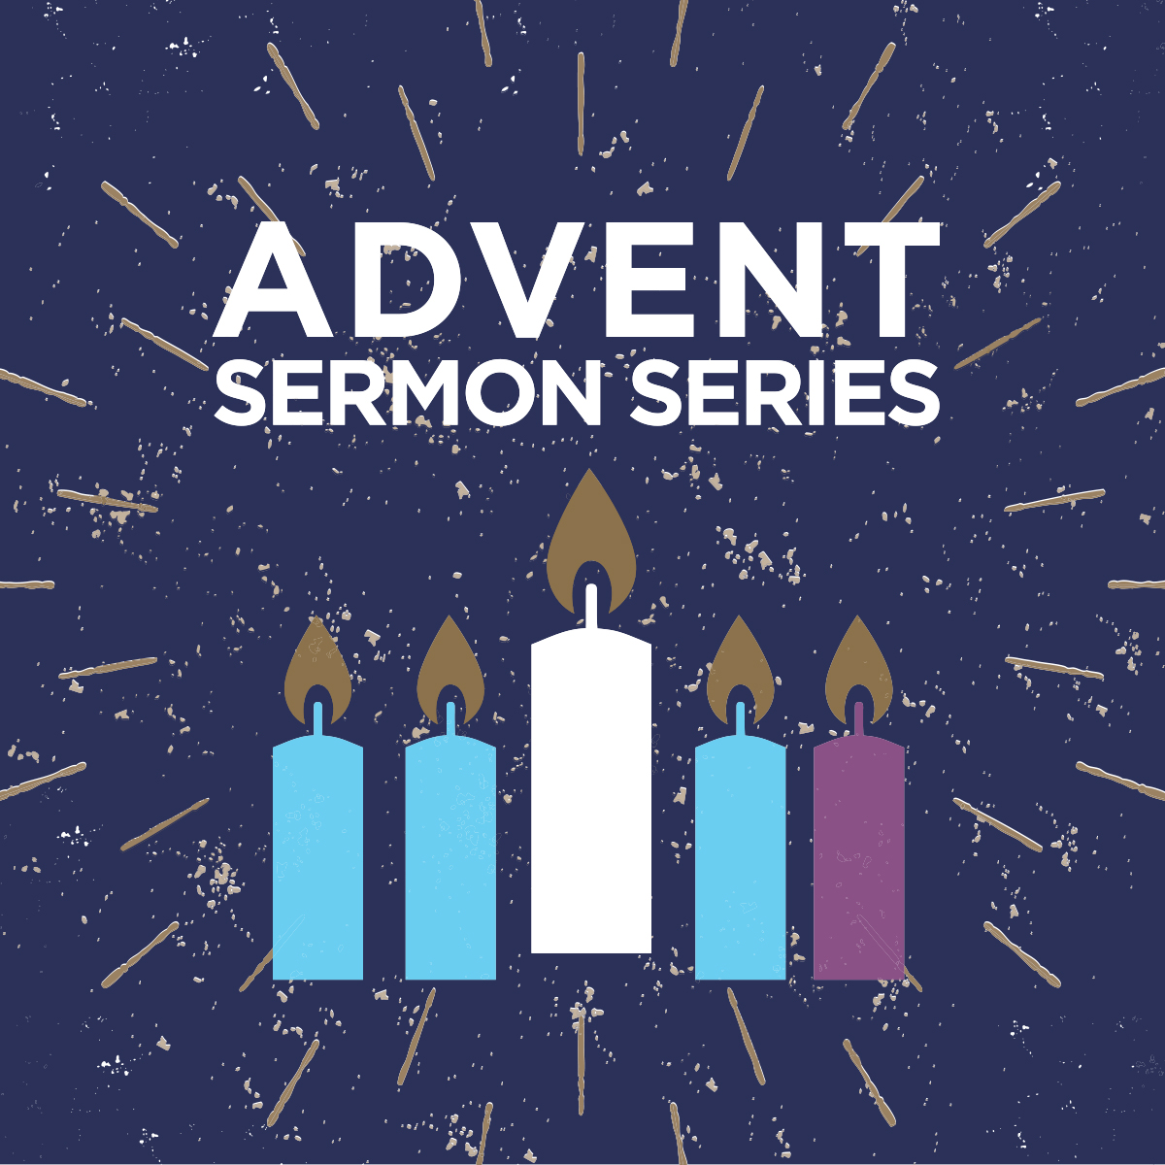



HOW CAN YOU HELP OUT?
Ushers and Greeters
Please see Bob Baughman to Usher or Brenda and Al Weis to Greet or Valet.
Helping Hands of St. Louis
Thursday, December 13th, 2018. Questions please contact Jerry Baumgartner at
419-666-7236.
Prayer Quilts
If you know of anyone who would benefit from a prayer quilt please call or see Nancy Stonerock. She can be reached at 419-874-3504.
UMC Market
The United Methodist Church has started a "market." This is a way for our church to earn money. You need to go online to www.umcmarket.org and sign up. Whenever you order from this site our church receives a % of what you purchase. There are 89 pages of participating stores and the amount we receive varies. Any questions, see Sue Perkins.
Cancelled Stamps
We are collecting cancelled postage stamps. The collection box is located in the Narthex. Please see Barb Chesson if you have any questions.
Can Drive
We would like to remind you that we are still collecting aluminum cans to raise money for our church. If you have any to donate, the container is outside the kitchen door. If you need a pickup, please call Doug Williams at 419-661-9484.
Kroger Rewards Program
The Kroger Rewards Program is a nationwide program that lets loyalty card holders select charities to which Kroger will donate, based on dollars they spend in stores. If you have a Kroger card, PLEASE check to see that you are signed up, so that our church gets a percentage of what you buy.
Our Kroger Plus Rewards Organization
# 84283

COMMITTEE CLIPS
From Larry Ulrich and the Finance Committee: The regularly scheduled meeting of November 13th, 2018 was cancelled due to a computer problem and inability to produce financial statements. The computer is expected to be fixed within the next week. When the computer is repaired, the chair will try to schedule a short meeting to discuss finances and other business.
From Kay Jacob and the SPRC Committee: At the request of our District Superintendent, we reviewed a checklist on the well being of our Pastor and information from Westpath, who manages the pension & benefits for all conference pastors. This is the last meeting of the year for SPRC and we bid farewell to committee members Kay Jacob & Laurie Seibold.



CONGREGATIONAL CARE COMMITTEE

How does another month that fly by!! Wow, Thanksgiving is done and Christmas is just around the corner.
I'd like to take a moment to thank our committee for another year of service to our church and the community. Betty Dowell, Caroline and Darrel Eschedor, Kathy Slomski, Kim Weyandt and Al and Brenda Weis. We're like a well oiled machine stepping up to serve.
Also, thank you to everyone who regularly volunteers to greet and valet, bring treats for coffee hour and help with everything! Your generosity is appreciated!!
December 16th will be Christmas caroling at 5:00 pm. A sign up sheet will be in the Narthex soon both for singers and requests for carols sung. If you know someone who would appreciate a visit please write it down!
December Greeter: Christy Foster
December Valet: Matt Foster
In Christ,
Al and Brenda Weis, Kim Weyandt, co-chairs, Congregational Care Committee

Thank you RUMC for your thoughts, prayers, and the prayer quilt you provided for our family since the passing of my beloved brother Doug. We are grateful for your kindness and love.
Thank you from the Shugert family
From Nancy Stonerocks' granddaughter
3 1/2 year old Marlee loves her prayer quilt. She has been retested and does not have fatal cancer, but has lymphatic cancer and is responding to chemo miraculously.
Thank you all!
RUMC,
Please thank the men and women of the church for the thoughtful prayer quilt. The thoughts and sentiments written on the quilt were very meaningful and I know all the prayers have helped me forge through this journey.
Blessings to you all,
Cheryl Grosick
Dear Friends,
I just wanted to send a note to you to thank you for having rummage sales. I know they are a lot of work but they are such a great ministry to the community and surrounding areas.
Sincerely,
Elaine Mendelsohn
Maumee, Ohio
Thank you from the Worship Committee:
Thank you to the Scouts and the leaders from our church. They have been so helpful to us in many ways. Recently they carried all the Christmas decorations up the steps for us and were so pleasant and willing to help. They also carried the rummage up the steps for us in September and we truly appreciate them! Thank you to everyone who worked in the kitchen and donated food for the Craft Bazaar this year. The luncheon alone made $375 after expenses.
A big THANK YOU to everyone who helped out in any way with the Craft Bazaar! I can't name everyone because I don't want to miss anyone. Everyone in the kitchen did an amazing job and those running the raffle, those running the church table, those who donated food for the luncheon and all the crafters! We couldn't do it without you!
Kim Weyandt


Birthdays
Hannah Markin 12/05
Barry Bashaw 12/22
Chris Bartlett 12/23
Grace Shugert 12/30
Brenda Zuchowski-Pliska 12/30

Anniversaries
Neil & Elaine MacKinnon 12/18
Bob & Shirley Ball 12/24
Larry & Sue Perkins 12/29

***If we missed you or someone else, please let us know at rossfordumc@yahoo.com or call 419-666-5323***

The UMMen will be selling Christmas Poinsettias for Scholarships! All sales will benefit the Maumee Watershed District Scholarship Fund, sponsored by the UMMen.
The men have a new vendor and will be offering multi-flowered poinsettias:
6 1/2" covered pot with 5-7 flowers in RED, PINK, WHITE and MARBLE.
The plants will cost $8.00 each

Orders can be submitted anytime through Sunday, December 16th. See the table in the Narthex for order envelopes.


CHECK OUT OUR ONLINE FORUM AND MEDIA TAB ON OUR WEBSITE
The Forum tab on our website includes a lifetime of top-quality Christian study and Bible sites. The Media tab is filled with fantastic Christian quality music and videos. Thank you to Larry Keeler who keeps this up to date and filled with useful information.
Forum
We learn by interacting with other Christians. The articles offered below provide an opportunity to discuss current events in the life of the church, offer sermon texts, and allow us to be in relationship with our Christian brothers and sisters online. Click the picture to be taken to the forum section of our website.

Media
Click the picture below to experience fabulous Christian music.


December 2018
SUN | MON | TUES | WED | THURS | FRI | SAT
 |  |  |  |  |  | 1
2 | 3 | 4 | 5 | 6 | 7 | 8
9:00 am Adult Sunday School  10:30 am Worship  5:00 pm DOCK | 8 - 10 pm HEMA (FLC) | 9:15 am Ladies Bible Study (Parlor)  6:30 pm Scouts | FLC in use all day for Rec. Center event | 6:00 pm Bells  6 - 8:00 pm Girl Scouts  7:00 pm Choir  8:30 pm AA |  | 9:00 am Men's Breakfast (Silver Moon)  Kitchen in use all day  7:30 pm Contra Dancers (FLC)
9 | 10 | 11 | 12 | 13 | 14 | 15
9:00 am Adult Sunday School  10:30 am Worship  5:00 pm DOCK | 8 - 10 pm HEMA (FLC) | 9:15 am Ladies Bible Study (Parlor)  6:30 pm Finance& Trustees  6:30 pm Scouts  7:30 pm Admin. |  | 7:00 am Kitchen Use  6:00 pm Bells  6 - 8:00 pm Girl Scouts  7:00 pm Choir  8:30 pm AA |  | 2:00 pm Manger scene display event
16 | 17 | 18 | 19 | 20 | 21 | 22
9:00 am Adult Sunday School  9:00 am Kingdom Kids Choir rehearsal  9:45 am DOCK meets to rehearse with choir  10:30 am Worship  Manger display event  5:00 pm DOCK | 8 - 10 pm HEMA (FLC) | 9:15 am Ladies Bible Study (Parlor)  6:30 pm Scouts Pack Meeting |  | 6:00 pm Bells  6 - 8:00 pm Girl Scouts  7:00 pm Choir  8:30 pm AA
23 | 24 | 25 | 26 | 27 | 28 | 29
9:00 am Adult Sunday School  10:30 am Worship | 7:00 pm Candlelight Service | Offices Closed | Offices Closed | 6:00 pm Bells  6 - 8:00 pm Girl Scouts  7:00 pm Choir  8:30 pm AA
30 | 31
9:00 am Adult Sunday School
9:00 am Youth Music Prep
10:30 am Youth Led Worship
No DOCK



ROSSFORD UNITED METHODIST CHURCH
270 DIXIE HWY
ROSSFORD, OH 43460


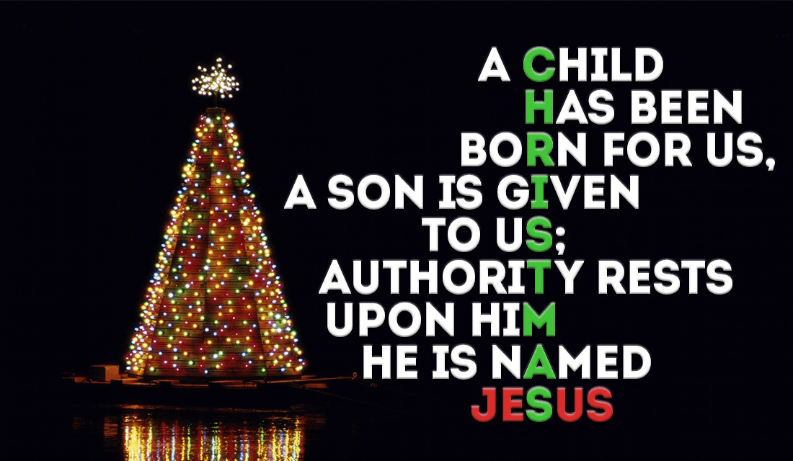

Staff

Pastor: Pastor Dwayne Shugert
Ministers: Every Member
Children’s Ministry: Kim Weyandt
Youth Ministry: Terri Seibold
Secretary: Jenny Graffius
Music Program Director: Sarah Buehrer
Organist: JeanE Waggoner
Custodians: Steve Agler
Jenny Riehm
Nursery: Carol Kotecki
MacKenzie Rodriguez

Lay Leadership

Lay Leader: Tom Ridenour
Head Usher: Bob Baughman
Media Directors: Troy Westfall
Jeff Comley

