

December 2017

Rossford

United Methodist Church
Our Mission:
"To Know Christ And to Make Christ Known"

Greetings Church,

Merry Christmas! I hope and pray that you have an amazing Christmas season with family and friends; with good gifts and good food. I hope and pray that you realize how amazing and important and loved you are, even in the midst of grief and loss and darkness. Christmas can be a hard time for so many of us, the cold, the dark, the hurt of loved ones not with us. But the hope this Advent season that leads right to Christmas, is that Jesus is near. In the Incarnation, which is a fancy way of saying that God became one of us, we see God coming near to us to remind us that indeed He loves us beyond our wildest imagination.

As a father of 5 I love each of my children with everything I have. I love them when they do amazing things, and I love them when they make bad decisions. As the three older ones we being born, I remember trying to get close enough to those little ones to hold them, and whisper in their uncomprehending ear that I love them. And when we first got Joe and Isaiha, we are adopting them, if you didn't know, Melissa and I both would fight, and nudge our way closer to them so we could tell them we love them too.

This is the message of Christmas, that God came near to hold us, and whisper in our (sometimes) uncomprehending ear, that He loves us beyond our wildest imagination.

So whether Christmas is your favorite season, or a season that is hard to make it through, hear these words:

YOU ARE LOVED BEYOND YOUR WILDEST IMAGINATION!!! Always and forever. No strings attached. God loves you as much as an infinite God could possible love.

As a fun way to hear this Christmas story again this year, we will be using some of the best and most famous Christmas movies to help tell the story of Jesus, of God coming near in this time of Christmas. So our schedule for the next five weeks will be:

Dec. 3rd - "It's A Wonderful Life" Isaiah 9:2-7
Dec. 10th - "A Christmas Carol" John 1:1-18
Dec. 17th - "A Christmas Story" Matthew 1:18-20
Dec. 24th - "Elf" Luke 2:1-7
Dec. 24th (Christmas Eve Service 7:00 p.m.) - "Elf" Luke 2:8-20
Dec. 31st - "The Grinch Who Stole Christmas" Matthew 2:1-12

Pass the word and invite someone to worship, so that they too can hear the true Christmas story, that we are loved beyond our wildest imagination every moment of every day.

MERRY CHRISTMAS!!
Pastor Dwayne

Rossford United Methodist Church

270 Dixie Hwy

Rossford, OH 43460

Phone:

(419) 666-5323

Office Hours:

M-F 8:00am-2:00pm

Facebook:

www.facebook.com/

RossfordUMC

E-Mail:

rossfordumc@yahoo.com

Visit us online at:
www.rossfordumc.org

Services

9:00 am Sunday School

10:30am Worship

Inside This Issue:

Pastor's Message 1

DOCK 2

Hospitality/Fellowship 3

A thanks from our Musician 4

Worship 5

Celebrations and
Fundraising 6

Calendar 7



DOCK News

We had a great time at the BIG CHURCH NIGHT OUT concert at the Huntington Center on Nov. 17th. We heard 7eventh Time Down, Sidewalk Prophets, The Newsboys and several other performers. We saw a massive light show along with a spinning drum set!!! AMAZING and LOUD. Just what we like!!! Lots of smiles were seen that night!!!

Thank you to all who donated to OPERATION CHRISTMAS CHILD. Altogether we donated 50 boxes this year. I dropped them all off and we prayed over them, asking God to watch over the boxes and get them to the kids safely. I’m sure we will put smiles on the children’s faces. This is a wonderful way to show the love of God. Thank you so much for supporting this mission.

December will be a fun and busy month. The youth group will be joining the adult choir in singing “He Shall Reign Forevermore” on the morning of Dec. 24th. We’ll be adding some percussion and chimes, as well. We’re also leading worship on Dec. 31st.

In order to prepare for these services we’re going to be meeting a little earlier throughout December. We’ll meet at 4:00 on Dec. 3rd, 10th and 17th to rehearse. I will provide a small meal each night so we don’t starve!!

Following our rehearsals on Dec. 3rd and 10th, Jerry Baumgartner will guide us in making glass and leaded angel ornaments. We will be cutting the glass and soldering the lead around it. They’re beautiful and we’ll learn some crafting techniques.

We’ll join in Christmas Caroling on the 17th and return for hot cocoa, cookies and a mini Christmas party!!! Fun, Fun, Fun!!

Here is the December calendar:

3rd | REHEARSAL | 4:00 | Music Prep for Dec. 24 and 31st, dinner included
 | D.O.C.K. | 5:00 - 7:00 | Angel Craft with Jerry Baumgartner
10th | REHEARSAL | 4:00 | Music Prep for Dec. 24 and 31st, dinner included
 | D.O.C.K. | 5:00 - 7:00 | Finish Angel Craft with Jerry Baumgartner
17th | REHEARSAL | 4:00 | Music Prep for Dec. 24 and 31st, dinner included
 | D.O.C.K. | 5:00 - 7:00 | Caroling and Christmas party
24th | Morning worship | 9:45 | Rehearse anthem with the choir
 |  | 10:30 | Worship begins
31st | Youth Led Worship | 9:00 | Prep for worship service
 |  |  | NO EVENING DOCK-HAPPY NEW YEAR

CHILDREN’S CHOIR

We had our first Children’s Choir rehearsal on Sunday, Nov. 19th. What fun we had! Kristen Vargo and Anna Fisher helped with crowd control! Alex Vargo was my assistant, leading the group with the melody and motions. The Children’s Choir will be singing “There Was A Little Baby” during worship on Dec. 17th. You won’t want to miss it. All of the Nativity characters represented!

Terri Seibold
Director of Youth Ministry
Disciples Of Christ’s Kingdom!



Ushers and Greeters
Please see Bob Baughman to Usher or Brenda and Al Weis to Greet or Valet.

Helping Hands of St. Louis
2018 dates to be announced soon. Questions please contact Jerry Baumgartner at 419-666-7236.

Prayer Quilts
If you know of anyone who would benefit from a prayer quilt please call or see Nancy Stonerock.
She can be reached at 419-874-3504.

UMC Market
The United Methodist Church has started a "market." This is a way for our church to earn money. You need to go online to www.umcmarket.org and sign up. Whenever you order from this site our church receives a % of what you purchase. There are 89 pages of participating stores and the amount we receive varies. Any questions, see Sue Perkins.

Box Tops and Stamps
We are still collecting Box Tops for Education and cancelled postage stamps. The collection box is located in the Narthex. Please see Barb Chesson if you have any questions.

Can Drive

We would like to remind you that we are still collecting aluminum cans to raise money for our church. If you have any to donate, the container is outside the kitchen door. If you need a pickup, please call Doug Williams at 419-661-9484.

Kroger Rewards
Program
The Kroger Rewards Program is a nationwide program that lets loyalty card holders select charities to which Kroger will donate, based on dollars they spend in stores. If you have a Kroger card, PLEASE check to see that you are signed up so that our church gets a percentage of what you buy. We get a check quarterly from Kroger.
Our Kroger Plus Rewards Organization
# 84283

Fellowship

Greetings from our committee to yours and first of all I'd like to thank our faithful and always cheerful committee for another year of dedicated service to RUMC!! You're the best!!
We will address Christmas cards to our shut ins on Sunday Dec 3rd. Unfortunately our list has grown shorter with several deaths this past year. If you know anyone please email or text me their address. We would love to send some Christmas cheer!!

On that same note, my mom Kathy Slomski is still sending the weekly bulletins to our shut-ins. A big thank you mom!! If you know someone who would appreciate this please let Jenny in the office know.

We will be serving cookies and punch after the Choraliers concert on December 10th. There is a signup sheet in the narthex.

Please continue to sign up for coffee hour for treats. Thank you to those who have. It's greatly appreciated.

On the Fellowship side we are not having craft night in December. Instead we will be going to Moe's for taco Tuesday on Tues. December 19th. Please join us!! Craft night will resume in January on the 3rd Tuesday of the month.

December also will be Christmas caroling on the 17th at 5 pm. If you know someone who would appreciate some carols please let Kim or myself know. That afternoon after the service we will plan to see the movie "The Star" and have lunch. Look for info in the bulletins.

December greeter and valet: Caroline and Darrel Eschedor
January greeter and valet: Sherry Engwert. We are still in need of a valet for the month.

I think that is all for our committees. It's a busy time around here at RUMC.

Merry Christmas to everyone! Take time to smell the roses and think about our true reason for the season!!

In Christ,
Al and Brenda Weis, Hospitality co-chairs
Kim Weyandt and Brenda Weis, Fellowship co-chairs



Page 3

THANKS FROM JAMIE BAUMGARTNER

I'd like to thank everyone involved in making my concert at the church in November such a big success. I've performed all over Toledo, and out of state, but this may have been my favorite show. I got to do what I love in a place that means so much to me, in front of an eager crowd of about 80 people, for a great cause. A huge thank you to Pastor Dwayne for bringing the idea to me and inviting me to perform. And another huge thank you to Jim Seibold for selflessly giving his time and running sound not only for the show, but for sound check the night before, making sure we sounded great.

Thank you to everyone that came out. The turnout was awesome, the energy in the building was amazing, and we were able to raise $200 for Hurricane Relief in a short amount of time. Thank you to my friend and label mate Raine Wilder for the awesome performance, and Dj Kut-Off for doing such a great job Deejaying for us both all night. And thank you to Kristen Lewis Vargo and Terri Seibold for organizing and collecting admission. It was truly an amazing night that I won't forget. It was really great to see everyone at the show.

Until we do it again,
THANK YOU for supporting Jamie Baumgartner!!!

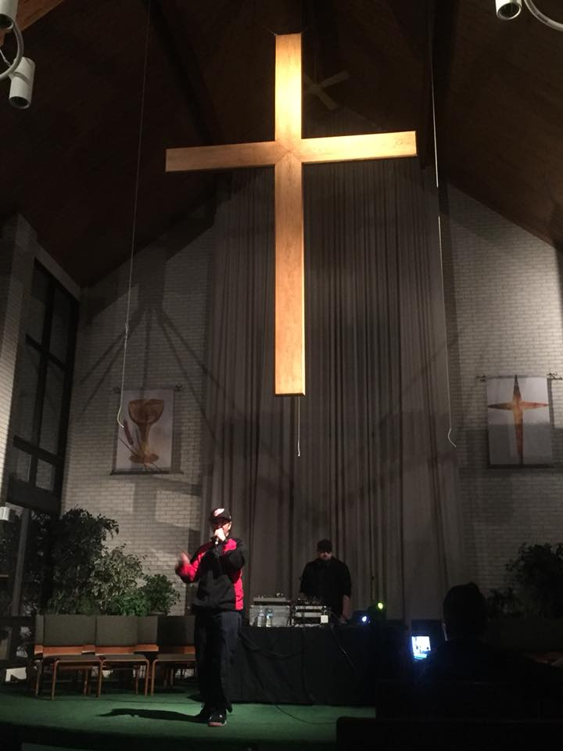

Meeting Night for January

Tuesday - January 9th, 2018
6:30 pm SPRC
6:30pm Trustees and Finance
7:30pm Admin

Annual Food Baskets

In the spirit of giving this Christmas season, we will once again assemble baskets of food items for those in need.
If you know of someone who could use a basket, please call the
office or see Nancy Rust or Cheryl Garlow

Schedule of Donations:
December 3rd - cereal, cans of fruit, stuffing, crackers
December 10th - pasta, noodles, boxed dinners or pouches of dinners, instant mashed potatoes

Delivery will be December 17th
There is a signup sheet for those that want to donate a ham or turkey. We appreciate your donations!

Page 4


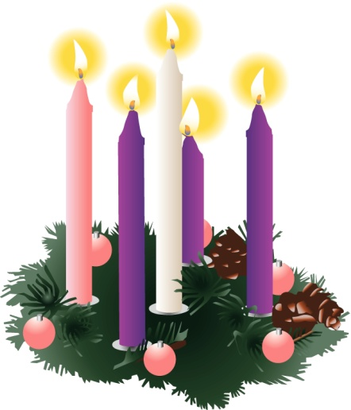

"Deck The Halls With Christmas Spirit"
December 2nd from 10:00 am to 4:00 pm, luncheon will be served starting at 11am. Vote on your favorite tree or wreath. Cash prizes will be awarded according to the highest number of votes in each category. We are excited to see what you come up with.

- Tree or wreath decorating contest
- Santa Claus live Photo opportunity
- Holiday booths and food
- Kids only Christmas shopping plaza

Worship News

A very special worship service was held in November when we honored our veterans and active military members. We are always so moved by their dedication to our country and to protecting us. Many of the veterans served long ago and seeing them in pictures of their youth and knowing them now is very emotional. In a special touch this year, little Avery Longnecker presented a handwritten and colored thank you note to each veteran or active military member. Thank you, Avery, for your heartfelt salute to those honored.

As we begin December, we will be celebrating Advent, the season of waiting for the Savior to come. Five families will lead us in lighting the advent candles for the four Sundays of Worship and on Christmas Eve. We look forward to the Keelers, Rusts, Vargos, Fosters, and Shugert's participation in the Advent worship. We also look forward to a series of special sermons by our pastor as he connects a different Christmas movie with the scriptures each Sunday. You will want to see how the Bible is relevant in our modern secular society. Please come and enjoy the Advent and Christmas season with us!

December Schedule:

December 3rd – First Sunday of Advent, Communion
December 10th – Second Sunday of Advent, our church family decorates the tree in the narthex
December 17th – Third Sunday of Advent, bring your manger scene to display for all to see. Set-up will be Saturday, Dec. 16, see the information on the next page.
December 24th – 10:30 AM Worship Service, Fourth Sunday of Advent
December 24th – 7:00 PM, Christmas Eve Service. Yes, church twice in one day. Attend and you will be doubly blessed! It will be a beautiful candlelight service!
December 31st – Youth Led Sunday

Our Worship Committee wishes you and yours a holy Christmas this year!

With Love,
Cheryl Garlow and Nancy Rust
Co-Chairpersons of Worship Committee
Page 5
FUNDRAISING NEWS

Volunteers Needed
As you look at these events you realize that they are not a one person project, or even a five person project. So please put these dates on your calendar and plan on helping any time you are able to.

Rummage Sale We have a favor to ask. If you donate rummage, please make sure it is useable items without holes or stains. We cannot sell these items. Also wash any items you donate so we don't have to do that. We have a reputation of a clean, organized sale and want to continue this. Thank you for your cooperation.
Start saving your "Treasures". We will have another sale in either March or April. More information will come later.

BAZAAR
On December 2nd, we will have a Bazaar. We always have a Church table with Christmas items. Join us for this new and exciting event. Luncheon will be served starting at 11am.

Thank you!
Sue Perkins
Chairperson

DECEMBER CELEBRATIONS

Anniversaries

Neil & Elaine MacKinnon 12/18

Bob & Shirley Ball 12/24

Larry & Sue Perkins 12/29

Birthdays
Hannah Markin 12/05
Barry Bashaw 12/22
Chris Bartlett 12/23
Grace Shugert 12/30
Brenda Zuchowski-Pliska 12/30

Thank You
Thank you to everyone who helped out, prayed, visited, and sent cards during and after Clayton's death. Especially moving rummage sale items for the luncheon. You are all so special in our hearts.
Thank you,
Weis Family

Come To The Stable

Collection of over 600+ Nativities
December 7th - 10th

Bowling Green Alliance Church
1161 Napoleon Rd, BG

Thursday 7th- 5pm - 9pm
Friday 8th - 10am - 9pm
Saturday 9th - 10am - 8pm
Sunday 10th - 12pm - 3pm

Choraliers

The Oregon Choraliers will present “The Magic of Christmas,” at our church this year on Sunday evening, December 10th at 7pm.
The concert is a great collection of familiar Christmas carols and songs. While the concert is free, an offering will be collected to help defray expenses. There are a number of our church members who belong to the Choraliers. Refreshments will be served. Come for an evening sure to put you into the Christmas spirit!





NATIVITY DISPLAY EVENT

Many of us have Nativity sets that we display in our homes at Christmas. They are such a meaningful part of our family traditions. We would like you to bring your Nativity set to share with the church family.

The church will be open from 9-12 on Saturday, December 16th to set up. We will provide tables and tablecloths.

They will be on display Sunday, December 17th before and after church and then you can take them back home with you.

We would love to hear more about your Nativity. Please print a card with your family name and any interesting information about your set that you would like to share. If you are unable to set up during those hours on Saturday, contact Cheryl Garlow, Nancy Rust, or Marcia Olwick to make other arrangements. We can't wait to see what you bring in. Thanks!

Page 6




Sun. | Mon. | Tue. | Wed. | Thu. | Fri. | Sat.
 |  |  |  |  | 1 | 2
 |  |  |  |  | 9am-3pm  Setup trees and wreaths | 10am - 4pm  Deck The Halls Craft Bazaar and luncheon
3 | 4 | 5 | 6 | 7 | 8 | 9
9:00am Sunday School  10:30am Worship  5:00pm DOCK | 8-10pm HEMA (FLC) | 9:15am Ladies Bible Study  6:30pm Cub Scouts | 6:30pm Boy Scouts | 6:00pm Bells  7:00pm Choir 8:30pm AA |  | 9:00am Men's Breakfast @ Silver Moon  7:00pm Contra Dance (FLC)
10 | 11 | 12 | 13 | 14 | 15 | 16
9:00am Sunday School  10:30am Worship  5:00pm DOCK | 8-10pm HEMA  (FLC) | 9:15am Ladies Bible Study  6:30pm Cub Scouts  6:30pm Finance, Trustees, SPRC  7:30pm Admin | 6:30pm Boy Scouts | 6:00pm Bells  7:00pm Choir 8:30pm AA |  | 9:00 am -12 pm  Nativity Display Set up
17 | 18 | 19 | 20 | 21 | 22 | 23
9:00am Sunday School  10:30am Worship  Nativity Set Display  5:00 pm Caroling and DOCK party | 8-10pm HEMA  (FLC) | 9:15am Ladies Bible Study  6:30pm Cub Scouts  Crafters meeting at Moe's for Dinner | 6:30pm Boy Scouts | 6:00pm Bells  7:00pm Choir 8:30pm AA
24 | 25 | 26 | 27 | 28 | 29 | 30
9:00am Sunday School  10:30am Worship  No DOCK  7:00pm Candlelight Service | Offices Closed  MERRY CHRISTMAS |   Offices Closed |  | 7:00pm Choir 8:30pm AA
31
9:00am Sunday School
10:30am
Youth Led Worship
No DOCK


NON-PROFIT
US POSTAGE
PAID
TOLEDO, OH
PERMIT #522

ROSSFORD UNITED METHODIST CHURCH
270 DIXIE HWY
ROSSFORD, OH 43460

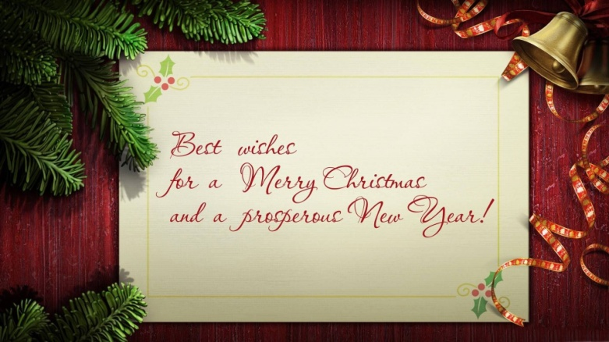

Staff

Pastor: Pastor Dwayne Shugert
Ministers: Every Member
Children’s Ministry: Kim Weyandt
Youth Ministry: Terri Seibold
Secretary: Jenny Graffius
Music Program Director: Sarah Buehrer
Organist: JeanE Waggoner
Custodians: Steve Agler
Jenny Riehm
Nursery: Carol Kotecki
MacKenzie Rodriguez

Lay Leadership

Lay Leader: Tom Ridenour
Head Usher: Bob Baughman
Media Directors: Troy Westfall
Jeff Comley

