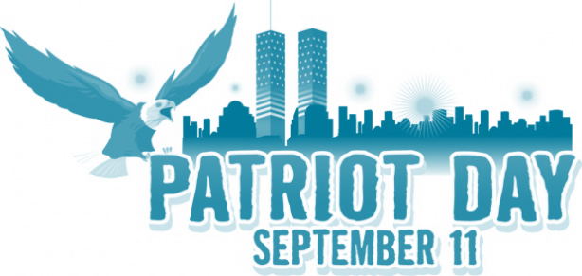

You are invited
to Celebrate Life at
Rossford United Methodist Church
270 Dixie Hwy Rossford Ohio

Live, Laugh, Love

Sunday, September 11th
12:00 Noon - 3:00 pm

We will be honoring Local:

Teachers
School Administrators
Board Members
Police and Fire
City Government
City Administrators
Public Works
Support Staff
Veterans
Active Military

Please RSVP with headcount by Sept. 1st to 419-666-5323 or rossfordumc@yahoo.com

