Rossford United Methodist Church

April 2019

Our Mission:
"To Know Christ And to Make Christ Known"

FROM PASTOR DWAYNE

In Luke 24 we have the story of Jesus' resurrection. But there is one particular verse that I want to highlight for you. In Luke 24:5 the angels ask the women, "Why do you look for the living among the dead?" I love this question. How often do we continue to do the same thing?

How often do we believe, but you know, is it really possible? How often do we think God is big enough to handle our worries, fears, and frustrations, and yet we still hold on to them, refusing to let God do what only God can do? How often do we celebrate Easter and then still beat ourselves up for the mistakes we made? How often do we know the forgiveness of Jesus and yet we don't forgive ourselves. How often do we look for the living among the dead?
Jesus showed us a better way to live life. He called it the Kingdom of God, where everyone is invited to the table to experience the life transforming power of God's love and grace and hope and forgiveness and unconditional acceptance. A place where no one is turned away, a place in which we all belong. A place of life, not death.
This is the Kingdom the church is to build and reflect
and this is the meaning of Easter. Easter is the event that changes everything, that completely unleashes the power and presence of God in our daily lives. This is what is so controversial and why the religious rulers sought out to kill Jesus: God is not contained or manipulated by our laws or rules. Jesus showed us a God without boundaries, a God who is with and for the most unworthy and the most worthy, a God who loves the sinner and the saint, a God who loves with wild abandon and continues to pursue us and woo us to come back home.
Easter is the living God, living with us and for us as we live our daily lives. So when those first few woman came to the tomb they learned this beautiful reality, that death itself cannot contain God. That Jesus is not dead, he has conquered death. It lead to Paul exclaiming to the church in Corinth: "Death has been swallowed up in victory. Where, O death, is your victory? Where, O death, is your sting?" (1 Corinthians 15:55)
But remember that we do not get to Easter Sunday, unless we go through Good Friday. Maybe you are in your Friday now, hurt, struggling, wondering if God is really for you and loves you. So, always remember, it may be Friday, but Sunday's coming! Amen and Amen! Sunday's Coming!

Grace and Peace,
Pastor Dwayne



RUMC OFFICERS FOR 2019
Regular meetings are scheduled for the 2nd Tuesday of each month. Please contact your committee chairperson if you have questions.
Administrative Council
Jerry Baumgartner - chair, Pastor Dwayne Shugert, Kim Weyandt, Kay Jacob, Tom Ridenour, John Rust Jr., Larry Ulrich, Ray McLargin, Brenda Weis, Al Weis, Kristen Vargo, Cheryl Garlow, Nancy Rust
Trustees
John Rust Jr. - chair, Doug Williams, Wendell James, Bill Garlow, Sue Perkins, John Rust III, Jim Sikorski, Tim Robinson
Finance
Larry Ulrich - co-chair, Ray McLargin - co-chair, David Feltner, Debra James, Kevin Cox, Judy Bowerman, Linda Rickwald, Elaine MacKinnon, Bill Seibold, Jim Seibold
Lay Leadership
Pastor Dwayne Shugert, Tom Ridenour, Marcia Olwick, Kim Weyandt, Jane Williams, Lindsay Brant, Tina Vogelpohl, Michelle Sutter, Jamie Baumgartner
Congregational Care
Brenda and Al Weis - co-chair, Kim Weyandt - co-chair, Caroline Eschedor, Darrel Eschedor, Betty Dowell
SPRC (Staff/Pastor Relations Committee)
Kristen Vargo - Chair, Todd Gordon, Jane Cox, Trudy McCamey, Pete Petersen, Troy Westfall, Ken Sutter, Christy Foster
Worship
Cheryl Garlow - co-chair, Nancy Rust - co-chair, Lisa Comley, Laurie Clingo, Michelle Sutter, Jane Williams, Kristen Vargo, Pat Baumgartner, Marcia Olwick, Trudi McCamey, Donna Robinson, Darlene Limmer
Church Historian
Sue Perkins
Communion Stewards
Michelle Sutter, Judy Ivoska, Jack Engwert, Bill Seibold, Laurie Seibold, Matt Foster, Christy Foster, Troy Brant, Lindsay Brant, Kristen Vargo, Doug Williams, Jane Williams

UPCOMING SERMON SERIES
Starting March 24, we will be exploring and studying together the teachings of Jesus from the Gospel of Matthew.
3/31 - "The Gates" Matthew 7:13-14
4/7 - "Your Sins Are Forgiven" Matthew 9:1-8
4/14 - "Palm Sunday" Matthew 21:1-11
4/21 - 8:00 sunrise service - "He Is Not Here" Mark 16:1-8
- 10:30 service - "He Is Risen" Matthew 28:1-10
4/28 - "Sabbath" Matthew 12:1-8
5/7 - "The End" Matthew 24:36-44

DOCK
I hope by the time this newsletter comes out that it feels like spring!! It’s about time, huh? D.O.C.K. will meet on April 7, 14 and lead worship on the 28th. We will not meet on Easter, April 21st.
Throughout April we’ll be “NTLT”… Noticing The Little Things. This was our Lenten commitment. We’ve been discussing how it’s important to do little things to make people’s lives a little better. It’s also important to notice the little things and see our own little blessings. We’re trying to pay attention to our little world and try to make it better in little ways.
On Palm Sunday, the 14th at 5:00, D.O.C.K. will meet for our annual Christian Passover/Seder Meal. We will talk about the Jewish tradition of celebrating the Passover meal in remembrance of God freeing them from slavery in Egypt, the Exodus. God sent 10 plagues to Egypt to convince Pharaoh to set them free. The 10th plague was the killing of first born children. The Israelite's were instructed to mark the doorposts of their homes with the blood of a slaughtered spring lamb and, upon seeing this, the spirit of the Lord would know to pass over the first-born in these homes. For the Christian, Jesus is the Passover Lamb. His blood was shed to save us from death. It’s quite a story of salvation.

KINGDOM KIDS CHOIR
Kingdom Kids Choir met on March 17th and learned a song called, “Hosanna, the Little Children Sing”. They’ll be singing it during the Children’s Moment on Palm Sunday, April 14th. They’ll be waving palms and playing boomwhackers. We’ll gather for a little review at 9:45 that morning. They’ll also participate in the procession, marching with palms throughout the opening song. Should be a fun morning!
Terri Seibold
Director of Youth Ministries



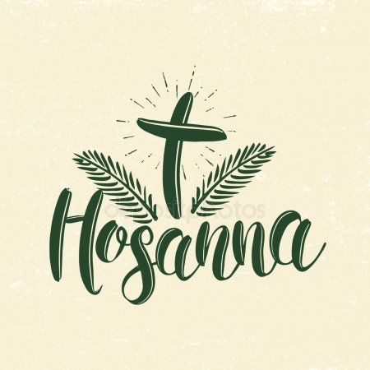


WORSHIP NEWS
The worship committee met Feb. 26th to discuss the many details for the Easter season. Here is a schedule of events for you:
Sunday, April 14, Palm Sunday Worship, 10:30am
Thursday, April 18, Maundy Thursday Tenebris Service, 7PM. If you miss this service, you will be missing probably the most meaningful and beautiful service of the year! Please come and remember the night Jesus was betray and served the last communion to his disciples.
Sunday, April 21, Easter Sonrise Service, 8AM. Pastor Dwayne has organized a short but nice service for us on that morning. Breakfast will be served afterwards in the Family LIfe Center. Please sign the sheet in the Narthex if you know you are coming to help us plan for everyone.
Sunday, April 21, Easter Worship, 10:30 AM. A beautiful service of song, scripture, and blossoming the cross. Bring some live flowers with you to help transform that old rugged cross into a thing of beauty!
We would like to publicly thank Trudy McCamey and Marcia Olwick for cleaning our the room behind the choir chairs. It has been a mess for a very long time and they did a wonderful job of organizing and pitching the old stuff. It sure doesn't look like the old room and that is good!
We are very excited about celebrating our 120th church birthday on the week-end of July 18 through 21. Please mark that time on your calendar. It will be a three day celebration with a car show, birthday cake for the community, and a special worship service. We will be meeting soon to plan for this event and it should be lots of fun for all!

Lenten Study Meetings, March 27th, April 3rd, and April 10th at 7 pm. Here is what we will be studying and our schedule:
Lenten Study 2019
Prayer and the book by Thom S. Rainer Autopsy of a Deceased Church: 12 Ways to Keep Yours Alive
3/13 - Prayer: What is it, why do we do it and why does it matter?
3/20 - Prayer: Lectio Divina (ancient prayer practice)
3/27 - Autopsy of a Deceased Church : Chapters 1-3
4/3 - Autopsy of a Deceased Church : Chapters 4-7
4/10 - Autopsy of a Deceased Church : Chapters 8-11

Thanks,
Cheryl Garlow and Nancy Rust
Co-Chairpersons of Worship Committee



Please put the following dates on your calendar and plan on helping in some way.
- Spring Rummage Sale - April 11 to 13 (Set up will begin Sunday March 31st. If you are in church on Sunday March 31 and are able, we need help bringing rummage up from the basement. This takes a lot of hands to move all the treasures upstairs. Remember "many hands make the task lighter!!") Donations will be accepted until Tuesday, April 9th.
- Spring BBQ - Sunday, May 5
- RUMC 120th Anniversary Car Show - Thursday, July 18 - 6:00 - 8:00 pm - more details below
- Ice Cream Social - Friday, July 19
- Fall Rummage Sale - September 19 to 21 (Set up will be Sunday, September 8 to Wednesday, September 18)
- Fall BBQ - Sunday, October 6
- Christmas Craft Bazaar - Saturday, November 16th
As always volunteers make the event a success! Be on the lookout for sign up sheets for the above events. Or contact Sue Perkins with questions.

RUMC 120th Anniversary Car Show
WHEN: THURSDAY JULY 18TH
WHERE: ROSSFORD UNITED METHODIST CHURCH,
270 DIXIE HIGHWAY, ROSSFORD, OHIO 43460
TIME: 6 to 8 p.m.
DETAILS: REGISTRATION $5.00, DRIVER WILL GET ONE FREE DINNER, DRAWINGS FOR DOOR PRIZES FOR ALL REGISTERED DRIVERS, 50/50, THE LADIES FROM THE CHURCH WILL BE HOLDING A RAFFLE TO BENEFIT THE CHURCH, THERE WILL BE A COLORING CONTEST FOR THE KIDS, MUSIC WITH CRUISIN ZEAKE, FOOD AND DRINKS WILL BE AVAILABLE TO PURCHASE WITH PROCEEDS GOING TO THE CHURCH



MEN'S BREAKFAST

Saturday, April 13th at 9:00 am
at Silver Moon Soda Grill. Sign up in the Narthex

CONGREGATIONAL CARE COMMITTEE
Happy spring! Kim and Brenda love winter but this has been an unusually long winter here in NW Ohio where the weather changes hourly!!
Our committee is right in the middle of our Lenten 40 items in 40 days project, hopefully you are filling those black trash bags! This is such an easy way to clean out a closet and give back!
Next up is the ongoing ministry of sending out bulletins to our shut ins. Since my mom Kathy is having knew surgery April 2nd; between Jenny and Brenda we will help her get those out weekly to our shut-ins. She will temporarily be one herself for several weeks at Kingston in rehab. We will also soon be sending Easter cards to these folks along with our Veteran patients in Ann Arbor VA. If you know of a person who would enjoy an Easter card please let us and know and we'll be happy to include them.
Plans are in the works for our annual Mud Hens game. This year we will be going on Friday, June 21st. We will plan a hot dog supper in the church kitchen and either travel by carpool or catch the muddy shuttle from All Saints church. Tickets are $14 each and I believe the shuttle is around $2 each way. Look for sign-up sheet in early May.
We also are planning a chili cook off for November, 3rd. Save the date for now. More info later.
Valet for April: Al Weis
Greeter for April: Sherry Engwert
Birthday Sunday will be April 14th, please consider signing up other Sundays for coffee hour.

Craft night will be the 4th Tuesday of the month at 6 pm in the Family Life Center. We've come to a general consensus that we really like eating taco salad for this! Please plan to join us with your favorite craft or just come to eat and enjoy fellowship!
The next craft night will be April 23rd
In Christ,
Al and Brenda Weis, Kim Weyandt, Congregational Care Committee Co Chairs



Birthdays
Steve Agler 4/5
Cheryl Garlow 4/5
Al Weis 4/6
Brenda Weis 4/6
Kathy Ulrich 4/7
Richard Brant 4/8
Olivia Rust 4/11
Kristen Vargo 4/11
Nancy Rust 4/16
Judy Sikorski 4/19
Zander Comley 4/22
Austin Vargo 4/23



Anniversaries
Tom & Sue Ferguson 4/26
Steve & Pam Agler 4/27

***If we missed you or someone else, please let us know at rossfordumc@yahoo.com or
call 419-666-5323***

HOW CAN YOU HELP OUT?

Ushers and Greeters
Please see Bob Baughman to Usher or Brenda and Al Weis to Greet or Valet.
Helping Hands of St. Louis
Thursday, April 18th
Questions? Please contact Jerry Baumgartner at 419-666-7236.
Prayer Quilts
If you know of anyone who would benefit from a prayer quilt please call or see Nancy Stonerock. She can be reached at 419-874-3504.
UMC Market
The United Methodist Church has started a "market." This is a way for our church to earn money. You need to go online to www.umcmarket.org and sign up. Whenever you order from this site our church receives a % of what you purchase. There are 89 pages of participating stores and the amount we receive varies. Any questions, see Sue Perkins.
No Longer Accepting Cancelled Stamps
We will no longer be collecting cancelled stamps. The
program has been discontinued. We appreciate all the
donations, and thank you to Barb Chesson for many years of help.
Can Drive
We would like to remind you that we are still collecting aluminum cans to raise money for our church. If you have any to donate, the container is outside the kitchen door. If you need a pickup, please call Doug Williams at 419-661-9484.
Kroger Rewards Program
Kroger Community Rewards makes fund-raising easy..all you have to do is shop at Kroger and swipe your Plus Card! Our Kroger Plus Rewards Organization #84283
Our last check from Kroger was for $91.82!! Thank you!!









SUN | MON | TUES | WED | THURS | FRI | SAT
 | 1 | 2 | 3 | 4 | 5 | 6
 | 5 - 8 pm Drama (Narthex)  RUMMAGE SET UP  9 - 12 pm | 5 - 8 pm Drama (Narthex)  SET UP  9 - 12 pm | 5 - 8 pm Drama (Narthex)  7 pm Lenten Study  SET UP  9 - 12 pm | 5- 8 pm Drama (Narthex)  SET UP  9 - 12 pm | SET UP  9 - 12 pm
7 | 8 | 9 | 10 | 11 | 12 | 13
Last day to order Easter Flowers  9:00 am Adult Sunday School  10:30 am Worship  5:00 pm DOCK | SET UP  9 - 12 pm  8 - 10 pm HEMA (FLC) | SET UP  9 - 12 pm  9:15 am Ladies Bible Study (Parlor) 6 - 9 pm Parent Project (Upstairs)  6:30 pm Scouts  6:30 pm Finance, SPRC, Trustees  7:30 pm Admin | SET UP  9 - 12 pm  7 pm Lenten Study | 6 - 8 pm Girl Scouts  7:00 pm Choir  8:30 pm AA  RUMMAGE SALE  9 - 6 pm | RUMMAGE SALE 9 - 4 pm | 9:00 am Men's Breakfast (Silver Moon)  RUMMAGE SALE 9 - 12 pm  7:30 pm Contra Dancers (FLC)
14 | 15 | 16 | 17 | 18 | 19 | 20
9:00 am Adult Sunday School  10:30 am Palm Sunday Worship  5:00 pm DOCK Seder meal | 6 - 9 pm Parent Project (Parlor)  8 - 10 pm HEMA (FLC) | 9:15 am Ladies Bible Study (Parlor)  6:30 pm Scouts |  | 6 - 8 pm Girl Scouts  7:00 Maundy Thursday Service | 12 - 5 pm Kitchen in use
21 | 22 | 23 | 24 | 25 | 26 | 27
8:00 am SonRise Worship Service  Breakfast following  10:30 am  Worship  No DOCk | 6 - 9 pm Parent Project (Parlor)  8 - 10 pm HEMA (FLC) | 9:15 am Ladies Bible Study (Parlor)  6:00 pm Craft Night (FLC)  6:30 pm Scouts |  | 6 - 8 pm Girl Scouts (FLC)  6:00 pm Bells  7:00 pm Choir  8:30 pm AA |  | 8 am 5 - 9 pm Private Event (FLC, Kitchen)
28 | 29 | 30
9:00 am Adult Sunday School  10:30 am Youth Led Worship  1:00 pm Baby Shower (FLC, Kitchen)  No DOCK | 6 - 9 pm Parent Project (Parlor)  8 - 10 pm HEMA (FLC) | 9:15 am Ladies Bible Study (Parlor)  6:30 pm Scouts



To Church and Friends,
Thank you for all the prayers, visits, cards, and all the goodies given to us. It has been a little rough at times. With prayers and god's healing, we're getting better each day. It's great to be back with our church friends.
Sincerest Thanks,
Ray and Shirley McLargin

CHECK OUT OUR ONLINE FORUM AND MEDIA TAB ON OUR WEBSITE
The Forum tab on our website includes a lifetime of top-quality Christian study and Bible sites. The Media tab is filled with fantastic Christian quality music and videos. Thank you to Larry Keeler who keeps this up to date and filled with useful information.
Forum
We learn by interacting with other Christians. The articles offered below provide an opportunity to discuss current events in the life of the church, offer sermon texts, and allow us to be in relationship with our Christian brothers and sisters online. Click the picture to be taken to the forum section of our website.
Media
Click the picture below to experience fabulous Christian music.

The 2019 Altar Flower schedule is out on the table in the
Narthex. Please consider signing up and honoring your
loved ones with flowers.









Watoto Fast Facts

What does the word Watoto mean?
Watoto is the Swahili word for "children".
What is Watoto?
Watoto is a Church based organization that cares for orphans and widows in Uganda. Our goal is to raise the next generation of Ugandan leaders.
How did Watoto begin?
In 1994 Watoto Church began rescuing orphans. Watoto was born out of the need to place parentless children into loving families. Through Watoto, these children receive the message of Jesus Christ and His salvation, a spiritual awakening, an excellent education and a family. To date, Watoto has over 3000 children in holistic care and this number continues to grow yearly.
What makes Watoto different from other organizations?
Watoto places children in families rather than in large, institutional style orphanages. This ensures that children receive the individual love and care they require.
How does Watoto care for children?
Watoto places the most vulnerable children into new families. Each family consists of 8 children and a mother who cares for them.
Where do the children come from?
Watoto employs several social workers who, with the approval of the Government of Uganda, locate and select the most vulnerable children. These children are some of the 2 million Ugandans who have been orphaned due to AIDS and war.
Where do the mothers come from?
Many Watoto mothers are widows. Some of them have children of their own. Watoto supports these women by giving them the opportunity to fulfill their roles as mothers. Each mother is responsible for the daily care of 8 children.
What are Children's Villages?
Watoto creates entire communities where children can learn and grow in a safe environment. These villages contain houses, schools, a medical clinic, a church & community hall, a clean water source, roads and electricity.
What is Baby Watoto?
Baby Watoto is a home for abandoned and orphaned babies. Here infants under the age of 2 receive the special care they need before they move to one of Watoto's Children's Villages.
Who are the Watoto Children's Choir?
The Watoto Children's Choir travel internationally to help raise an understanding of the plight of Africa's orphans. Watoto's performances are a soulful blend of native African rhythms, contemporary gospel music and ethnic dance. During their concerts, audiences are encouraged to donate towards one of Watoto's many projects in Uganda.
How can I help Watoto?
Each month we insert an envelope for Watoto donations, typically it will appear on our Youth Led Sunday worship service. Book the Watoto Children's Choir for a performance in your community; make a donation or even make a trip to Watoto in Uganda to use your skills or talents.
What countries does Watoto operate in?
All of the children in Watoto are from Uganda. We also operate offices in Asia, Australia, Canada, Netherlands, Scandinavia, UK and the USA.
Who makes decisions at Watoto?
Watoto has a board of directors in each country it operates in. Additionally, an international board of directors oversees the policies that drive the day to day functioning of Watoto. These boards of directors are made up of individuals who are passionate about helping Watoto fulfill our goal of raising the next generation of Ugandan leaders.

Meet Alex Gatonya

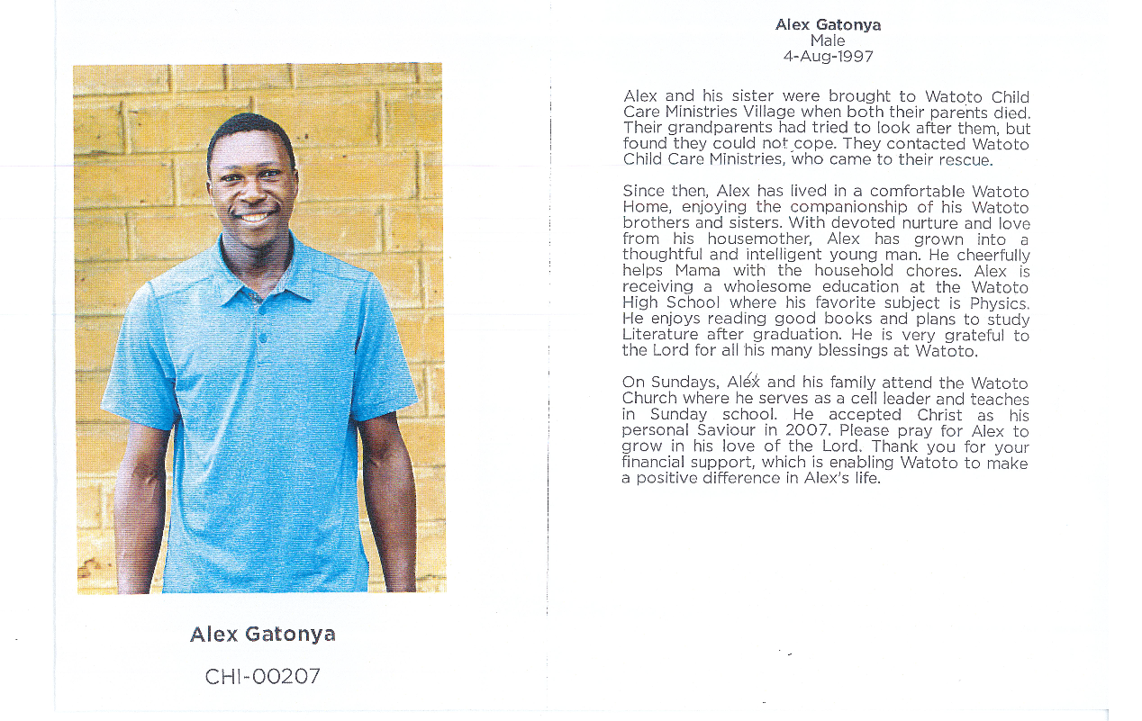



Rossford United Methodist Church

Phone: (419)666-5323 Office Hours: M-F 8:15am-2:15pm Facebook: www.facebook.com/RossfordUMC

Services: 9:00 am Sunday School and 10:30am Worship Office Hours: M-F 8:15am-2:15pm

E-Mail: rossfordumc@yahoo.com Visit us our website: www.rossfordumc.org





Staff

Pastor: Pastor Dwayne Shugert
Ministers: Every Member
Children’s Ministry: Kim Weyandt
Youth Ministry: Terri Seibold
Secretary: Jenny Graffius
Music Program Director: Sarah Buehrer
Organist: JeanE Waggoner
Custodians: Steve Agler
Jenny Riehm
Nursery: Carol Kotecki
Emilie Fisher

Lay Leadership

Lay Leader: Tom Ridenour
Head Usher: Bob Baughman
Media Directors: Troy Westfall
Jeff Comley

