

April 2018

Rossford

United Methodist Church
Our Mission:
"To Know Christ And to Make Christ Known"

Rossford United Methodist Church

270 Dixie Hwy

Rossford, OH 43460

Phone:

(419) 666-5323

Services

9:00 am Sunday School

10:30am Worship

Office Hours:

M-F 8:15am-2:15pm

Facebook:

www.facebook.com/

RossfordUMC

E-Mail:

rossfordumc@yahoo.com

Visit us online at:
www.rossfordumc.org

Greetings Church,

Easter! Jesus is Risen! He is Alive! Can you imagine what the first disciples felt when they rushed to the tomb and say it empty? Or when the women heard the angel say, “Why do you look for the living among the dead? He is not here; he is risen!” (Luke 24:5b) The wonder and awe and confusion and disbelief. But over and above all these things, hope. Could it be true? Could Jesus really be alive? Could he really conquer death? Could he really be the Messiah? Could what we have prayed for and hoped for really be coming true right before our eyes?

The answer to each of the above questions is yes! Yes it is true; the tomb is empty! Yes it is true; Jesus is alive and with us, loving us beyond our wildest imagination and calling us to serve others. Yes it is true; he conquered death, and so will we. Yes it is true that Jesus is the Messiah, the Christ, the one who saves us and rescues us and forgives us and makes the way straight for us to come home to the open and loving arms of God. And yes it is true that what we have prayed for and hoped for is true. The messiah has come, and all those things that hold us down and hold us back have been torn down by the love and grace of Jesus Christ!

Easter reminds us that we are loved; truly, unconditionally, always and forever! And this love sets us free to live lives that are characterized by love and strength and boldness and courage and hope. That we are the people who live and love like Jesus. Reminding all people that no one is beyond the love and grace of Jesus Christ, our Risen Lord.

May we live out the Easter story of love and live in such a way that others will ask us how can we live with such love and peace and joy and patience and kindness and goodness and gentleness and faithfulness and self control (Galatians 5:22-23).

May the Easter event not be just a once a year thing, but how we live every day. May we share the joy and hope that Jesus brings. And may you know and experience the Risen Christ who is with you and loves you beyond your wildest imagination!

Happy Easter!

Pastor Dwayne

Inside This Issue:

Pastor's Message 1

DOCK/Children's Choir 2

How can you help/ Celebrations/Worship 3

SPRC/Fundraising 4

Congregational Care Committee 5

Calendar 6


Sermon Series for the month of April

After Easter we will be starting a sermon series called "Overcoming the Stereotypes"

4/8 - "Christians are Hypocritical"
Galatians 5:13-26
4/15 - "Christians are Anti-Science"
Genesis 1: 1-19
4/22 - "Christians are Judgmental"
Romans 2:1-4
4/29 - "Christians Don't Care"
Isaiah 49: 1-6

Read the scripture each day, several times a day. Think through what Jesus is saying and what that means for us today. And may this reality bring you comfort and joy; Jesus prayed for you. He prayed that whatever separates or divides us will be turn down and overcame, will be healed and we will be made whole.



DOCK News

A big thank you goes to all who attended, participated in and brought desserts to the Dessert Auction/Talent Show. An extra big thank you to Laurie Seibold who managed the kitchen and Tom Ridenour who was our auctioneer. We couldn’t have done it without you. (Drumroll please…) we earned $1220.00! The proceeds were divided between the youth group and the Katrina Relief mission. I’d say it was successful ☺

April will be a quiet (ha) month for the youth. We won’t meet on April 1st because of Easter. We’ll meet at our regular time (5pm – 7pm) on April 8th and 15th.

On April 22nd I will be taking the youth the see “Joseph and the Amazing Technicolor Dreamcoat” at Perrysburg High School. We’ll meet after church for lunch and then we’ll carpool to the high school. The show is at 2:00 p.m. We’ll should be back to RUMC by 4:00 for pick-up. No DOCK meeting that evening. Our next youth led worship is April 29th.

As usual, thanks for your support.

CHILDREN’S CHOIR

Our next rehearsal date will be April 15th after the children’s sermon. We’ll be working on “If I Were a Butterfly”.

Terri Seibold
Director of Youth Ministry
Disciples Of Christ’s Kingdom!





Ushers and Greeters
Please see Bob Baughman to Usher or Brenda and Al Weis to Greet or Valet.

Helping Hands of St. Louis
Thursday, April 5th, 2018. Questions please contact Jerry Baumgartner at 419-666-7236.

Prayer Quilts
If you know of anyone who would benefit from a prayer quilt please call or see Nancy Stonerock.
She can be reached at 419-874-3504.

UMC Market
The United Methodist Church has started a "market." This is a way for our church to earn money. You need to go online to www.umcmarket.org and sign up. Whenever you order from this site our church receives a % of what you purchase. There are 89 pages of participating stores and the amount we receive varies. Any questions, see Sue Perkins.

Box Tops and Stamps
We are still collecting Box Tops for Education and cancelled postage stamps. The collection box is located in the Narthex. Please see Barb Chesson if you have any questions.

Can Drive

We would like to remind you that we are still collecting aluminum cans to raise money for our church. If you have any to donate, the container is outside the kitchen door. If you need a pickup, please call Doug Williams at 419-661-9484.

APRIL CELEBRATIONS

Anniversaries

Tom & Sue Ferguson 4/26

Birthdays
Steve Agler 4/5
Cheryl Garlow 4/5
Al Weis 4/6
Brenda Weis 4/6
Kathy Ulrich 4/7
Charlie Brant 4/8
Olivia Rust 4/11
Kristen Vargo 4/11
Nancy Rust 4/16
Judy Sikorski 4/19
Zander Comley 4/22
Austin Vargo 4/23

Worship News

Thank you to Terri, Jim, and the Youth for a wonderful Palm Sunday service. Hope you were able to follow the "Daily Prayers and Meditations With Your Cup" which was passed out to everyone that morning during Worship.

The younger children did a great job too singing for us during the March 18th service!

As of the time of this writing, we are ready for Holy Week and a glorious Easter. Sarah, JeanE, and the choir have worked hard on special music. The Worship Committee, media guys, and Steve, are prepared too for Maundy Thursday, Sonrise Service, Easter Breakfast and Easter Worship. Christ is Rising indeed!!!!

We will celebrate communion April 8 instead of April 1.

With Love,
Cheryl Garlow and Nancy Rust
Co-Chairpersons of Worship Committee

Meeting Night for April

Tuesday - April 10th, 2018
6:30pm SPRC
6:30pm Trustees and Finance
7:30pm Admin

Contact your council chair if you have questions or can't make the meeting

Did you know RUMC now videos the sermons each week? We've placed a link on the Rossfordumc.org website for you to view and share with others or check out our Facebook page (www.facebook.com/rossfordUMC)





FUNDRAISING NEWS

Volunteers Needed
As you look at these events you realize that they are not a one person project, or even a five person project. So please put these dates on your calendar and plan on helping any time you are able to.

The fundraiser committee met and have set several dates for 2018.

Spring Rummage Sale - April 26th to 28th.
Set up begins April 15th

Spring BBQ - May 6th.
Set up begins May 2nd

Fall Rummage Sale - September 27th to 29th.
Set up begins September 16th

Fall BBQ - October 7th
Set up begins October 3rd

Christmas Bazaar - Saturday, November 17th
Set up the week before
RUMMAGE SALE

Our Spring Rummage Sale is April 26, 27 and 28. We will begin setting up on Sunday, April 15. If you are able, we need help getting rummage from the basement. Then we begin working on Monday, April 16. Please plan on helping during these 2 weeks if you are able. Worker sheets are in the Narthex. You can bring your "Treasures" any time. Any questions, see Sue Perkins.

FEEDING OUR CHILDREN

This summer we would like to have sack lunches provided to children in our community. We are in the planning stages. If you know of a church or organization that does this, please see Sue Perkins. We are thinking of providing lunches 2 days a week. We will need people to prepare the lunches. If you are interested in helping, also see Sue.

SPRING BBQ

Our Spring BBQ is Sunday, May 6. Please plan on helping if you are able. There will be sign up sheets in the Fellowship pads. More information in the next newsletter.

SPRC - Staff Parish Relations Committee

An effective committee builds a strong positive relationship between staff and congregation so that the congregation makes disciples of Jesus Christ for the transformation of the world. This committee will work with the lead pastor and other staff to fulfill legal and ethical responsibilities related to staff.

Our 2018 SPRC Representatives to Employees

Employee Representative
Sarah Buehrer Trudy McCamey
Jean E. Waggoner Tom Ridenour
Terri Seibold Troy Westfall
Jenny Graffius Jane Cox
Carol Kotecki & MacKenzie Rodriguez Laurie Seibold
Doug Albright Laurie Seibold
Pastor Dwayne and family Kay Jacob
Jenny Reihm Todd Gordon
Steve Agler Pete Petersen
Kim Weyandt Tom Ridenour

Thank you,
Kay Jacob
Chairperson for SPRC Committee


Talent Show and Dessert Auction
2018

Congregational Care Committee
*Formally known as Hospitality and Fellowship*

Happy Spring from the Congregational Care Committee! We continue to have our craft night on the 3rd Tuesday of every month from 6:00 to 9:00 pm. We've had about 9 who come on a regular basis. The next one is April 17th. Everyone is welcome! Bring a craft to work on or just come to sit and talk! Our next pallet painting to support our VBS is scheduled for Friday, May 11th at 6:00 pm. This is a really fun event. No painting skills necessary. See Brenda Weis or Kim Weyandt for details.

We have also decided to send out bulletins to the shut in list every other week instead of every week to save on postage.

Valet for April: Al Weis
Greeter for April: Bethany Rust

Sincerely,
Al and Brenda Weis, Kim Weyandt,
Congregational Care Committee co-chairs

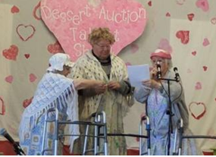

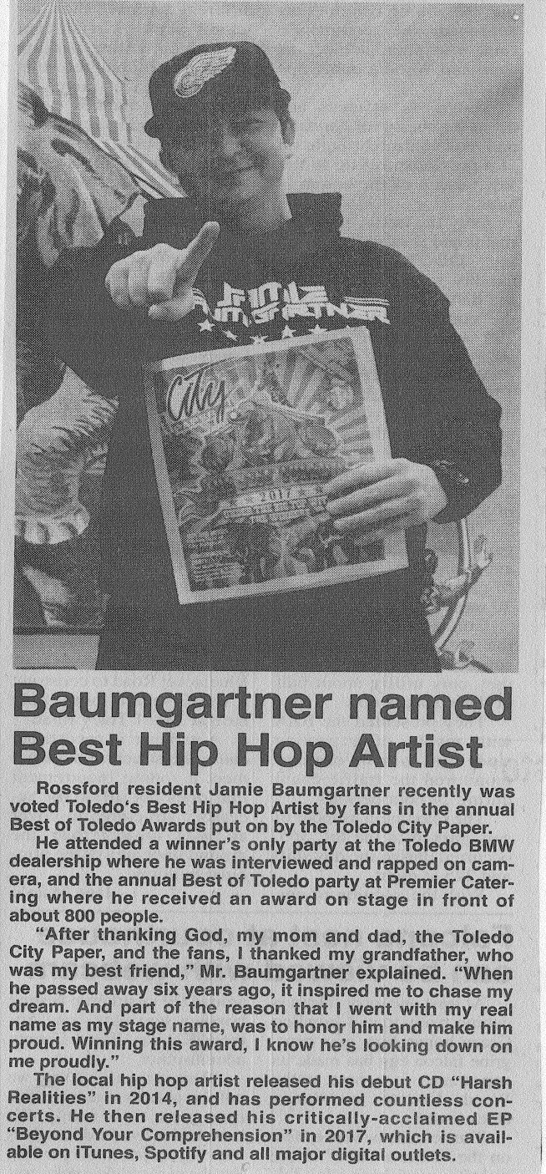

Kroger Rewards
Program
The Kroger Rewards Program is a nationwide program that lets loyalty card holders select charities to which Kroger will donate, based on dollars they spend in stores.

If you have a Kroger card, PLEASE check to see that you are signed up, so that our church gets a percentage of what you buy.
Our Kroger Plus Rewards Organization
# 84283

Your purchases really do help! We received $91.88 from our loyalty card holders from the last quarter of 2017, Thank you!






Sunday | Monday | Tuesday | Wednesday | Thursday | Friday | Saturday
1 | 2 | 3 | 4 | 5 | 6 | 7
8am SonRise Worship  8:30am Breakfast  10:30am Worship  No DOCK | 6-9pm Parent Project (Parlor)  8-10pm HEMA (FLC) | 9:15am Ladies Bible Study  6:30pm Cub Scouts | 6:30pm Boy Scouts | 6:00pm Bells  7:00pm Choir  8:30pm AA | 7-10:00pm Private Event (FLC, Kitchen) | All day Birthday Party (FLC, Kitchen)
8 | 9 | 10 | 11 | 12 | 13 | 14
9:00am Sunday School  10:30am Worship with Communion  5:00 pm DOCK | 6-8pm Parent Project (Parlor)  8-10pm HEMA (FLC) | 9:15am Ladies Bible Study  6:30pm Cub Scouts  6:30pm Finance, Trustees  7:30pm Admin | 6:30pm Boy Scouts | 6:00pm Bells  7:00pm Choir 8:30pm AA |  | 9:00am Men's Breakfast @ Silver Moon  7:30 pm Contra Dance (FLC)
15 | 16 | 17 | 18 | 19 | 20 | 21
9:00am Sunday School  10:30am Worship  5:00pm DOCK  Rummage Sale Set Up (FLC, Parlor, Narthex) | No Parent Project  No HEMA | 9:15am Ladies Bible Study  6:30pm Cub Scouts  6:00pm Craft Night (Parlor) | 6:30pm Boy Scouts | 6:00pm Bells  7:00pm Choir 8:30pm AA
22 | 23 | 24 | 25 | 26 | 27 | 28
9:00am Sunday School  10:30am Worship  5:00 pm DOCK  Rummage Sale Set Up (FLC, Parlor, Narthex) | No Parent Project  No HEMA | No Ladies Bible Study  6:30pm Cub Scouts | 6:30pm Boy Scouts | No Bells  No Choir 8:30pm AA  Rummage Sale  9am-6pm | Rummage Sale  9am-4pm | Rummage Sale  9am-12pm
29 | 30
9:00am Sunday School  10:30am Youth Led Worship  No DOCK | 6-8pm Parent Project (Parlor)  8-10pm HEMA (FLC)


NON-PROFIT
US POSTAGE
PAID
TOLEDO, OH
PERMIT #522

ROSSFORD UNITED METHODIST CHURCH
270 DIXIE HWY
ROSSFORD, OH 43460



Staff

Pastor: Pastor Dwayne Shugert
Ministers: Every Member
Children’s Ministry: Kim Weyandt
Youth Ministry: Terri Seibold
Secretary: Jenny Graffius
Music Program Director: Sarah Buehrer
Organist: JeanE Waggoner
Custodians: Steve Agler
Jenny Riehm
Nursery: Carol Kotecki
MacKenzie Rodriguez

Lay Leadership

Lay Leader: Tom Ridenour
Head Usher: Bob Baughman
Media Directors: Troy Westfall
Jeff Comley

