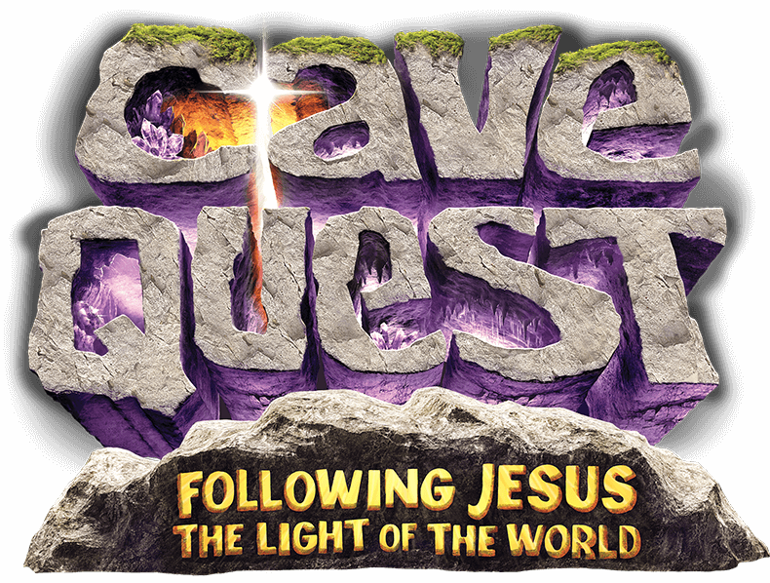
VBS Registration Form
Rossford United Methodist Church
June 20th - 23rd, 2016 5:15 PM - 8:30 PM
(Dinner will be provided to all kids and volunteers)

Child's Name:
Parent/Guardian Name:
Address:
Email Address:
Phone Numbers:
Home: Cell: Work:

Age Information:
Date of Birth: Age:
Last school grade completed:
Home Church:
Allergies/Medical Information/Other:

Emergency Contacts:
Name: Phone:
Name: Phone:

Dismissal Information:
Name (s) of person (s) who may pick up this child from VBS:

